GEOL 342 Sedimentation and Stratigraphy
Lecture 1: Introduction
26 January 2006
Assoc. Prof. A. Jay Kaufman

Introduction to Sedimentation and Stratigraphy

Goals of this course

1. To explore the origin and evolution of sediments and sedimentary rocks
2. To examine the nature of sedimentary deposits across all time and length scales
3. To provide the tools necessary to properly describe features of sedimentary rocks
4. To provide practical laboratory and field experience in the description of sedimentary deposits in order to interpret Earth’s long history
5. To integrate aspects of sedimentation and stratigraphy into other aspects of the earth sciences

Rock d’jour

Each lecture will highlight a rock d’jour (rock of the day) that will be described and used to illustrate important concepts in sedimentary geology. These may show up on later tests, so make sure to take notes on their characteristics and the discussion issues they highlight.

Descriptions of sedimentary rocks

- Color
- Composition

In contrast to the study of igneous and metamorphic rocks where compositions are often characterized by elemental abundances, sedimentary rocks are most often characterized by their mineralogy. Describing the composition of a sedimentary rock using bulk chemistry is misleading because it often obscures important genetic distinctions. If necessary, review the characteristics of minerals introduced in Physical Geology.

- Texture

Texture refers to the size, shape and arrangement of grains that make up a sedimentary rock, of which there are two fundamental types: clastic and crystalline. When rocks contain fragments of pre-existing rocks or minerals that were transported as discrete particles they are known as clastic (from klastos, Gk. For broken). On the other hand, when sedimentary grains are interlocked or intergrown the texture is called crystalline.

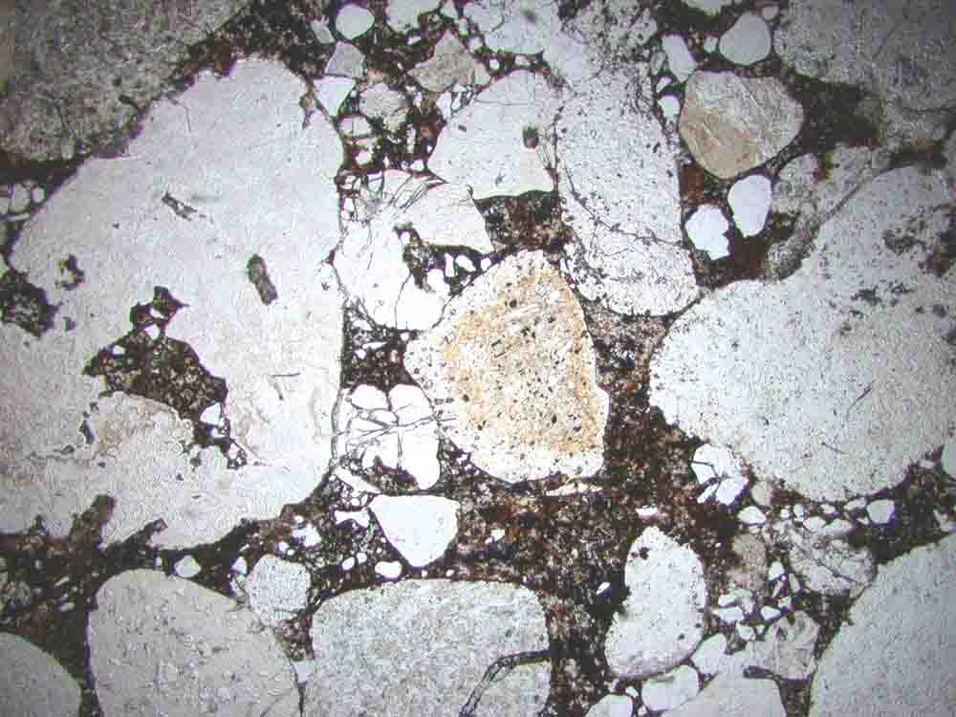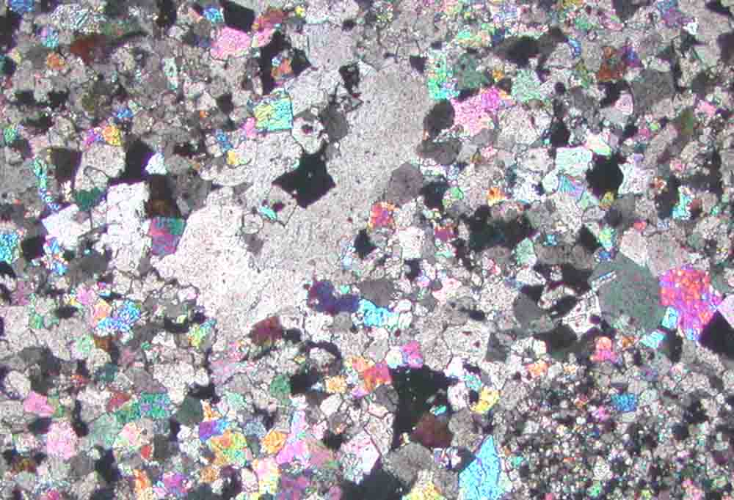
Grain size of clasts or crystals are characterized by maximum grain diameters. Variation grain size is called sorting. The degree of sorting is often a function of the mode of transport of the materials. For example, while ice is a fluid, it has little ability to sort or round the particles it transports, so a glacial deposit generally has poorly sorted, angular clasts. Particle size is the primary basis for classifying clastic sediments and sedimentary rocks, regardless of the mineralogy of the clasts.

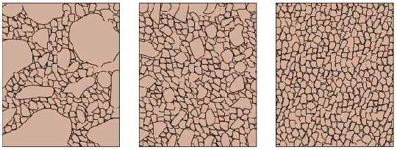

The shape of grains can also be a diagnostic tool (e.g. sphericity, roundness or angularity), which usually implies something about the distance and mode of transport.

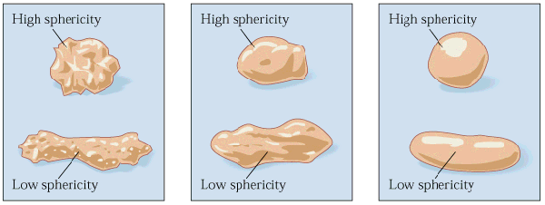

Finally, the degree of packing and cementation of a sedimentary rock are important textural characteristics.

- Fossil content

Fossils can be characterized as hard parts (i.e. “body fossils” including shells, bones, or their replacements), or as traces of organisms (such as tracks, trails, and burrows, known collectively as ichnofossils).

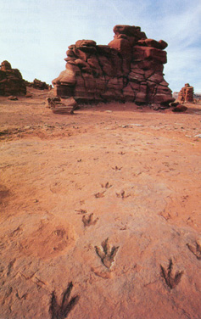

- Sedimentary structures

Various sedimentary structures in hand sample and outcrop yield clues to the origin of the rock and its depositional environment. Bedding and stratification are the hallmark of sedimentary rock. The layers, or strata, are built up from the accumulation of particles of various sizes and arrangements. These particles formed during the breakdown and transport of pre-existing rock, or by precipitation from ions in solution.

Sedimentary rock interpretations

1. When was it deposited? HISTORY
2. What is its lateral distribution? STRATIGRAPHY
3. What rocks were deposited at the same time? CORRELATION
4. What were the source rocks and how far away were they? PROVENANCE
5. How was the material weathered, broken, and transported? WEATHERING AND TRANSPORTATION
6. How was the material deposited and lithified? DEPOSITIONAL SETTING
7. What has happened to the sediment since it was laid down? DIAGENESIS

Categories of sedimentary rocks

Sediments and sedimentary rocks are classified into three groups based on the types of particles they contain. These groups include:

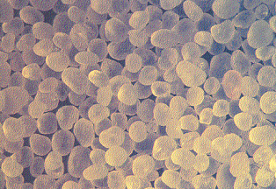

Clastic sediments form from loose rock and minerals produced by weathering and erosion.

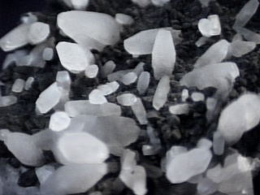

Chemical sediment is formed by the precipitation of minerals dissolved in fresh or sea water.

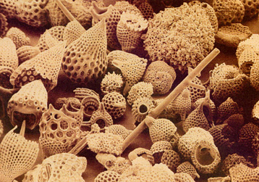

Biogenic sediment is mainly made of the remains of plants and animals.

Loose sediments are transformed into rock, that is they are lithified, by compaction, recrystallization, and cementation. Together, these changes are commonly referred to as diagenesis.

Sedimentary basins

Most of the surface of the Earth is covered with sedimentary rocks or soils (over 90%), including some 75% of land areas and 100% of the ocean basins. At the same time, sedimentary rocks compose only about 5% of lithosphere, so it is a very thin veneer.

What are sedimentary basins?

Sedimentary basins are holes filled with dirt, which was originally weathered rock (igneous, metamorphic, or sedimentary) in mountains that was transported by gravity and accumulated in the oceans (eventually, although there may have been several waystations along the traverse). The base level is a horizon below which erosion will not occur, and this is typically sea level. Accomodation space is the area below the base level where sediments may accumulate.

What different types of sedimentary basins are there?

- topographic - low-lying areas of the earth's surface surrounded by higher areas; subaerial and/or subaqueous.
- structural – syn- to post-depositional deformation (folding and faulting)
- sedimentary – a hole in the ground, filled or filling with dirt due to its own loading

Sedimentary depositional environments

Depositional environments include a set of physical, chemical, and biological processes, acting at a certain time, place, and intensity, preserving recognizable set of geometric and physical attributes. These commonly correspond to some geomorphic entity (e.g., a river)

