GEOL 342 Sedimentation and Stratigraphy
Lecture 3: Fluid dynamics and sediment transport
2 February 2006
Assoc. Prof. A. Jay Kaufman

Fluid dynamics and sediment transport

Weathered rock is transported from source areas to depositional sites by three kinds of processes, including 1) dry, gravity-driven mass wasting, 2) wet, gravity-driven mass wasting, and 3) direct fluid flows of air, water, and ice.

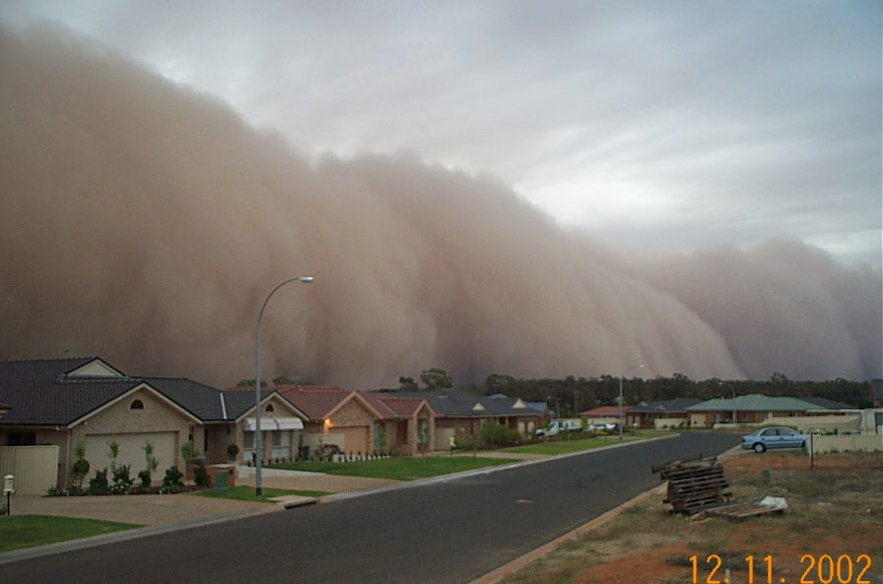

Fluid properties

Fluid plays an important role in most models of sediment transport. Thus knowledge of hydraulics, the science of fluid flow, is essential to sedimentation and stratigraphy. Although fluids resist forces that tend to change their volume, they readily alter their shape in response to external forces. The ability of a fluid to entrain particles is dependent on 1) fluid density, 2) viscosity (resistance to shearing), and 3) flow velocity.

What are the units of these physical measures?

Viscosity – the constant of proportionality between shear stress and shear rate. All fluids will deform when stressed. The more they are stressed, the more they are deformed. For most fluids, this relationship is directly proportional and can be written as follows:

τ = μ*du/dy

τ is the shear stress, and du/dy is the shear rate. μ is viscocity. Fluids of this type are called Newtonian fluids. Units of this force (of internal friction) are in Poise (Ns/m²). The names Poiseuille and the shortened Poise are from the great French physician, Jean Louis Poiseuille (1799 - 1869).
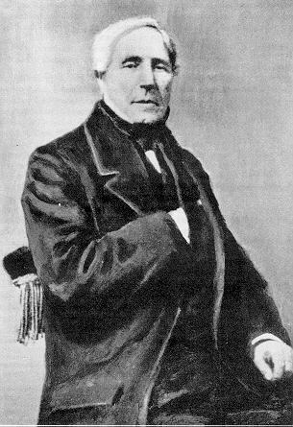

Common viscosities of fluids at 20ºC

water (1 cPoise)
oil (1-2 cP)
glaciers (1 x 10¹¹ P)
air (~1.7 x 10⁻⁵ Poise)
natural Gas (1 x 10⁻⁵ Poise)
mantle (1 x 10²⁰ Poise)

T (ºC) |  | μ (cPoise)  Importantly, viscosity varies as a function of temperature, since it depends on chemical and material effects. This table demonstrates the change of water viscosity with temperature.
0 |  | 1.792
20 |  | 1.002
40 |  | 0.656
60 |  | 0.469
80 |  | 0.357
100 |  | 0.284

Velocity
The velocity of a fluid (distance traveled per unit time) determines the type of fluid flow, of which there are two fundamental types: laminar and turbulent. In laminar flow particles move uniformly in subparallel sheets or filaments (streamlines). In turbulent flow particles move in a random, haphazard pattern. Turbulent flows are more effective agents of erosion and transportation. The only non-turbulent agents of erosion and deposition are ice and mud-supported gravity flows. Two basic equations are used to describe the hydraulics of fluid flow and sediment deposition. These are known as the Reynolds and Froude numbers.

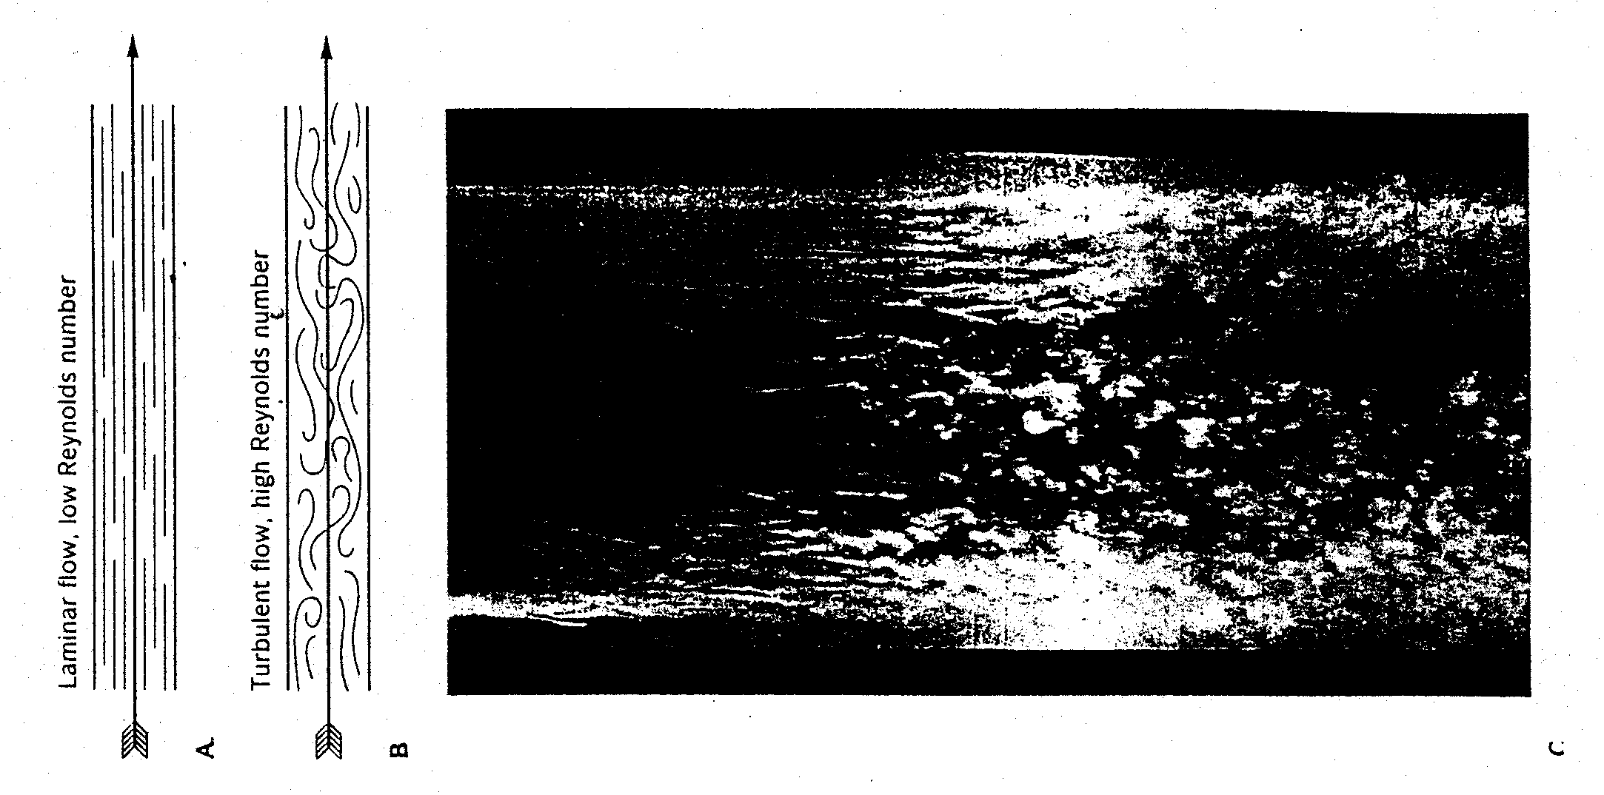

Reynolds number

The transition from laminar to turbulent flow occurs as velocity increases, viscosity decreases, and the roughness of the flow boundary increases, and/or the flow becomes more narrowly confined. These variables were elucidated by the English physicist Sir Osborne Reynolds.
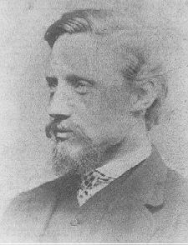

The Reynolds number is a mathematical representation of inertial forces/viscous forces.

Reynolds number = R_{e} = 2rVρ/μ

Where r is the hydraulic radius, V is the flow velocity, ρ is the fluid density, and μ is viscocity.

Viscous forces tend to resist fluid motion, keeping flow smooth, while inertial forces generate disordered (turbulent) motions. As such high inertial flows (Re > 5000) tend to be turbulent, and viscous flows (Re < 1500) tend to be laminar. Unconfined fluids moving across open surfaces (windstorms, surface runoff sheet flow, very slow-moving streams, and continental ice sheets) have Re <500-2000 and exhibit laminar flow. Fast-moving streams and turbidity currents have Re >2000.

Froude number

The Froude number is a ratio of inertial to gravitational forces for a fluid. It compares the tendency of a moving fluid to continue moving with the gravitational forces that act to stop its motion.

Froude number = F_{r} = flow velocity/(acceleration of gravity)(force of inertia) = V/√gD

Where D = depth and gD = speed (celerity) of the gravitational wave. F_{r} >1 occurs in fast and/or shallow flows; F_{r} <1 occurs in slow and/or deep flows)

What is a gravity wave?

Throw a stone into a standing body of water and watch the waves move out in concentric paths – this is a gravity wave; now throw a stone into moving water – if you can see the gravity wave move upstream then it is faster than the velocity of the stream. Thus F_{r}<1 otherwise known as tranquil flow, which is typical of most bodies of flowing water. If, however, F_{R}>1 then the velocity of the stream is faster than the gravity wave and rapid flow occurs.

Froude numbers are important to understanding the ripples and other structures that form at the base of rapidly moving streams.

Particle motion

Particles get picked up when the forces of fluid drag (F_{D}) and fluid lift (F_{L}) work in unison resulting in a net fluid force (F_{F}). Drag exerts a horizontal force, which causes particles to roll, whereas lift raises the particles vertically into the current.

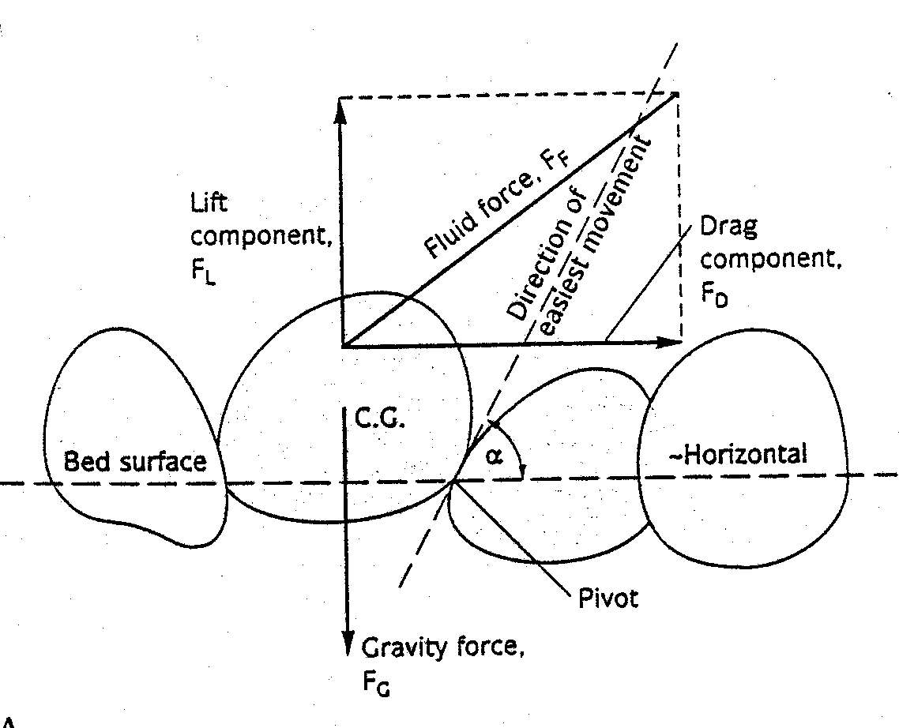

Lift force is an example of Bernoulli’s principle, which states that the sum of the velocity and pressure on an object in a flow must be constant. Whenever a flow speeds up, it exerts less pressure than a slower moving part of the flow.

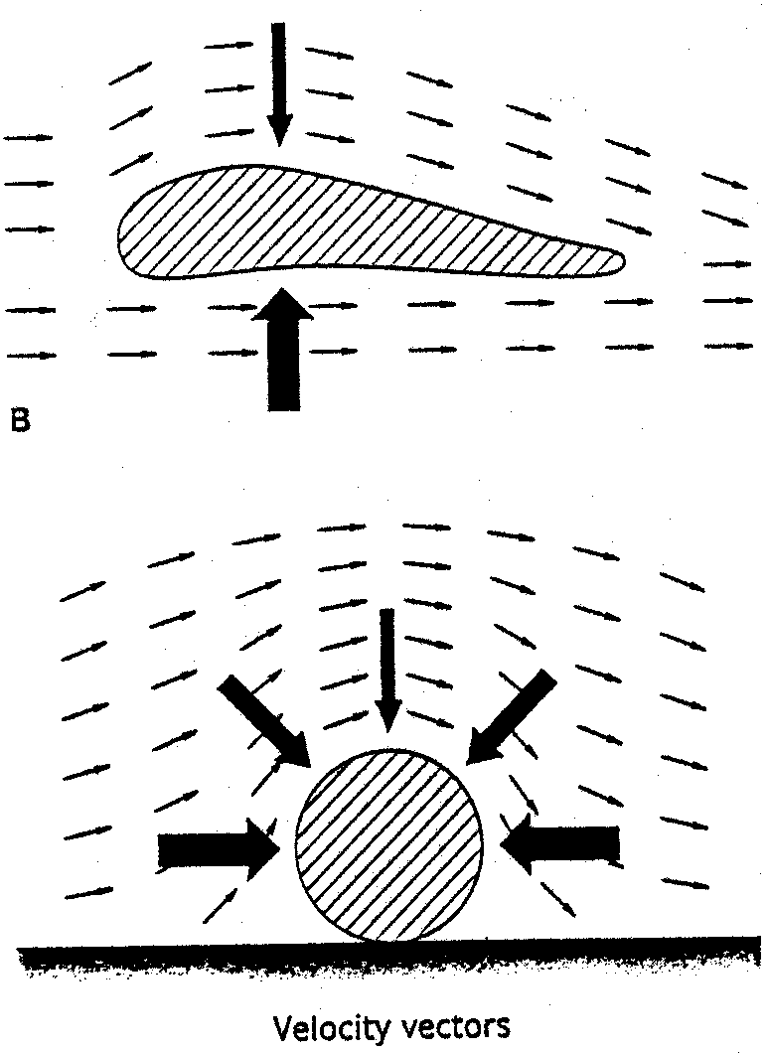

How do sediments move once they have been lifted?

Sedimentary particles are moved in the bedload by 1) traction (rolling and dragging), or 2) saltation (bouncing, skipping, and jumping). The remainder of particles are carried by suspension.
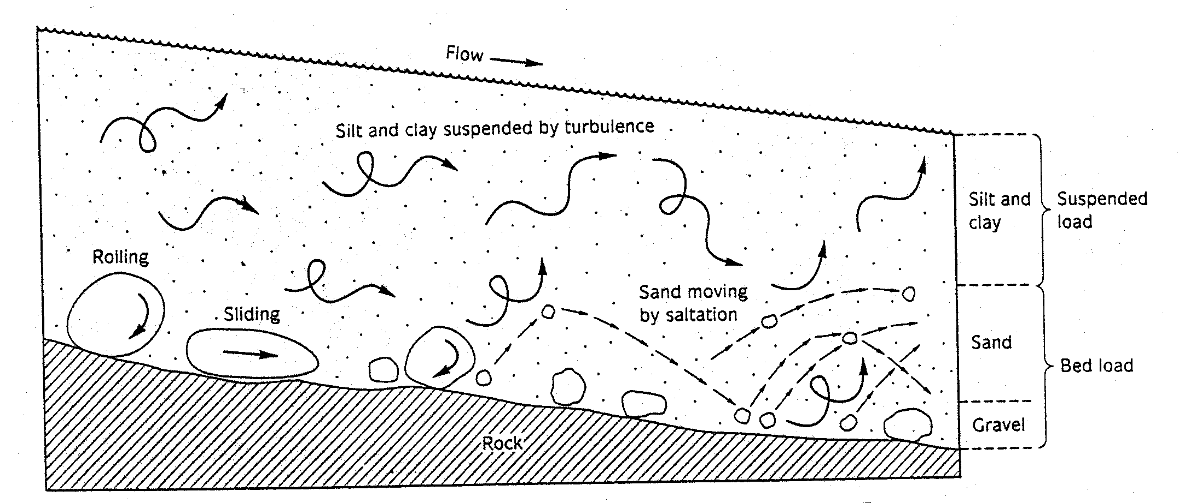

The relationship between grain size, entrainment, transportation, and deposition is shown in the Hjulstrom diagram, which shows the minimum critical velocity necessary for erosion, transportation, and deposition of clasts of various sizes and cohesion.

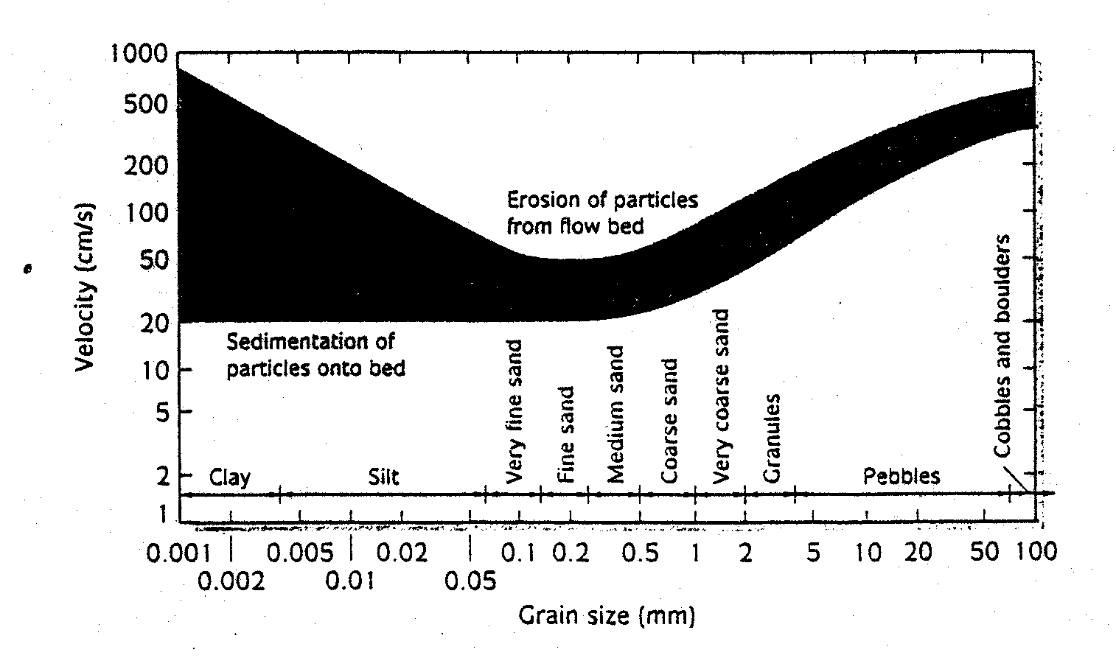
Stoke’s Law

Once a particle is entrained in a fluid it begins to sink again under gravitational forces. The distance it travels depends on the drag force of the fluid and the settling velocity of the particle. The settling velocity is calculated using Stoke’s Law, which can be considered as the sum of the gravitational pull downward versus the drag force of the fluid pushing upward.

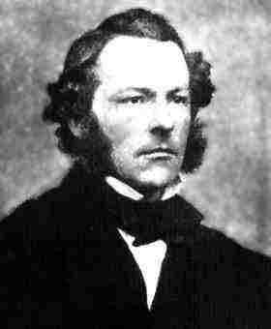

A freefalling particle will cease to accelerate when the downward force of gravity (F_{g}) is balanced by the frictional force (F_{up}) exerted on the particle by the fluid and the drag forces (F_{d}). The velocity of the particle under these conditions is called the “fall velocity” or “terminal velocity” and can be written as follows:

F_{d} = F_{g} - F_{up}

Stokes calculated the fall velocity for small particles, < 0.1 mm diameter. First, consider the frictional resistance that the fluid offers to movement of a settling sphere

F_{d} = C_{d}πr²ρ _{f} V²/2

where F_{d} = resistance (frictional drag), r = particle radius, ρ_{f} is fluid density, and V = settling velocity of sphere.

Then consider the force of gravity pulling the sphere downward

F_{g} = 4/3 πr³ρ_{s}g

where ρ_{s} = density of the sphere and g = acceleration due to gravity

The bouyant force of the liquid is given by

F_{up} = 4/3πr³ρ_{f}g

where ρ_{f} = density of the fluid

Substituting these three factors into the first equation, we get the following:

C_{d}πr²ρ _{f} V²/2 = 4/3 πr³ρ_{s}g - 4/3πr³ρ_{f}g

This can be simplified into

V² = 8gr(ρ_{s} - ρ_{f})/3C_{d}ρ _{f}

If the temperature and fluid density are constant and the sphere and fluid densities known then this equation can be simplified significantly to

V = Cr²

where C is a constant given by 2(ρ_{s} - ρ_{f})g/18η. At 20ºC, in water, with a sphere density of 2.65 g/cc, C = 3.59 x 10⁴

