GEOL 342 Sedimentation and Stratigraphy
Lecture 2: Weathering
31 January 2006
Assoc. Prof. A. Jay Kaufman

Weathering

Given that most of the igneous continental mass is composed of feldspars, what has happened to these minerals when we look at clean quartz sand at the beach? The physical and chemical processes of breakdown of rocks and minerals are known as weathering. It is the simple consequence of exposing pre-existing rocks to the conditions at the Earth’s surface, which is considerably different from where they formed. Regolith is the general term for particles of broken down rock, including gravel, sand, silt, and clay.
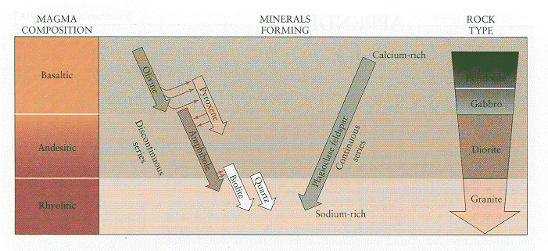
800ºC
1400ºC
1200ºC
1050ºC

Bowen’s reaction scale

Physical weathering

There are four major mechanisms of physical weathering, including 1) freeze-thaw. 2) insolation, 3) stress release, and 4) organic activity. In addition, the action of the wind, rivers, glaciers, and landslides add to the physical breakdown of rock and the landscape.

Freeze-thaw (ice-wedging) – when water freezes a 9-10% expansion of volume occurs, which can create forces as great as several kilograms per square centimeter in cracks and fissures of a rock. This is greater than the tensile strength of most rocks. The process is most efficient where fractures are abundant and where there the daily temperature range hovers around the 0ºC mark. Similar processes occur when evaporite minerals crystallize in cracks and crevices.

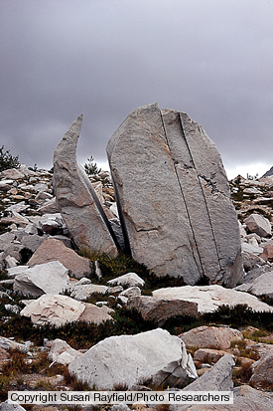

Insolation – when rocks and minerals are exposed to changing temperatures stresses are generated causing differential expansion and contraction. This is most likely in desert regions where temperatures fluctuate greatly, or may occur following wildfires. In moist climates, the hydration and dehydration of clay minerals aids in insolation.

Expansion of Clay Minerals by Volume:

Ca-montmorillonite (45-185%)
Na-montmorillonite/bentonite (1400-1600%)
Illite (15-120%)
Kaolinite (5-60%)

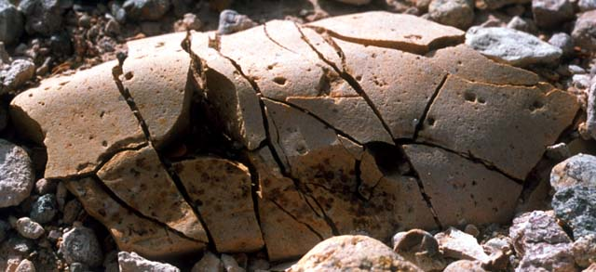

Stress release – rocks that are buried deep beneath the surface experience high confining pressures, so when overburden is removed the rock expands. A series of expansion cracks or joints develop roughly parallel to the surface, which results in the exfoliation and spheroidal weathing of rock in onionskin-like sheets.

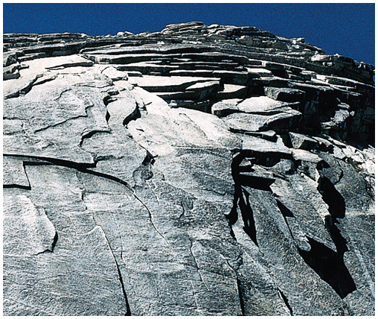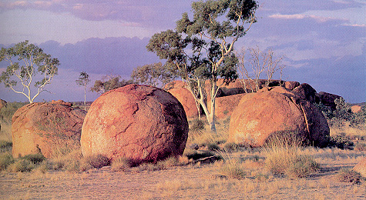

Organic activity – the activities of organisms and plants that live on and in rocks promotes their physical breakdown. These organisms also leave behind organic acids, which promote the chemical attack on minerals in rocks.

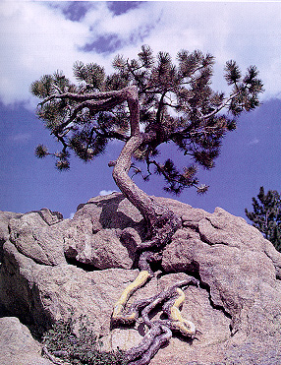

In addition, physical weathering processes promote chemical weathering of rocks and minerals by greatly increasing the exposed surface area, which may be attacked by water and other acids.

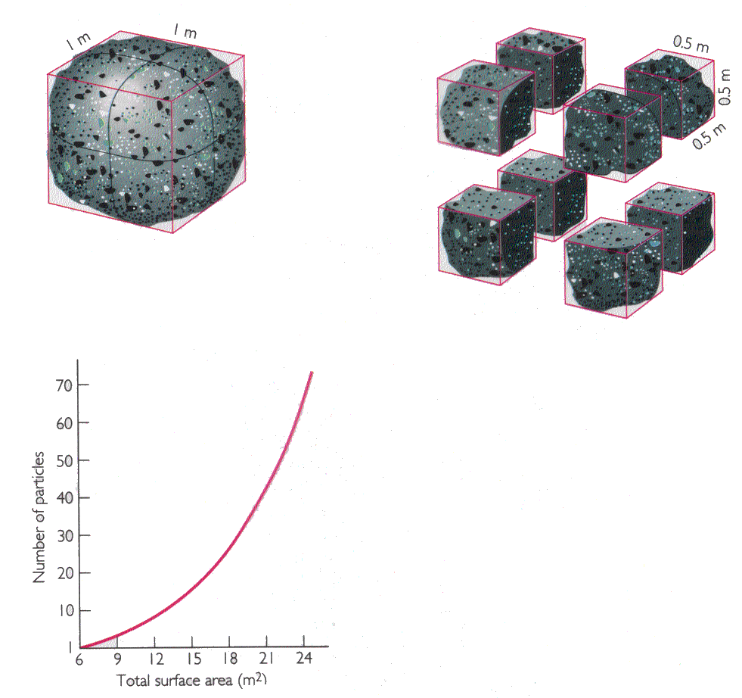
Volume = 1 m³
surface area = 6 m²
Volume = .5³ x 8 = 1 m³
surface area = 12 m²

Chemical weathering

Chemical weathering proceeds through complete dissolution (e.g., halite and calcite) or through the conversion of one mineral into another (e.g., feldspar → clay). The new, and generally finer-grained, minerals form when selected components are removed and carried away. Chemical weathering involves a variety of chemical reactions, including 1) hydrolysis, 2) hydration, 3) simple solution, and 4) oxidation.

Simple solution

SiO₂ + 2H₂O → H₄SiO₄ (6 ppm)

H₂O + CO₂ → H₂CO₃
H₂CO₃ + 2CaCO₃ → Ca²⁺ + 2HCO₃⁻

NaCl + H₂O → Na⁺ + Cl⁻

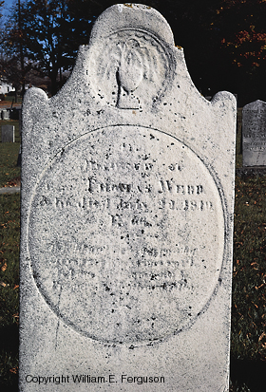

Hydration and Dehydration
The addition or removal of water during weathering is known as hydration or dehydration. These processes produce minerals that are in better equilibrium with the environment.

CaSO₄.H₂O → CaSO₄ + 2H₂O

Fe₂O₃ + 3H₂O → 2Fe(OH)₃

Hydrolysis
Hydrolysis is the replacement of cations in a mineral structure by hydrogen ions from water or other acids. The cations are released to solution and the mineral is converted to an entirely different mineral, or it dissolves completely. Most silicates weather through hydrolysis reactions.

Mg₂SiO₄ + 4H⁺ → 2Mg²⁺ + H₄SiO₄

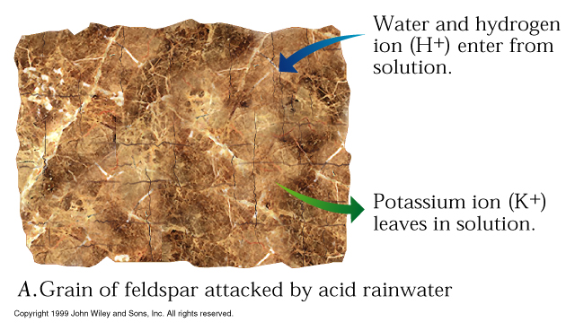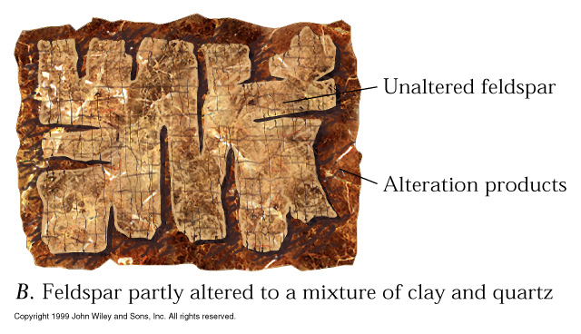
While mafic minerals such as olivine and pyroxene tend to dissolve completely, felsic minerals like orthoclase and plagioclase dissolve partially and leave behind a residue of fine-grained, and easily transportable, clays.

KAlSi₃O₈ + H⁺ → Al₂Si₂O₅(OH)₄ + K⁺ + H₄SiO₄

Oxidation
When minerals gain oxygen from the atmosphere they lose electrons and become “rusted.” Conversely, when a mineral becomes reduced it gains electrons.

Fe₂S + O₂ → Fe₂O₃ + 2S

(Fe²⁺)₂SiO₆ + O₂ + H₂O → 4Fe³⁺(OH)₃ + H₄SiO₄

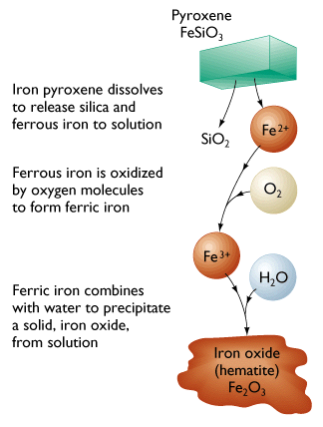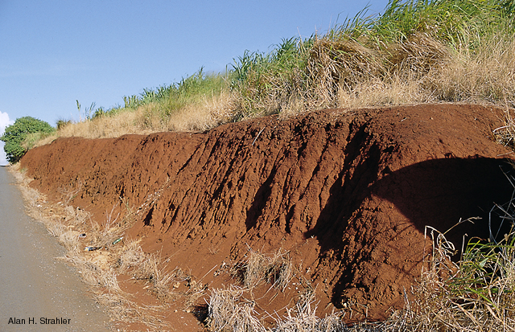

The Controls on Weathering

Climate is perhaps the primary control on the type and intensity of weathering around the world. For example, higher temperatures promote chemical weathering as the increase in kinetic energy facilitates reactions. Thus chemical weathering will predominate in warmer (and wetter) climates.
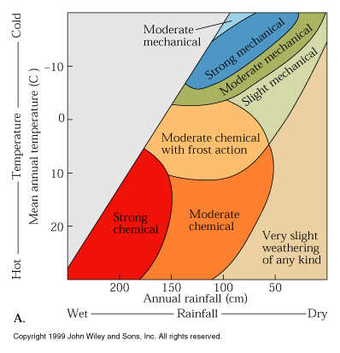

Insofar as hydrolysis is an important weathering process, the availability of hydrogen ions is a critical constraint. The activity of hydrogen ions in solution is known as pH and is controlled by the acidity or alkalinity of the solution. Acids are the key to hydrolysis reactions as they release protons (H⁺) to replace cations in the mineral lattice. pH ranges from 1-14, but most natural waters range from 4-9. Fresh water is typically acidic (<7) because water absorbs atmospheric CO₂ (and SO₂) as it falls as rain. In contrast, seawater has a pH of ~8.2, so little submarine hydrolysis occurs. Its alkalinity promotes the precipitation of carbonate minerals.

Oxidation of mineral depends on the free availability of electrons, which is more easily understood as free oxygen. The oxidation potential of a solution is known as the Eh, which is measured in volts; higher Eh solutions are more oxidizing and lower
Eh solution are more reducing (usually physically isolated from the atmosphere).

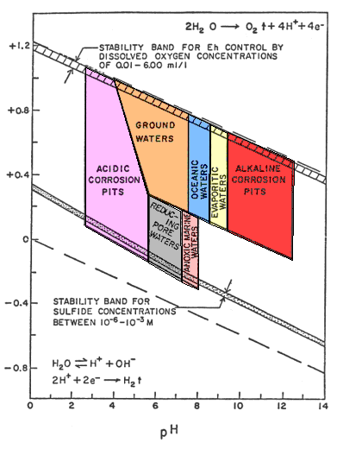

Natural weathering

Source rock breaks down in a complex fashion depending on 1) physical and chemical weathering and 2) climate, as well as 3) source composition, 4) drainage, and 5) topographic relief.

Source composition
Recall Bowen’s reaction scale, and recognize that the simple crystal lattices (e.g., olivine, pyroxene) are less tightly bonded together. These minerals also contain abundant cations (i.e., iron, magnesium, and calcium) that are subject to chemical weathering, and are readily absorbed by roots in biological weathering. Rocks rich in quartz, feldspar, and muscovite are more resistant to weathering.

Drainage
Weathering reactions require that products must be removed (LeChatelier’s Principle).

Topographic relief
Rivers with high relief, regardless of climate, carry more dissolved and suspended load due to increased water and freeze thaw. Mass wasting and runoff occur at higher rates in steep-sloped mountainous areas. Soils, however, usually develop where slopes are gentle and relief is low allowing solutions to move through them and permitting extensive decomposition.

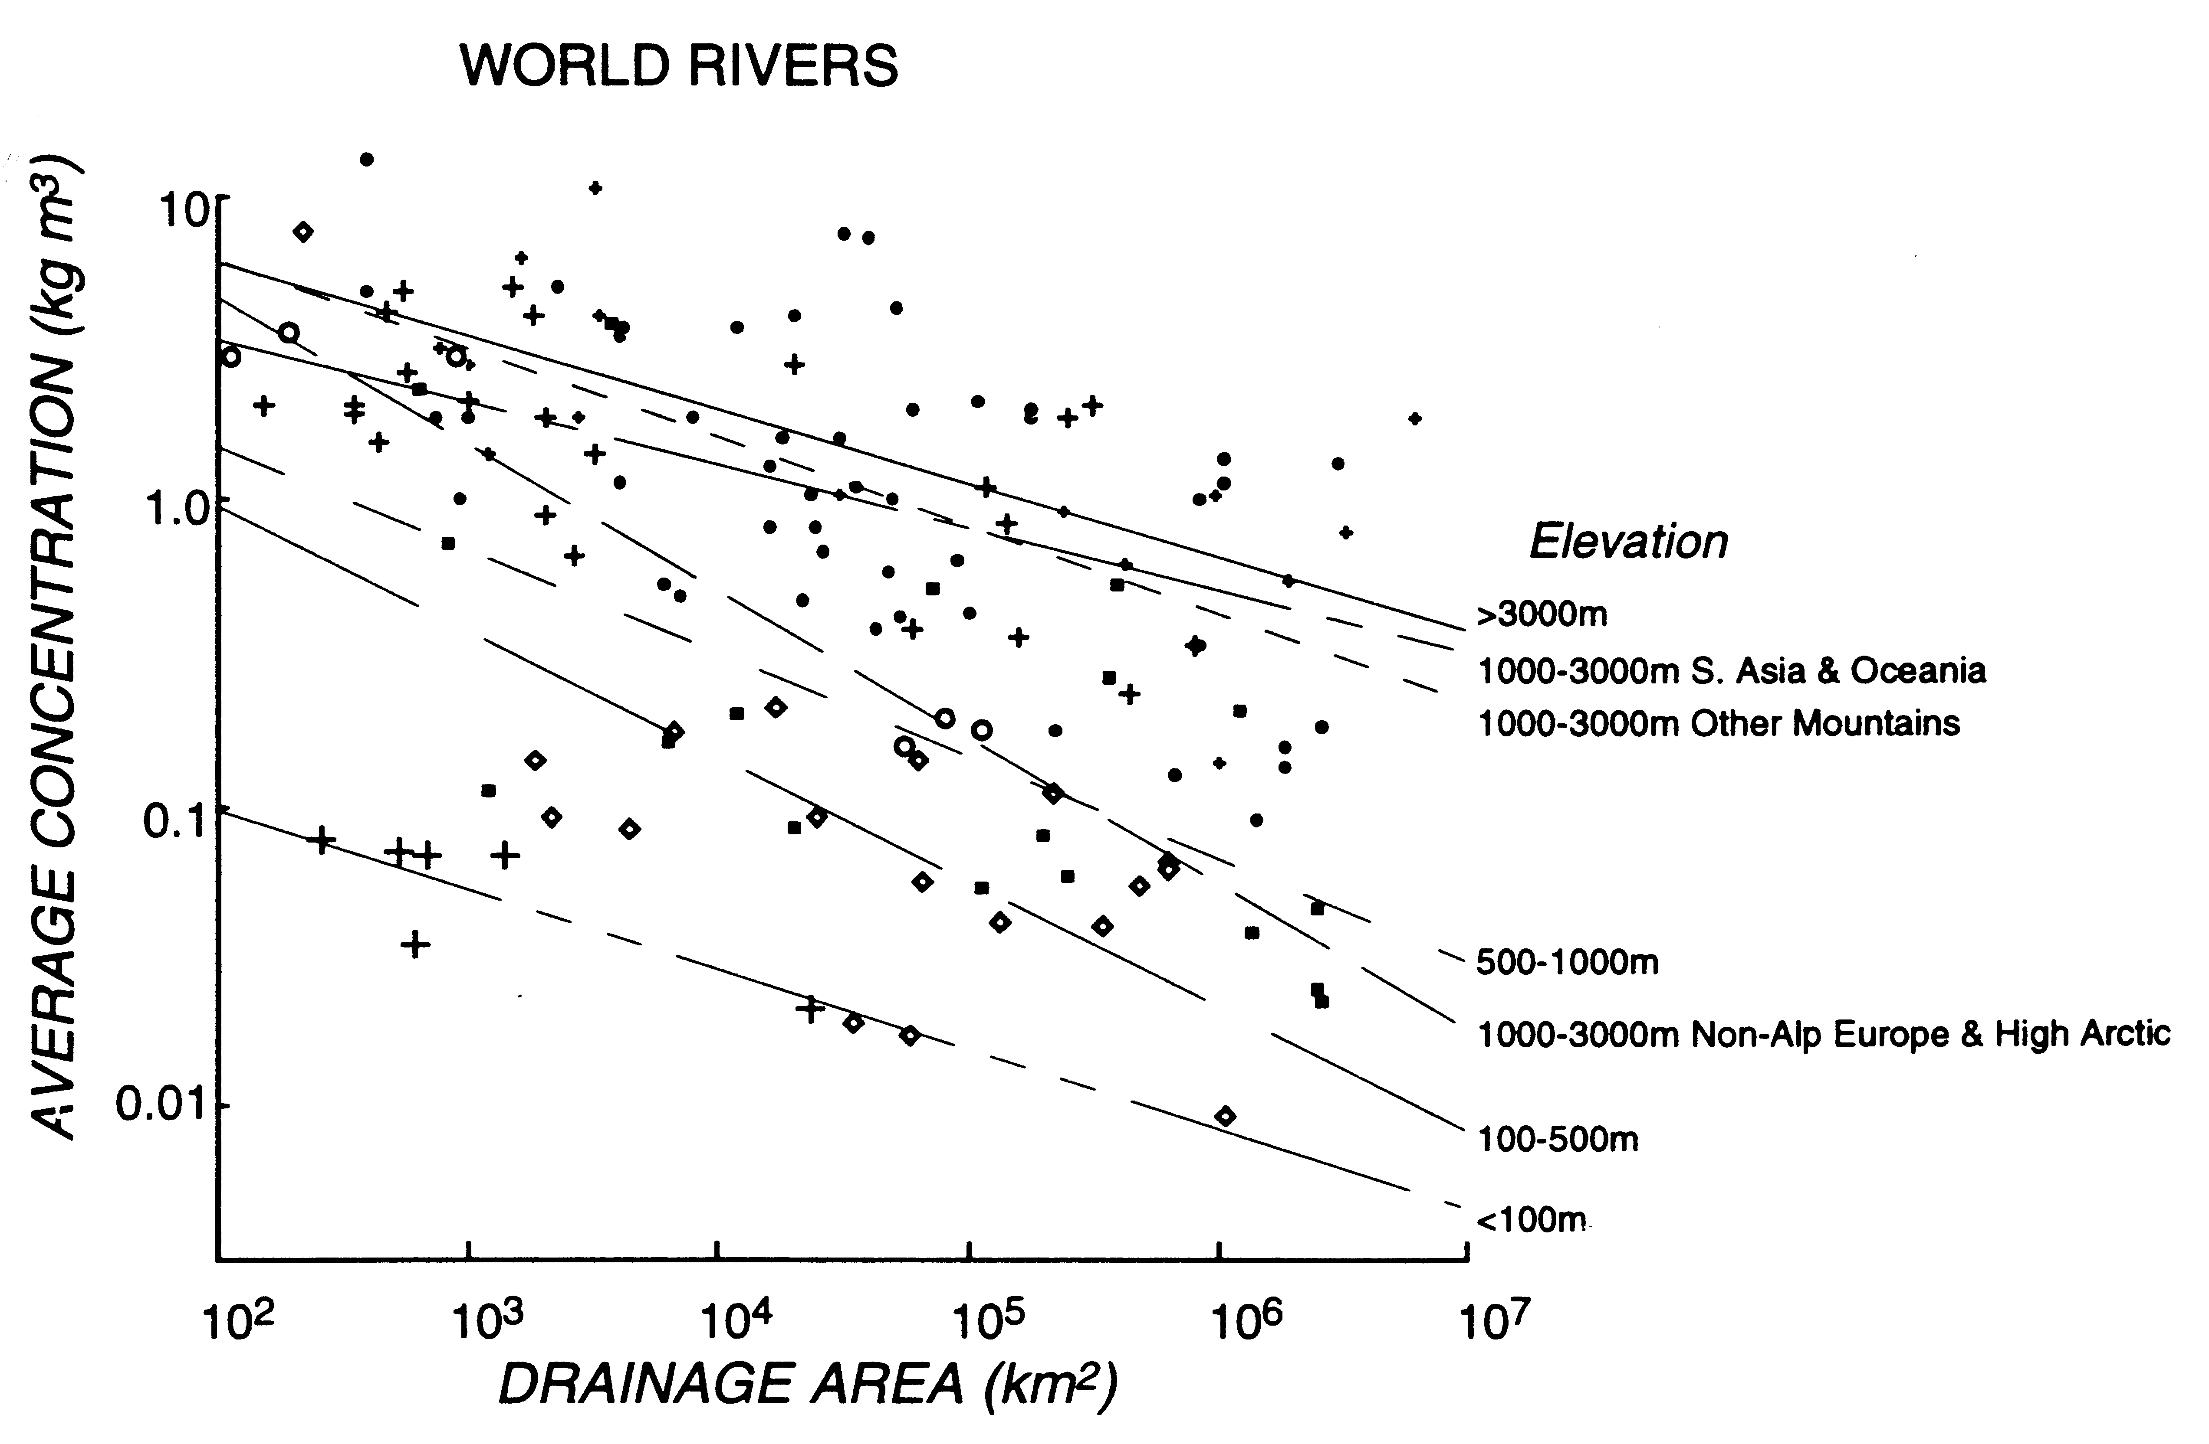

Soils

Soils are a natural product of weathering, which usually include a mixture of biological, chemical, and physical processes. These products of weathering are obviously critical to agriculture and human communities. Different climates and bedrocks produce different types of soils.

