8 November 2005
G436 Biogeochemistry
Assoc. Prof. A. Jay Kaufman

The marine carbon cycle

With respect to the marine carbon cycle, we need to consider the various reservoirs in which carbon may reside, including both organic and inorganic forms, and the possible isotope fractionation between these reservoirs related to either EIEs or KIEs or both. Remember that it is the difference between two isotopic compositions (fractionation) that is meaningful, not the individual δ¹³C values. Paleobiogeochemists are interested in end members CO₂ and CaCO₃.

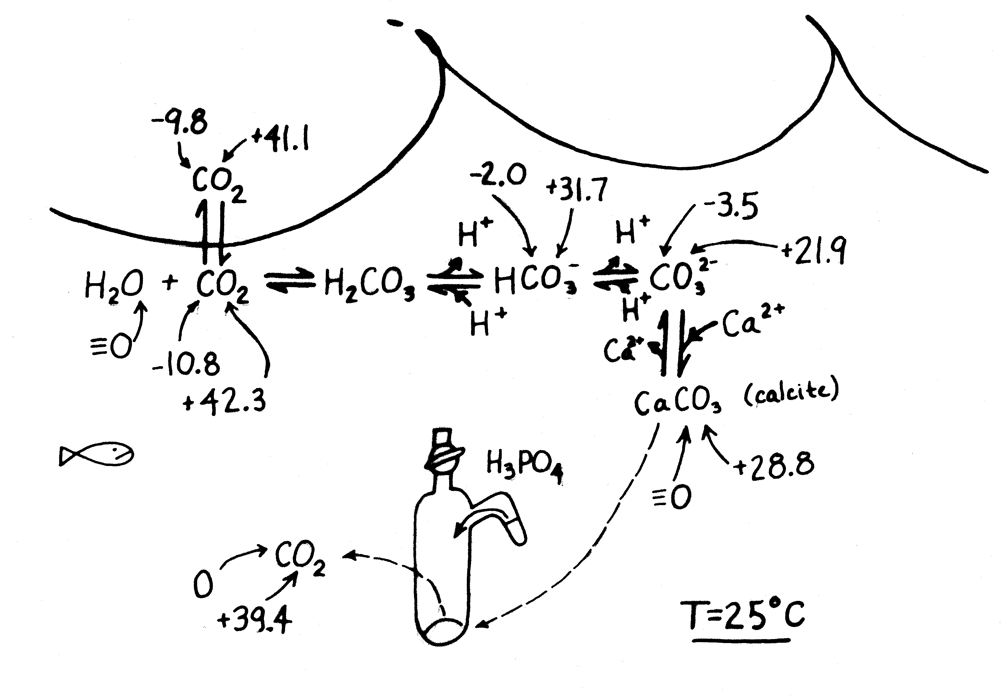

ε  (α – 1) 1000
α = R_{a}/R_{b} = δ_{a} + 1000/δ_{b} + 1000

where R = ¹³C/¹²C and units for a and b are both in ‰

Δ_{a/b} = δ_{a} – δ_{b} ~ ε_{a/b}

if δ_{a} = -27 and δ_{b} = -31, then Δ_{a/b} = 4.0 and ε_{a/b} = 4.1 (both are close in value, but it is more exact to use ε).

Isotope differences between species of paleobiogeochemical interest may be summarized conveniently in terms of EIEs relative to bicarbonate (the most abundant C bearing species in seawater at pH 8.2). The equilibrium isotope effects noted with each reaction are dependent on temperature, but not on concentration of reactants (an EIE). The relative abundance of each species is, however dependent strongly on pH.

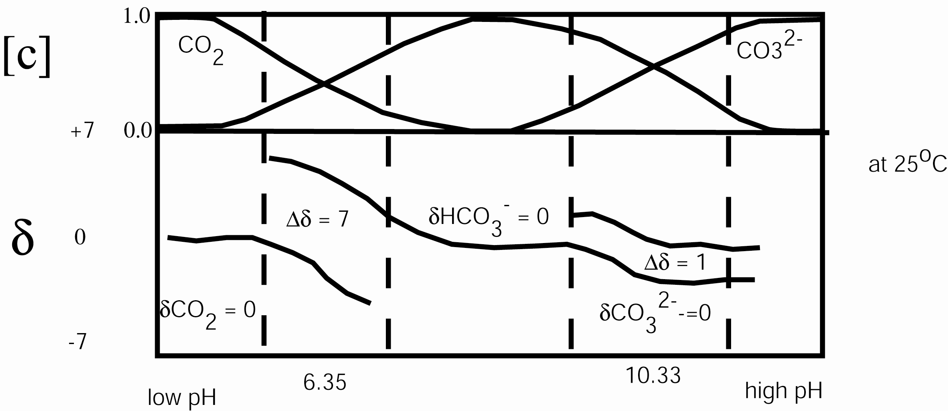

ε_{d/b} = [(δ_{d} + 1000)/δ_{b} + 1000) – 1] 1000 = 24.12 – 9866/T

for calcite where d is dissolved CO₂ and b is HCO₃⁻

ε_{m/b} = [(δ_{m} + 1000)/δ_{b} + 1000) – 1] 1000 = -14.07 + 7050/T

where m is the mineral calcite. The resulting difference between the mineral and dissolved CO₂ is strongly temperature dependent

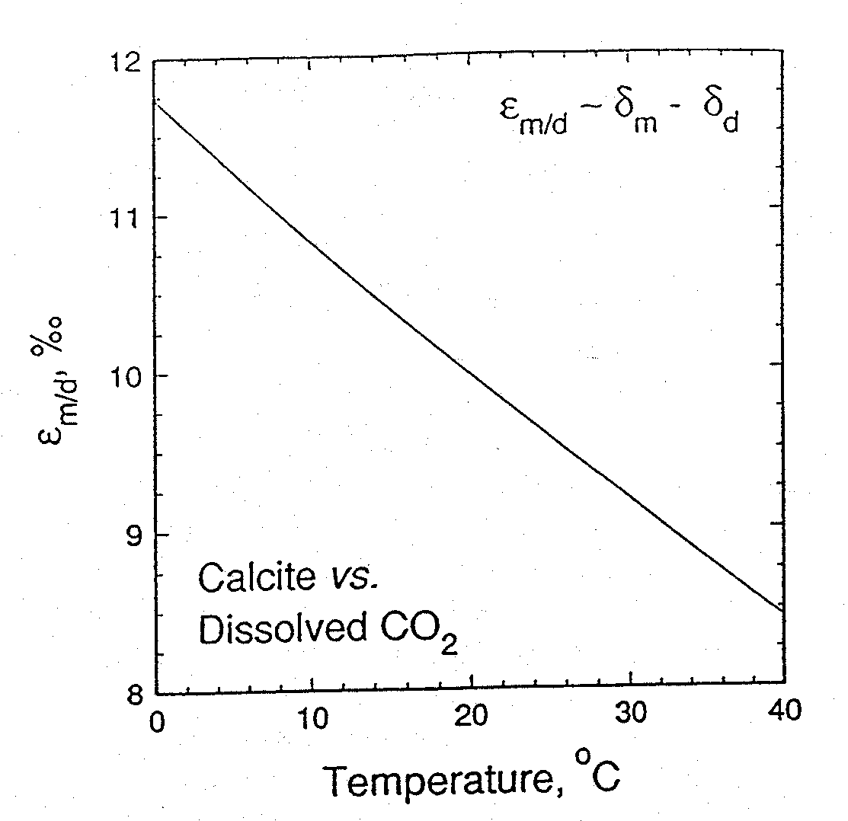

Problems in reconstructing ocean dissolved CO₂ values

- cannot assume equilibrium between CaCO₃ and dissolved CO₂, especially in biomineralized carbonates affected by metabolic activities (forams (f) have “vital” effects on the order of a few permil.

Δ_{m/f} = δ_{m} – δ_{f} = -0.70‰

- site of equilibration important
- diagenesis

The inorganic carbon cycle in the oceans

Let’s consider the inorganic carbon cycle in the oceans first starting with CO₂. Note that there is 56 times more CO₂ in the oceans than the atmosphere, so that gas exchange is important and controlled by Henry’s gas law:

S = kP

where S is solubility in g/liter, k is a solubility constant and P is the partial pressure of the gas in the atmosphere. For CO₂, S = 1.4 g/liter at 25ºC; it is twice as soluble at 0ºC. Notably much of the surface ocean is undersaturated with respect to CO₂ because of photosynthesis and the biological pump of carbon to the deep oceans and sediments.

What then might be the source of much deep ocean CO₂?

North Atlantic Deep Water (NADW) supplies the deep ocean with oxygen, which is transferred globally on an oceanic conveyor belt, and which re-oxidizes organic matter formed in the shallow ocean that settles to depth.

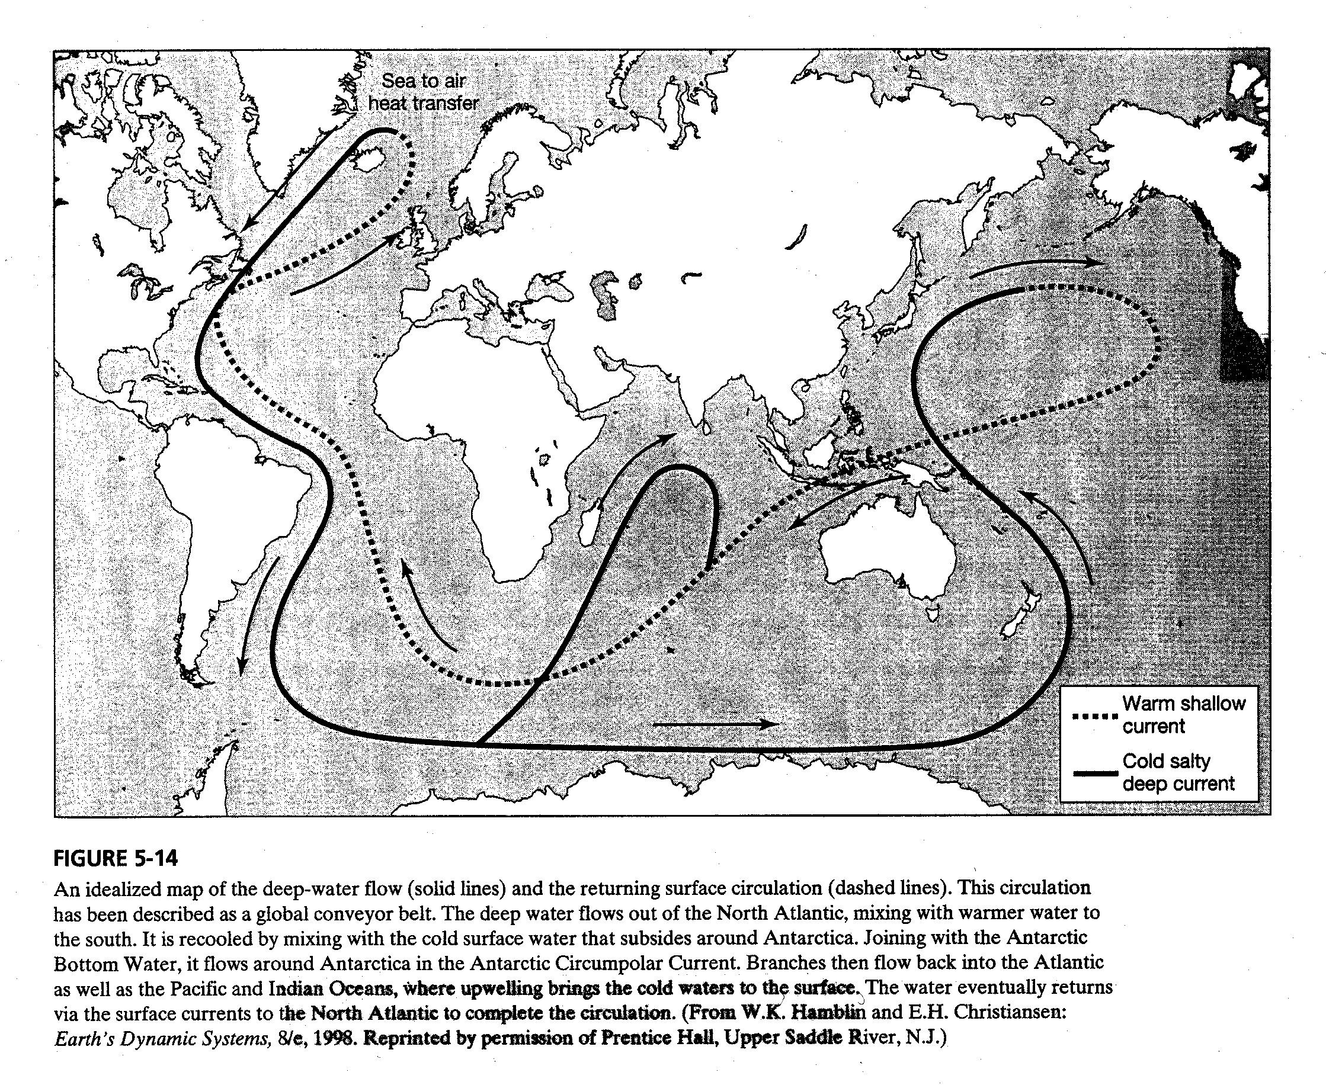

Once dissolved in seawater, CO₂ can equilibrate with water to form other carbon bearing species. Consider the equilibrium constants for the generalized reaction.

A + B ↔ C + D (reactants and products)

k₁ (equilibrium constant) = (C)(D)/(A)(B)
k₂ (equilibrium constant) = (A)(B)/(C)(D)

k₁ > k₂ reaction moves to the right, and visa versa

k_{eq} = 1 x 10⁻¹⁴ for water dissociation

Now consider the specific reactions for carbon bearing species.

CO₂ + H₂O ↔ H₂CO₃ k_{eq} = 10^{-1.43}
H₂CO₃ ↔ H⁺ + HCO₃⁻ k_{eq} = 10^{-6.40}
HCO₃⁻ ↔ H⁺ + CO₃²⁻ k_{eq} = 10^{-10.33}
Ca²⁺ + CO₃²⁻ ↔ CaCO₃ k_{eq} = 10^{-8.33} for aragonite and 10^{-8.48} for calcite

Fully deprotonated carbonate ion can combine with a number of divalent cations (like Ca²⁺) to form minerals, calcite and aragonite are the most common.

Is carbonate precipitation increased or decreased by the removal of CO₂ from seawater?

Controls on carbonate deposition

- temperature
- pressure
- degree of agitation
- biologic activity
- sediment masking – areas of high siliciclastic input preclude carbonates
- light
- carbonate compensation depth

But if CO₂ must be removed to precipitate carbonate, where does the carbonate alkalinity come from?

In modern marine environments most alkalinity (HCO₃⁻ and CO₃²⁻ and balancing cations) come from the weathering of exposed continents and delivery from rivers to the seas.

For example, carbonate weathering:

CaCO₃ + H₂CO₃ → Ca²⁺ + 2HCO₃⁻

Since carbonate precipitation in the ocean is the exact opposite of this reaction, the net result is that CO₂ is neither lost nor gained by the atmosphere due to carbonate weathering (on long time scales).

For example, silicate weathering:

2CO₂ + 3H₂O + CaAl₂Si₂O₈ → Ca²⁺ + 2HCO₃⁻ + Al₂Si₂O₅(OH)₄

or more simply

CaSiO₃ + 2H₂CO₃ → Ca²⁺ + 2HCO₃⁻ + SiO₂ + H₂O

Here the situation is different since two moles of CO₂ are removed from the atmosphere, and only one is returned by carbonate precipitation.

The net result is:
CaSiO₃ + CO₂ → CaCO₃ + SiO₂

How might this reaction be mediated by plant growth on land? On anthropogenic inputs to the atmosphere?

Burning of fossil fuels adds ~6 x 10¹⁵ g C/year to the atmosphere, which should result in an annual increment of +0.8%, but notably we measure only about a +0.4% rise (~1.5 ppm). Estimates suggest that 1/3 of anthropogenic input of CO₂ (an acid) to the atmosphere is actually dissolved in the oceans (2 x 10¹⁵ g C/year) due to its high buffering capacity.

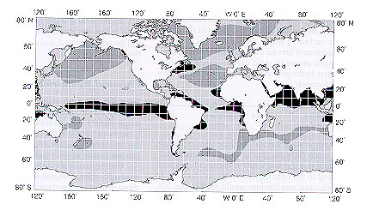

This excess CO₂ is buffered by the large capacity of CO₃²⁻ in the ocean

H₂O + CO₂ ↔ H⁺ + HCO₃⁻ + H₂CO₃

or

CO₂ + CO₃²⁻ ↔ H₂O + 2HCO₃⁻

CaCO₃ + H₂CO₃ ↔ Ca²⁺ + 2HCO₃⁻

The accumulation of CO₂ makes deep water undersaturated with respect to CaCO₃, and dissolution increases ocean alkalinity. In terms of the carbon rain rate in the ocean four times more C is sent to the depths as carbonate relative to organic matter, usually as the tests of marine phytoplankton.

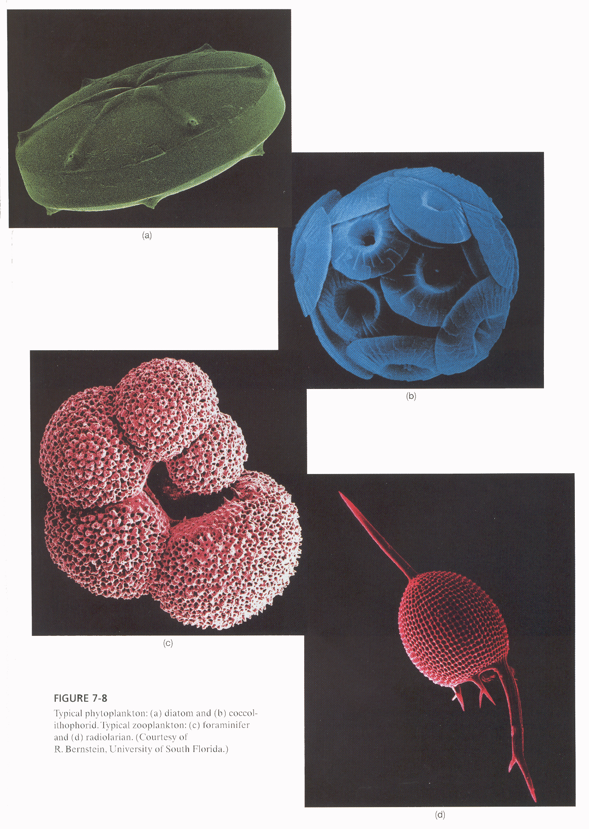

The depth at which carbonate starts dissolving is known as the lysocline; the depth beneath which all carbonate will dissolve is called the carbonate compensation depth or CCD. In the Pacific Ocean this depth is around 4200-4500 m while in the Atlantic it is ~5000 m.

Why is there a difference in the position of the CCD in the two ocean masses?

Carbonate that is sedimented on the seafloor, which is not dissolved due to undersaturated conditions, may be buried and preserved. Some of these sediments are carried down in subduction zones where they are heated. The intense temperature and pressure result in the metamorphism of the carbonate, thereby eventually returning CO₂ to the atmosphere.

CaCO₃ + SiO₂ → CaSiO₃ + CO₂

Quantitative aspects of the modern carbon cycle are summarized in the following table. Note that organic C in sediments is <<1% of marine NPP.

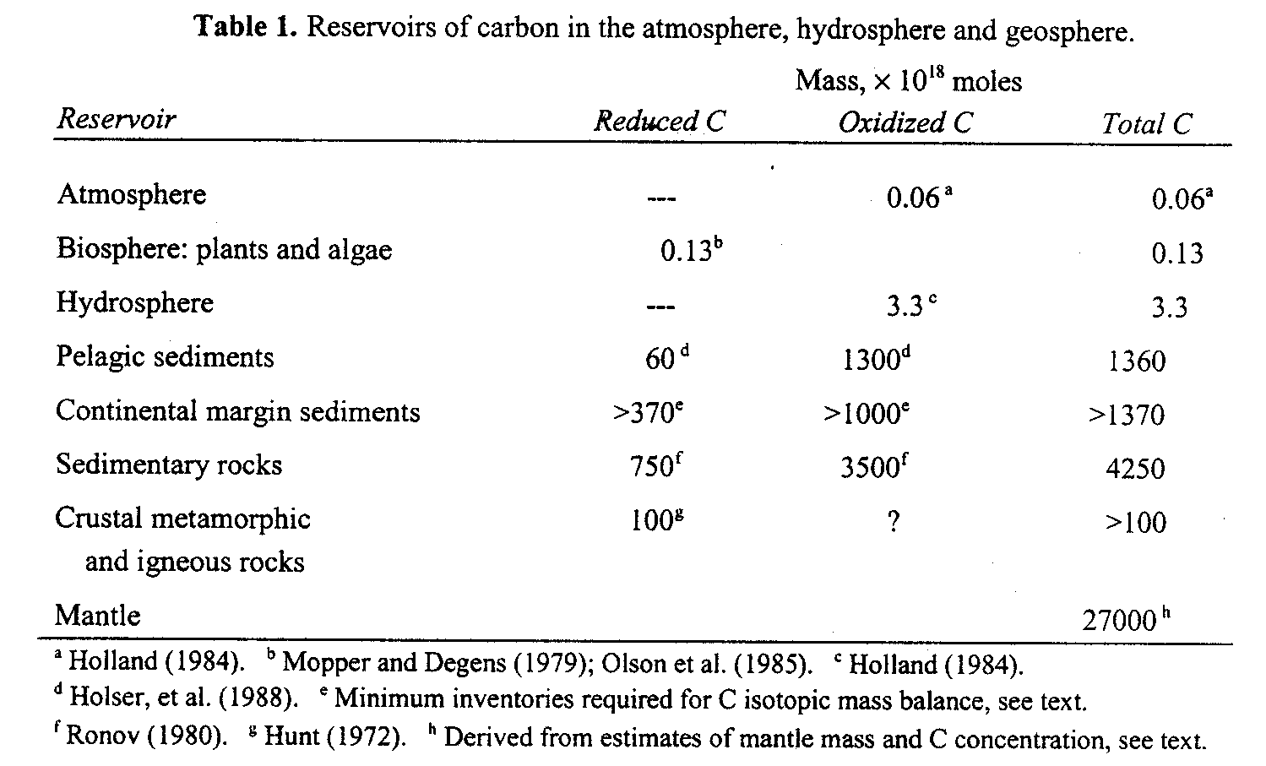

How might the carbon cycle have run differently before and after the advent of oxygenic photosynthesis?

