GEOL 342 Sedimentation and Stratigraphy
Lecture 11: Eolian, glacial, and paralic environments
14 March 2005
Assoc. Prof. A. Jay Kaufman

Eolian environments

Eolian sand dunes are among the best-known depositional environments because of their spectacular cross beds and their use as paleoenvironmental indicators. High angle (20 to 35º) cross beds; individual beds up to 35 meters (there is no depth limitation to the air) with generally longer asymptotic bottom sets than marine dunes. Most beds are tabular-planar, or trough or wedge-shaped. Wind ripples are typically lower in amplitude and more assymetrical than water ripples.

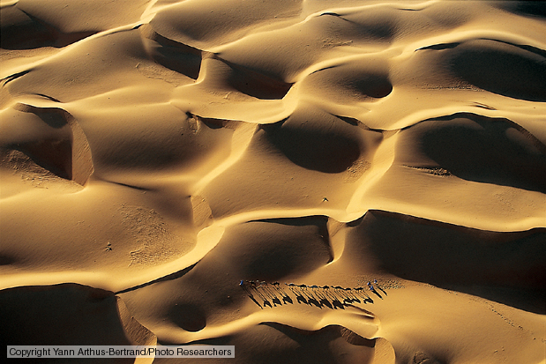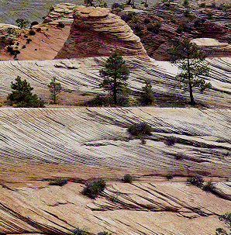

Sand dunes are best known from desert environments. A desert is an arid region, which generally lacks vegetation and cannot support a large population. Many deserts occur where dry air descends along the 30ºN and S latitudes in areas of persistant high pressure, or behind mountain ranges that have a rain shadow. Deserts can also occur in coastal areas, arctic regions, and far inland in continental interiors..

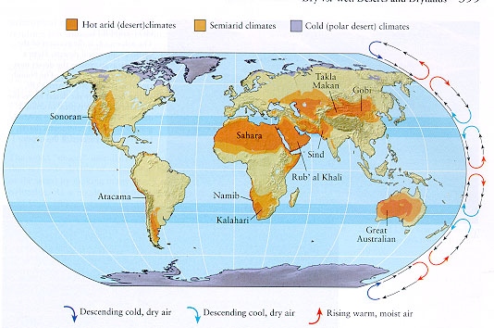

Wind has much less competence to entrain particles than does water (it is some 700x less viscous) so eolian processes are very different than subaqueous processes.

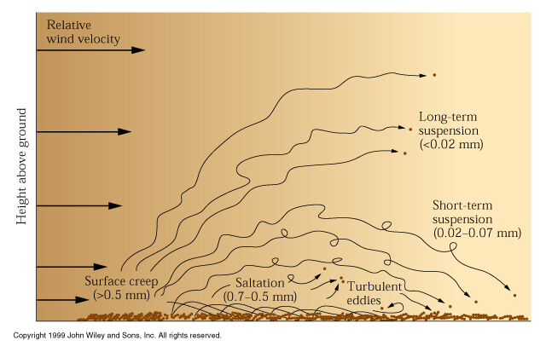

How then might we differentiate between a beach sand dune and an eolian sand dune?
Wind has much less competence than water to pick up particles, so the coarsest material is often left behind as a deflation lag, or desert pavement.
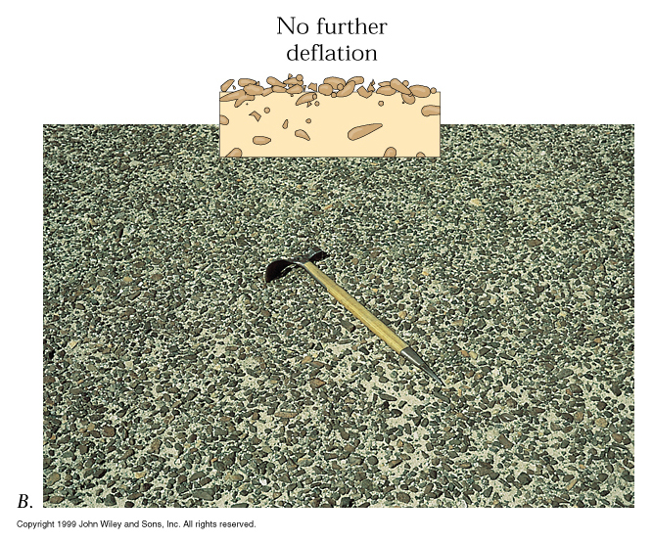

Deposits are very well sorted, well rounded, and surfaces of quartz (predominantly, but not always) are pitted and frosted.

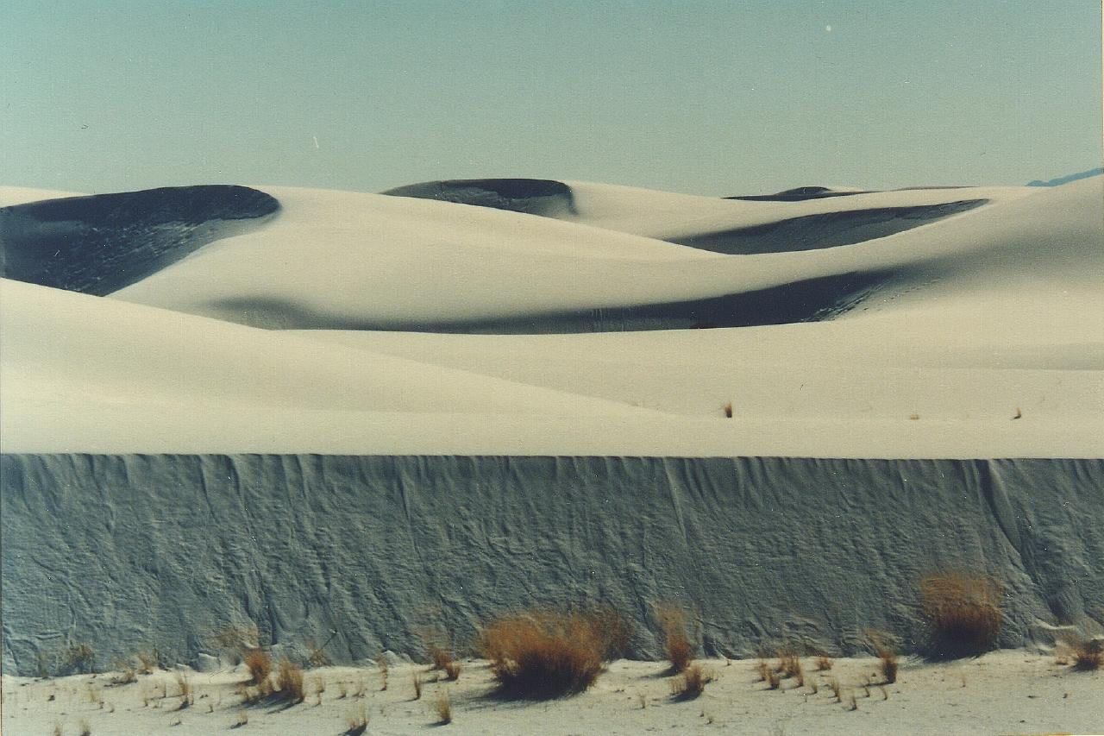

Glacial environments

Only about 10% of the Earth’s surface is currently covered by permanent glacial ice and associated glacial deposits, but these are nonetheless important indicators of cold climate and have been intensively studied. During the Pleistocene ice age as much as 30% of the surface was glaciated, but in older events the coverage has been considered by some to be complete.

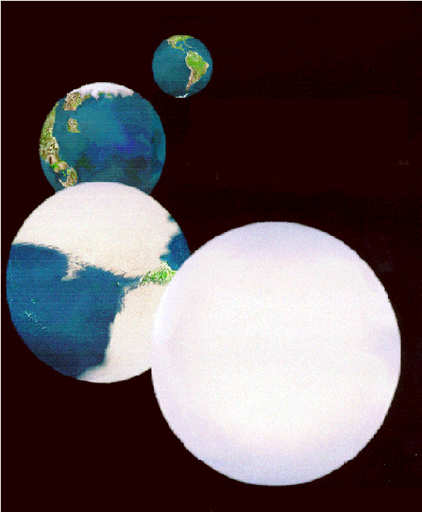

During a so called “Snowball Earth” event, which may have lasted for millions of years, it is suggested that there would have been a nearly complete shutdown of surface processes due to extreme albedo and cold, including oceanic photosynthesis, the hydrologic cycle, as well as weathering (more on this latter).

How would the Earth ever have gotten out of this mess?
Glaciations occurred in several discrete intervals of Earth history, including the Paleoproterozoic, Neoproterozoic, Ordovician, Carboniferous, and, of course, the Pleistocene, which we know the most about.

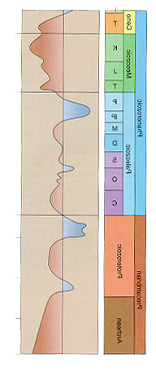
Although glacial environments have been primarily studied by geomorphologists and Quaternary geologists, they still deserve attention from sedimentologists and economic geologists as climate indicators. The primary glacial deposits are often massive, but poorly sorted due to the inability of ice to sort materials. Glacial deposits (tills and diamictites) most often lack internal stratification, but these should not be immediately interpreted as glacial in origin as other types of mass wasting, including debris flows and mud flows. Indicators that a diamictite is glacial include the presence of dropstones, as well as striations on clasts or on bedrock pavements. In Proterozoic examples, the glacial deposits are often overlain by uniquely textured and isotopically anomalous carbonates, called “cap carbonates”, which were formed during post-glacial sea level transgression.

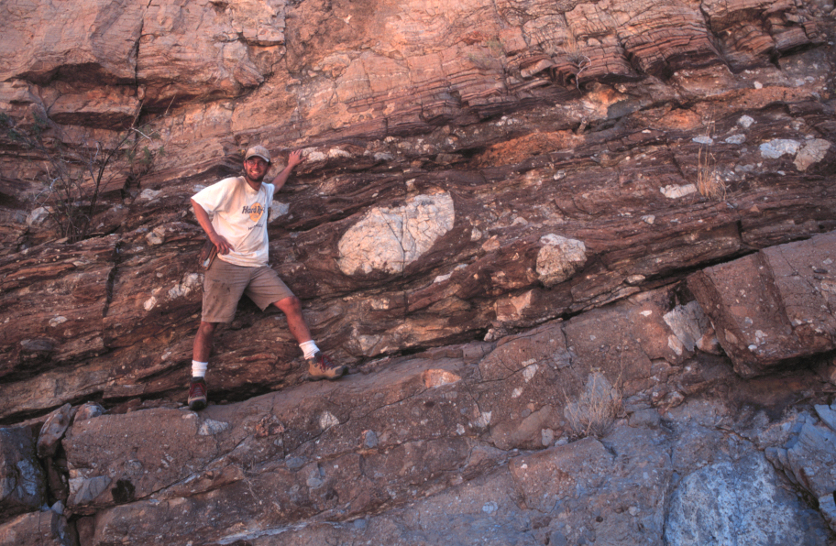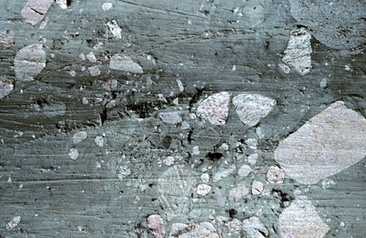

Most glacial deposits have a lodgement till at the base, which may be overlain by braided gravel bars or cross-bedded sands and gravels from outwash streams, or possibly by varved lacustrine mudstones, which may contain dropstones.

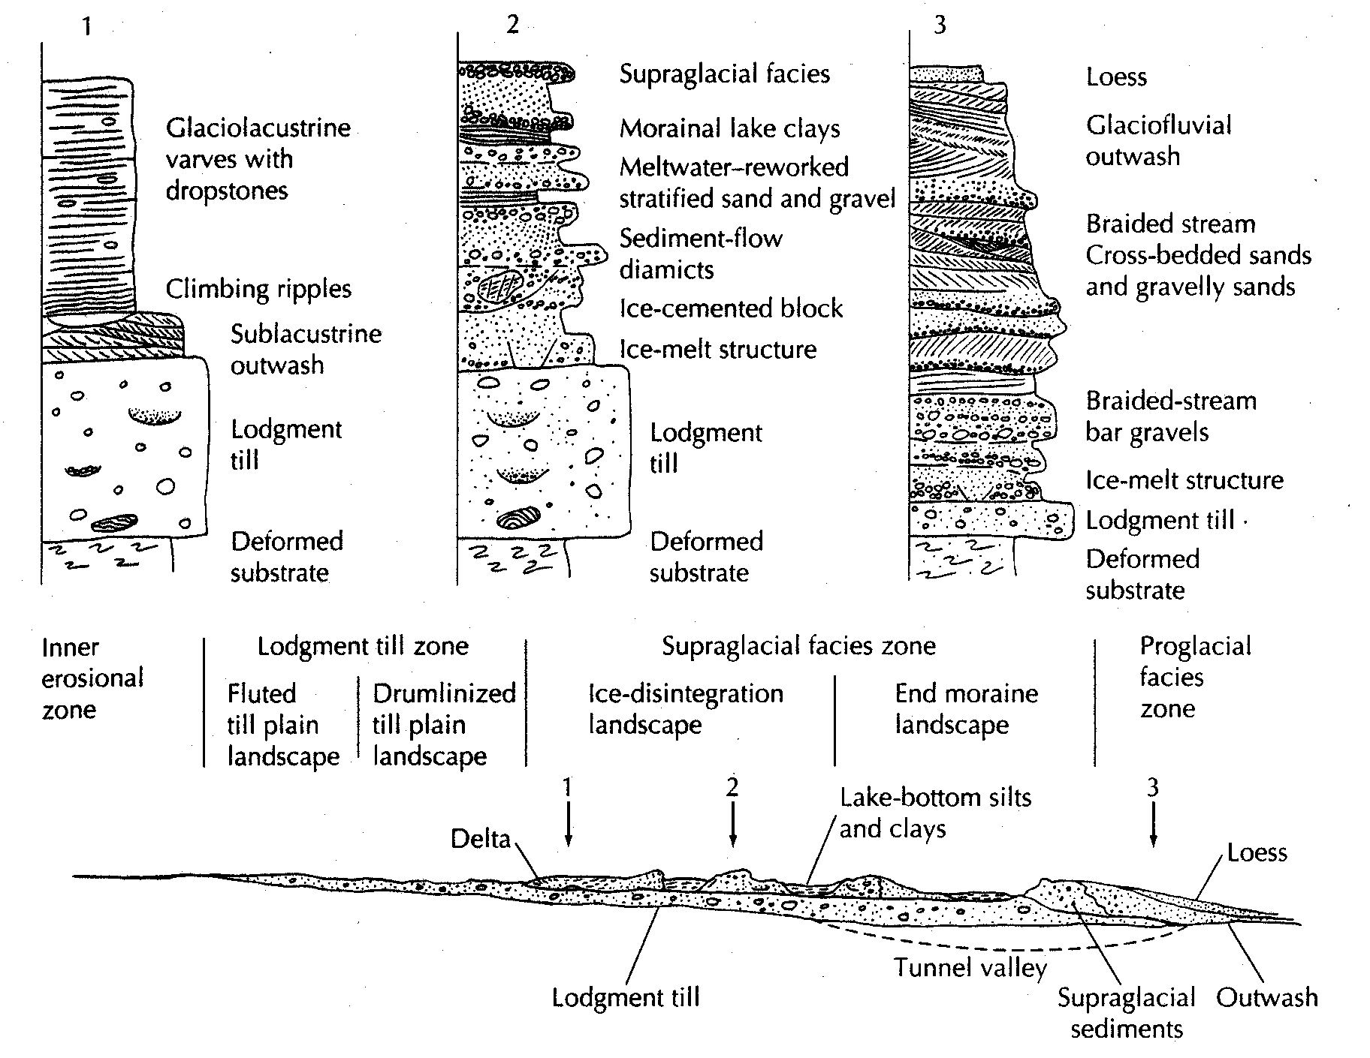

Paralic (marginal marine) environments

The vast majority of sedimentary record accumulated in marine settings on continental shelves. As such, most land aquifers & hydrocarbon reservoirs are associated with these locations. In addition, coastal land uses are critically linked to coastal processes, which can be studied in modern and ancient successions.

Recognition:
Paralic setting are diverse in occurrence, and a number of schemes have been used to break out these specific systems. All schemes differentiate based on the primary sedimentary transport mechanism, tied to hydraulic energy. They also look for biological signatures as well to help identify specific environments.

Classification:
Paralic systems fall into three broad categories:

Name | Main sediment transport agent | Main sedimentary structures | Bioloigal signatures (trace fossils) | Map pattern
Deltaic | River transport, turbidity currents | Unidirectional current | Low diversity, low abundance | Paddle-shaped
Shoreface | Wave action | Oscillation ripples and dunes (hummocks) | High diversity, high abundance | Long and linear
Tidal | Tide action | Unidirectional, but organized by regular energy variation (Sigmoidal, flaser) | Low diversity, moderate abundance | Narrow and entrenched

Deltas: Rivers bring sediment to the coast. When they do, the flow of the river expands and decelerates. As it does, the flow quickly drops its sedimentary load. This means that sediment accumulates rapidly at the river front, forming a delta.
Deltaic sub-environments (from distal to proximal), include the following:
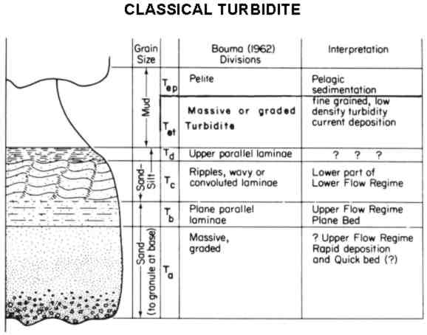
Bouma Sequence
- Prodelta – fine grained distal mudstones
- Delta front – thin bedded turbidites, increasing in vertical amalgamation upwards. This is the steeply-dipping part of the delta.
- Mouth bars – channelized sands that accumulate at the mouth of distributary channels. They fail, making the turbidity currents that accumulate on the delta front. These are characterized by massive bedding, trough cross-bedding, and climbing current ripples and dunes.

Due do the high volume of sediment coming into the system and the rapidly changing salinity, deltas are stressed environments and are commonly poor in organisms.

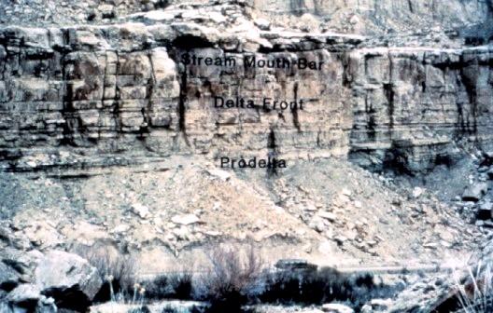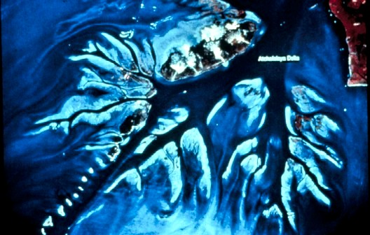

Shorefaces/Beaches: One the sediment accumulates in deltas, wave action moves the sediment along the coast by long-shore drift to form beaches. The wave action sorts the sand by energy level, creating a beach profile. The different zones in a beach profile are a functin of regular and storm wave energy.

- Offshore – Always below wave base, accumulating sediment from the water column. Fine grained distal mudstones
- Lower Shoreface – Only associated with storm wave action. Lots of oscillation ripples deeper in the profile, progressing to hummocky beds higher up.
- Upper Shoreface – Within regular wave energy. As a result, this zone is dominated by long-shore currents. Perhaps counterintuitively, this zone is dominated by trough cross-bedding, a unidirectional current indicator.
- Foreshore – the swash zone. These flows are very strong and shallow, so dominated by upper flow regime conditions, chiefly planar bedding.

Due to the stable energy and salinity conditions, shorefaces are full of organism that leave trace fossils of different sorts.

Tidal Estuaries: These are commonly coastal re-entrants that accentuate the earth’s tides, creating macrotidal (> 4 m) conditions. The sand enters the system both from rivers entering the estuary and from long-shore drift from adjacent beaches. The latter dominates – most of the river flow brings the fine-grained sediment into the system.

Tidal energy organizes the sand frction into enormous composit bedforms or bars that migrate within the tidal channel. The migration of those bodies creates the strata preserved there. However, away from these bars the sedimentation is dominated by fine-grained accumulation.

Several sedimentary structures are very typical of tidal environments:

- Herringbone cross-stratification: The regular and balanced alternation of unidirection flow. These are troughs that migrate in opposite directions for hours at a time. Rare.
- Sigmoidal beds: These beds arre like troughs, but they presernve both the stoss and the lee sides due to the fall out of sediment from suspention and the regular tidal energy.
- Flaser/Wavy/lenticular beds: These are essentially ripples that have varying amounts of mud in them. Flaser beds are ripples draped in mudstone, lenticular beds are mudstones with disbursed, starved ripples. Wavy beds are in between
- Tidal bundles – These are beds deposited by a single tidal event. They cluster together to form bundles associated with stronger tides (spring) and weaker tides (neap)

Due to the changing energy, sediment, and salinity conditions, tidal succession commonly lack a diverse biotic population.

Other environments:

In paralic environments, there are a set of associated subenvironments

Name | Association | Depositional Style | Associated deposits
Coastal plain | All EOD’s | Fine-grained, lots of biota | Often coaly, lots of silstones and shales, some sandy channels
Lagoons | Shorefaces | Fine-grained, low diversity biota | Wash-over fans, coquinas, siltstones and shales
Tidal inlets | Shorefaces | Coarse-grained, low diversity and abundance biota | Sands with tidal characteristics
Tidal flats | Tidal systems | Fine-grained, evidence of exposure, low diversity biota | Organic-rich siltstones and shales, thin sandstones
Eolian dunes | Shorefaces | Fine sand, essentially no biota | Eolian dunes
Rivers | Deltas | Coarse-grained, low diversity and abundance biota | Various kinds of fluvial deposits

