GEOL 342 Sedimentation and Stratigraphy
Lecture 7: Mudstone and shale
22 February 2005
Assoc. Prof. A. Jay Kaufman

Mudstone and shale

Because of their extreme fine grain size little is known of the provenance or origin of mudstone and shale, even though they represent perhaps 75-80% of the stratigraphic record. If one could read them correctly much of Earth history might be deciphered, especially the record of climatic change, biological activity, and paleogeography. Our oil and gas come from them, our art and science come from them (e.g., ceramics), and even life might have sprung from them. Give them love, since they surely deserve it.

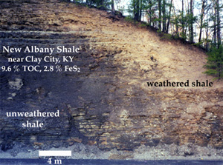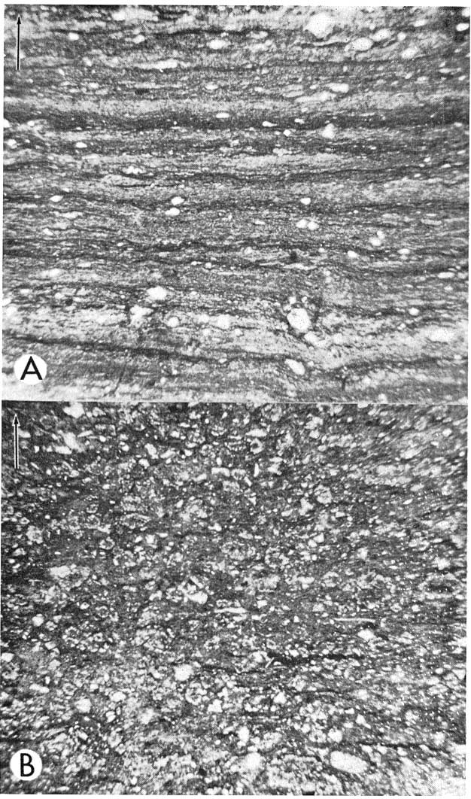

Classification

There is no standard classification for mudstone and shale. This is in part because they are unloved and understudied. In part, it is because there are many different kinds of fine-grained siliciclastic rock and most schemes are impractical. Finally, it is often very hard to get accurate grain-size or chemical descriptions of fine-grained sediment without a lot of detailed scrutiny.

Name | Grain-size (μm) | Φ | Composition | Other
Silt & siltstone | 64 -- 4 | 4 – 8 | >66% silt | Poor for everything
Clay & claystone | 4 – 0.5 | 8 -- 11 | >66% clay | Good seal rocks, many economic uses
Mud & mudstone | 64 – 0.5 | 4 -- 11 | 33–66 % clay/silt | Mixed bags
Organic rich | 64 – 0.5 | 4 -- 11 | > 0.5 % T.O.C. | Excellent source rocks
Marl | 64 – 0.5 | 4 -- 11 | > 10% carbonate | Waste rock
Loess | 64 -- 2 | 4 --9 | Mostle silts | Wind-blown (aeolian)
Calcareous ooze & chalks |  |  | > 30% calc. nannos | See below
Siliceous ooze &  porcelinites |  |  | > 30% silic. nannos | See below

Shale is a mudstone with a fissile or platy fabric, and is usually thinly laminated. Shales are composed of clay minerals, fine-grained quartz and feldspars and various amounts of carbonates, sulfides, iron oxides, heavy minerals, and organic carbon

Chemical composition of average shale

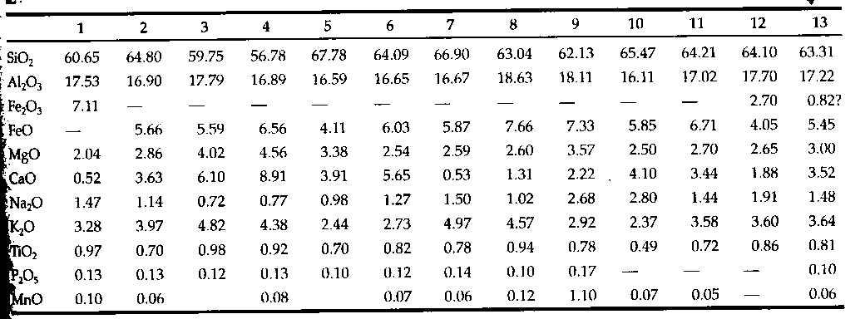

Clay minerals

Primary sheet silicates (phyllosilicates) are composed of alternating sheets of silica-oxygen tetrahedral (brucite) and/or alumina-hydroxyl octahedral (gibbsite). These combine to make “open faced” and “close faced” sandwiches of clay layers. Primary groups of clay minerals are defined by their structure.
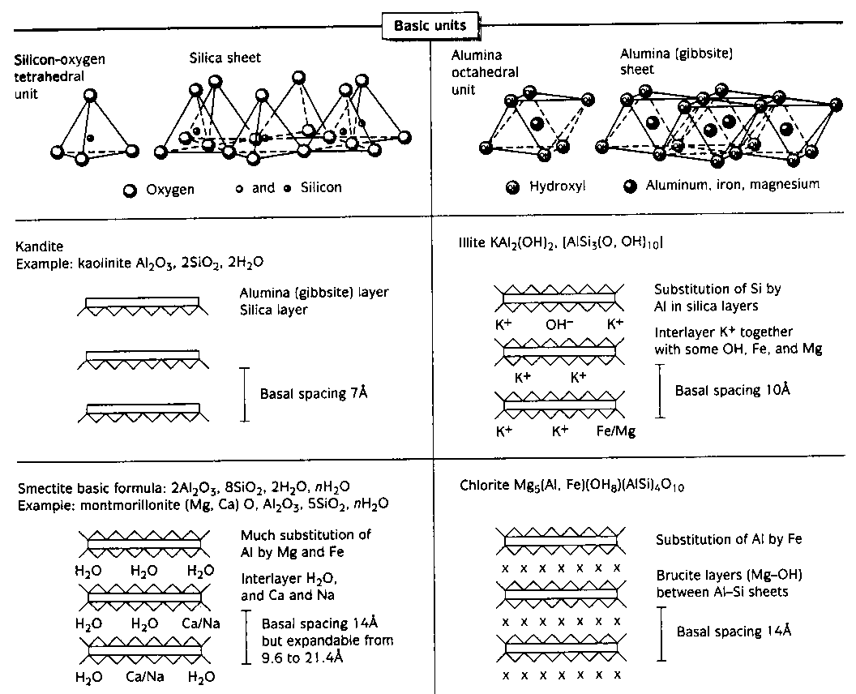

Kaolinite (Kandite) – Al₂SiO₅ * H₂O
No cations: chemically intert. “Open faced”

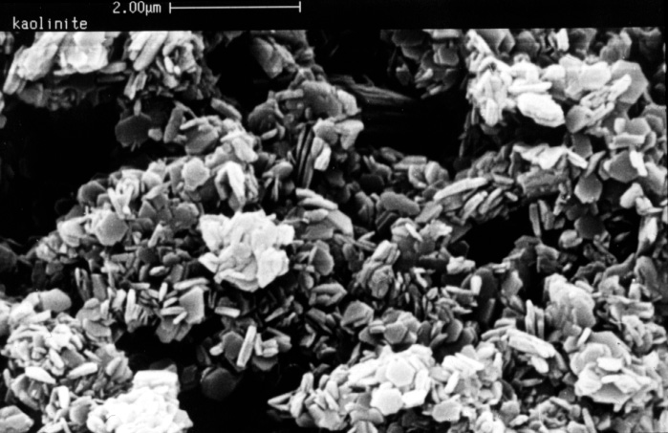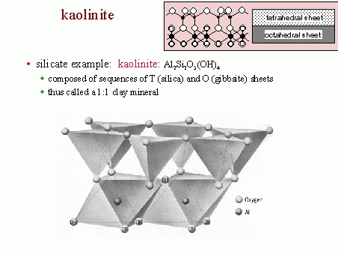

Illites – Potassium is a common cation. H₂O% & “crystallinity” vary with depth.
“Close faced” phyllosilicate

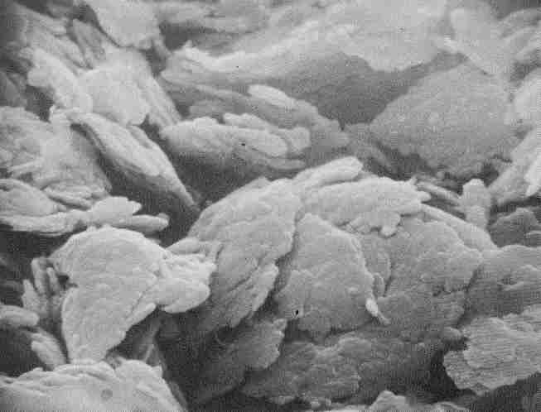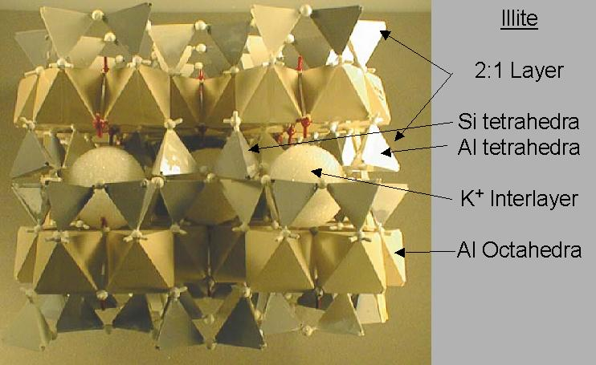

Chlorite – Iron and magnesium rich phyllosilicate.
“Close faced”

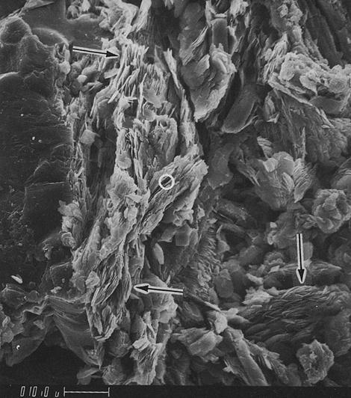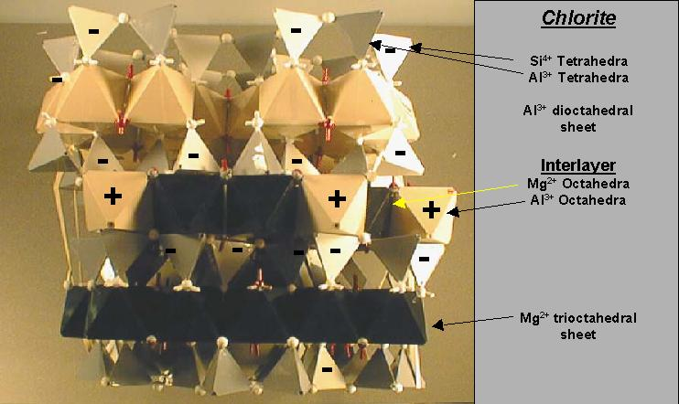

Smectites/Montmorillonite – Chemically complex. Can hold huge H₂O volumes.
“Close faced”
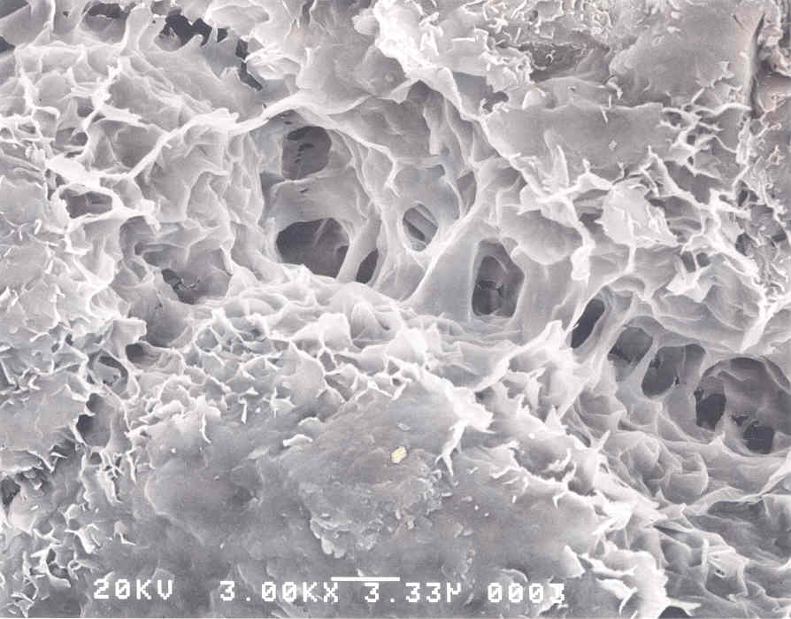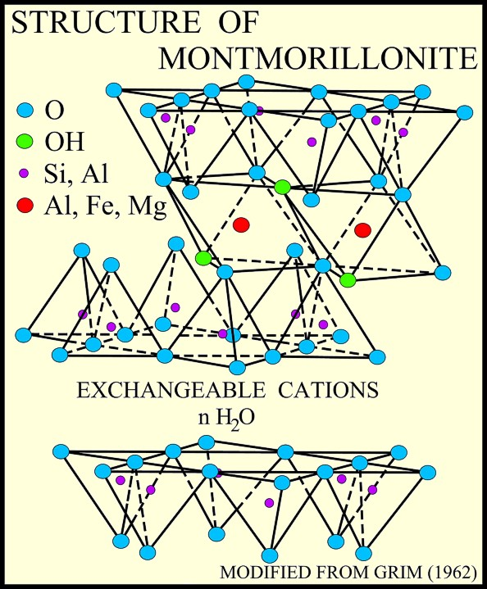

Special fine-grained siliciclastic rock and sediment types:

Glauconite
An iron-rich clay mostly found in sand-sized aggregates (usually old fecal pellets). This mineral only occurs in open marine conditions in agitated water, and usually during episodes of sediment starvation or major transgression.

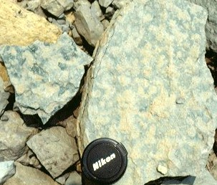

Bentonite
Mostly smectites and montmorillonites. Commonly form from chemical alteration of volcanic ash. Very high electrical conductivity. Very high water expansion. Many agricultural industrial uses, including construction and drilling

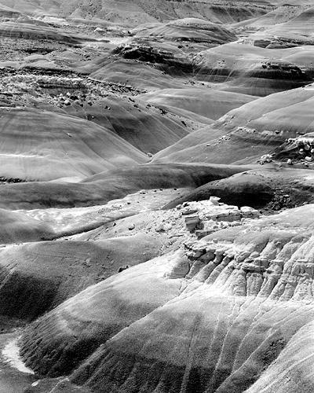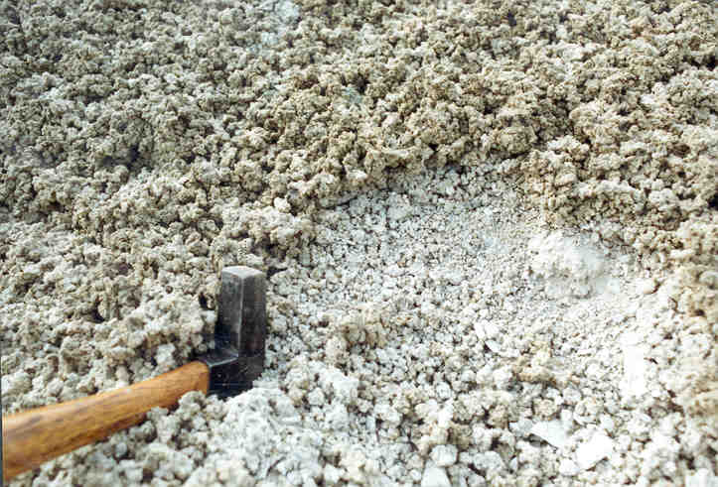

Vermiculite
Clay beds with lots of vermiculite, a clay mineral with complex arrangements of water molecules. Many agricultural uses.

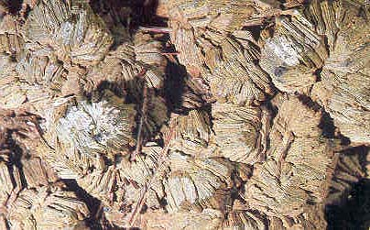
Loess
Mostly wind-blown silt particles that accumulate in thick intervals (often > 100 m). Commonly develop during glacial epochs, and are studied for paleoclimatic information

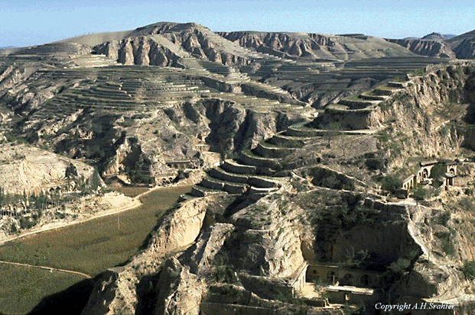

Rock Flour
Clay-sized particles of rock made by glaciers, but NOT clay minerals. Commonly ground up feldspars and quartz.

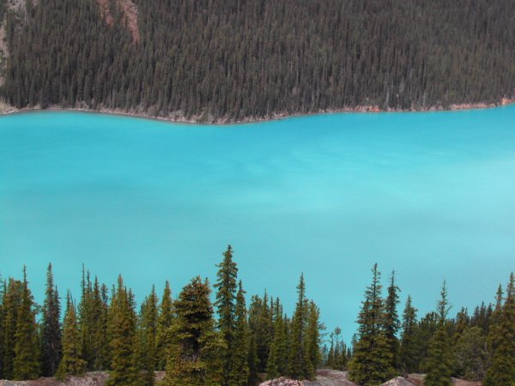

Marls
Everybody’s waste rock. Poor for almost everything and not very attractive. Mixture of siliciclastic and carbonate materials – can form in many marine environments, but are commonly deep-water. Lead a better life when metamorphosed into spectacular calc-pelites.

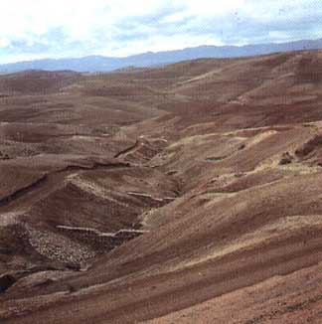

Oozes
Extremely fine-grained rocks with a very large component of inorganic biological precipitates, chiefly carbonate and silica. This material is usually the skeletons of marine microorganisms. This lithify into chalks, bedded cherts, and porcellinties (diatomaceous earth)

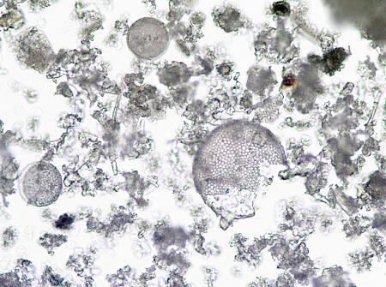
Organic-rich mudstones
These can be silt or clay dominated, but always have > 0.5% total organic carbon content (TOC). These form source rocks and oil shales during burial and graphite beds at greater depth. Organic material is commonly preeseved under two conditions:
anaerobic (<0.1 ml O₂/liter seawater)
dysaerobic (between 0.1 and 1.0 ml O₂/liter seawater)



