GEOL 342: Sedimentation and Stratigraphy
Lecture 18: magnetostratigraphy
26 April 2005
Assoc. Prof. A. Jay Kaufman

Magnetostratigraphy

Everything in stratigraphy hinges on two separate issues: 1) understanding depositional geometry, and 2) constraining time. We have thus far investigated the use of lithostratigraphy, biostratigraphy, and chemostratigraphy to elucidate relative time. Today we will begin to discuss magnetostratigraphy (or magnetic reversal stratigraphy) as a method to constrain both relative and absolute time.

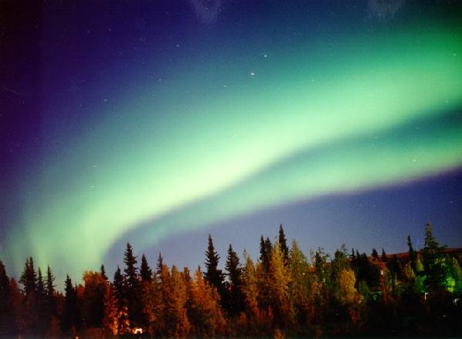

Polarity reversals

”Eighty years have passed since Joseph Larmor suggested that dynamos operating in the interiors of planetary bodies are the source of their magnetic fields. In that time, much analytical and numerical work has been done to convince us that he was very likely correct. Only recently have laboratory experiments been able to complement the theory with an operating homogeneous dynamo. However, even these recent successes in the lab have occured in constrained flows unlike, say, the outer core of Earth.” Dan Lathrop – University of Maryland, Department of Physics

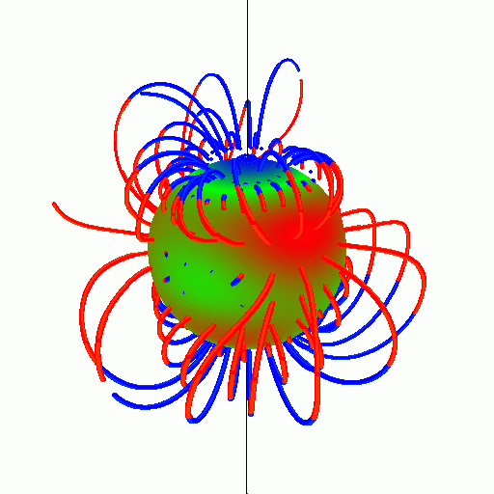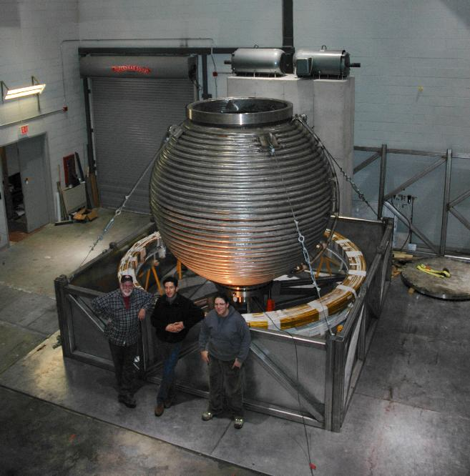

Although we don’t understand the cause, it is clear from the sea-floor spreading record that the polarity of the earth’s magnetic field regularly flips polarity. The main component of the magnetic dynamo, the dipole, switches every 1-1.5 Ma, although many reversal events are MUCH shorter or longer in duration. Because this record IS preserved in the magnetization of the earth’s crust, we can date those points directly and construct a global magnetic polarity time scale.

The Dipole Field

Because of the Earth’s dynamo, igneous and metamorphic rocks, as well as sediments and sedimentary rocks containing magnetic grains or minerals will show a preferred orientation. The iron-bearing minerals typically identified for their magnetic properties are magnetite, ilmenite, and hematite.

Insofar as iron-rich minerals in molten rock are free floating, they will orient towards magnetic north as the rocks cool and solidify below their Curie point. Because the Earth’s magnetic polarity changes periodically from north to south and back again, lava extruded along midocean ridges (which forms new ocean crust when solidified) records the Earth’s changing polarity, as symmetrical stripes on either side of the spreading centers.

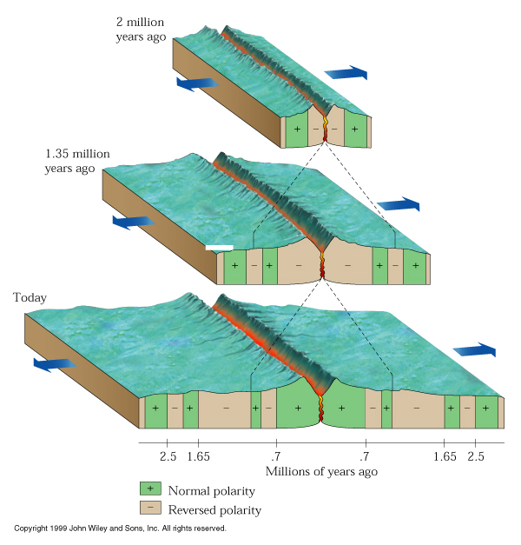

On land, igneous rocks can be both dated and measured for their magnetic polarity. Comparison of terrestrial reversal patterns with those on the seafloor indicates that the ocean basins are no older than about 175 million years old.

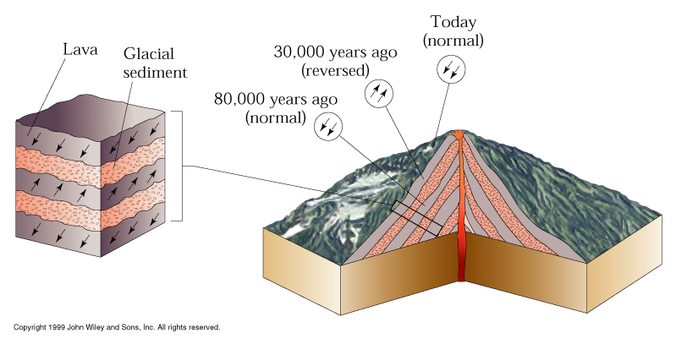

Iron bearing minerals that sediment out of suspension or that form in sediments as the result of diagenetic reactions will also orient themselves towards magnetic north. During the current magnetization, northern hemisphere rocks show a “down” magnetization pointing north, whereas southern hemisphere rocks point “up” and to the north. This is considered a normal polarity. When they point the opposite direction, they show reversed polarity. The key attributes measured are inclination and declination. Inclination is the up-down portion of the magnetic vector, and declination is the azimuth of the magnetic vector. These attributes can be used to constrain both polarity and paleolatitude. For stratigraphy, we only care about polarity

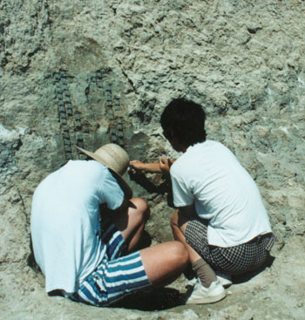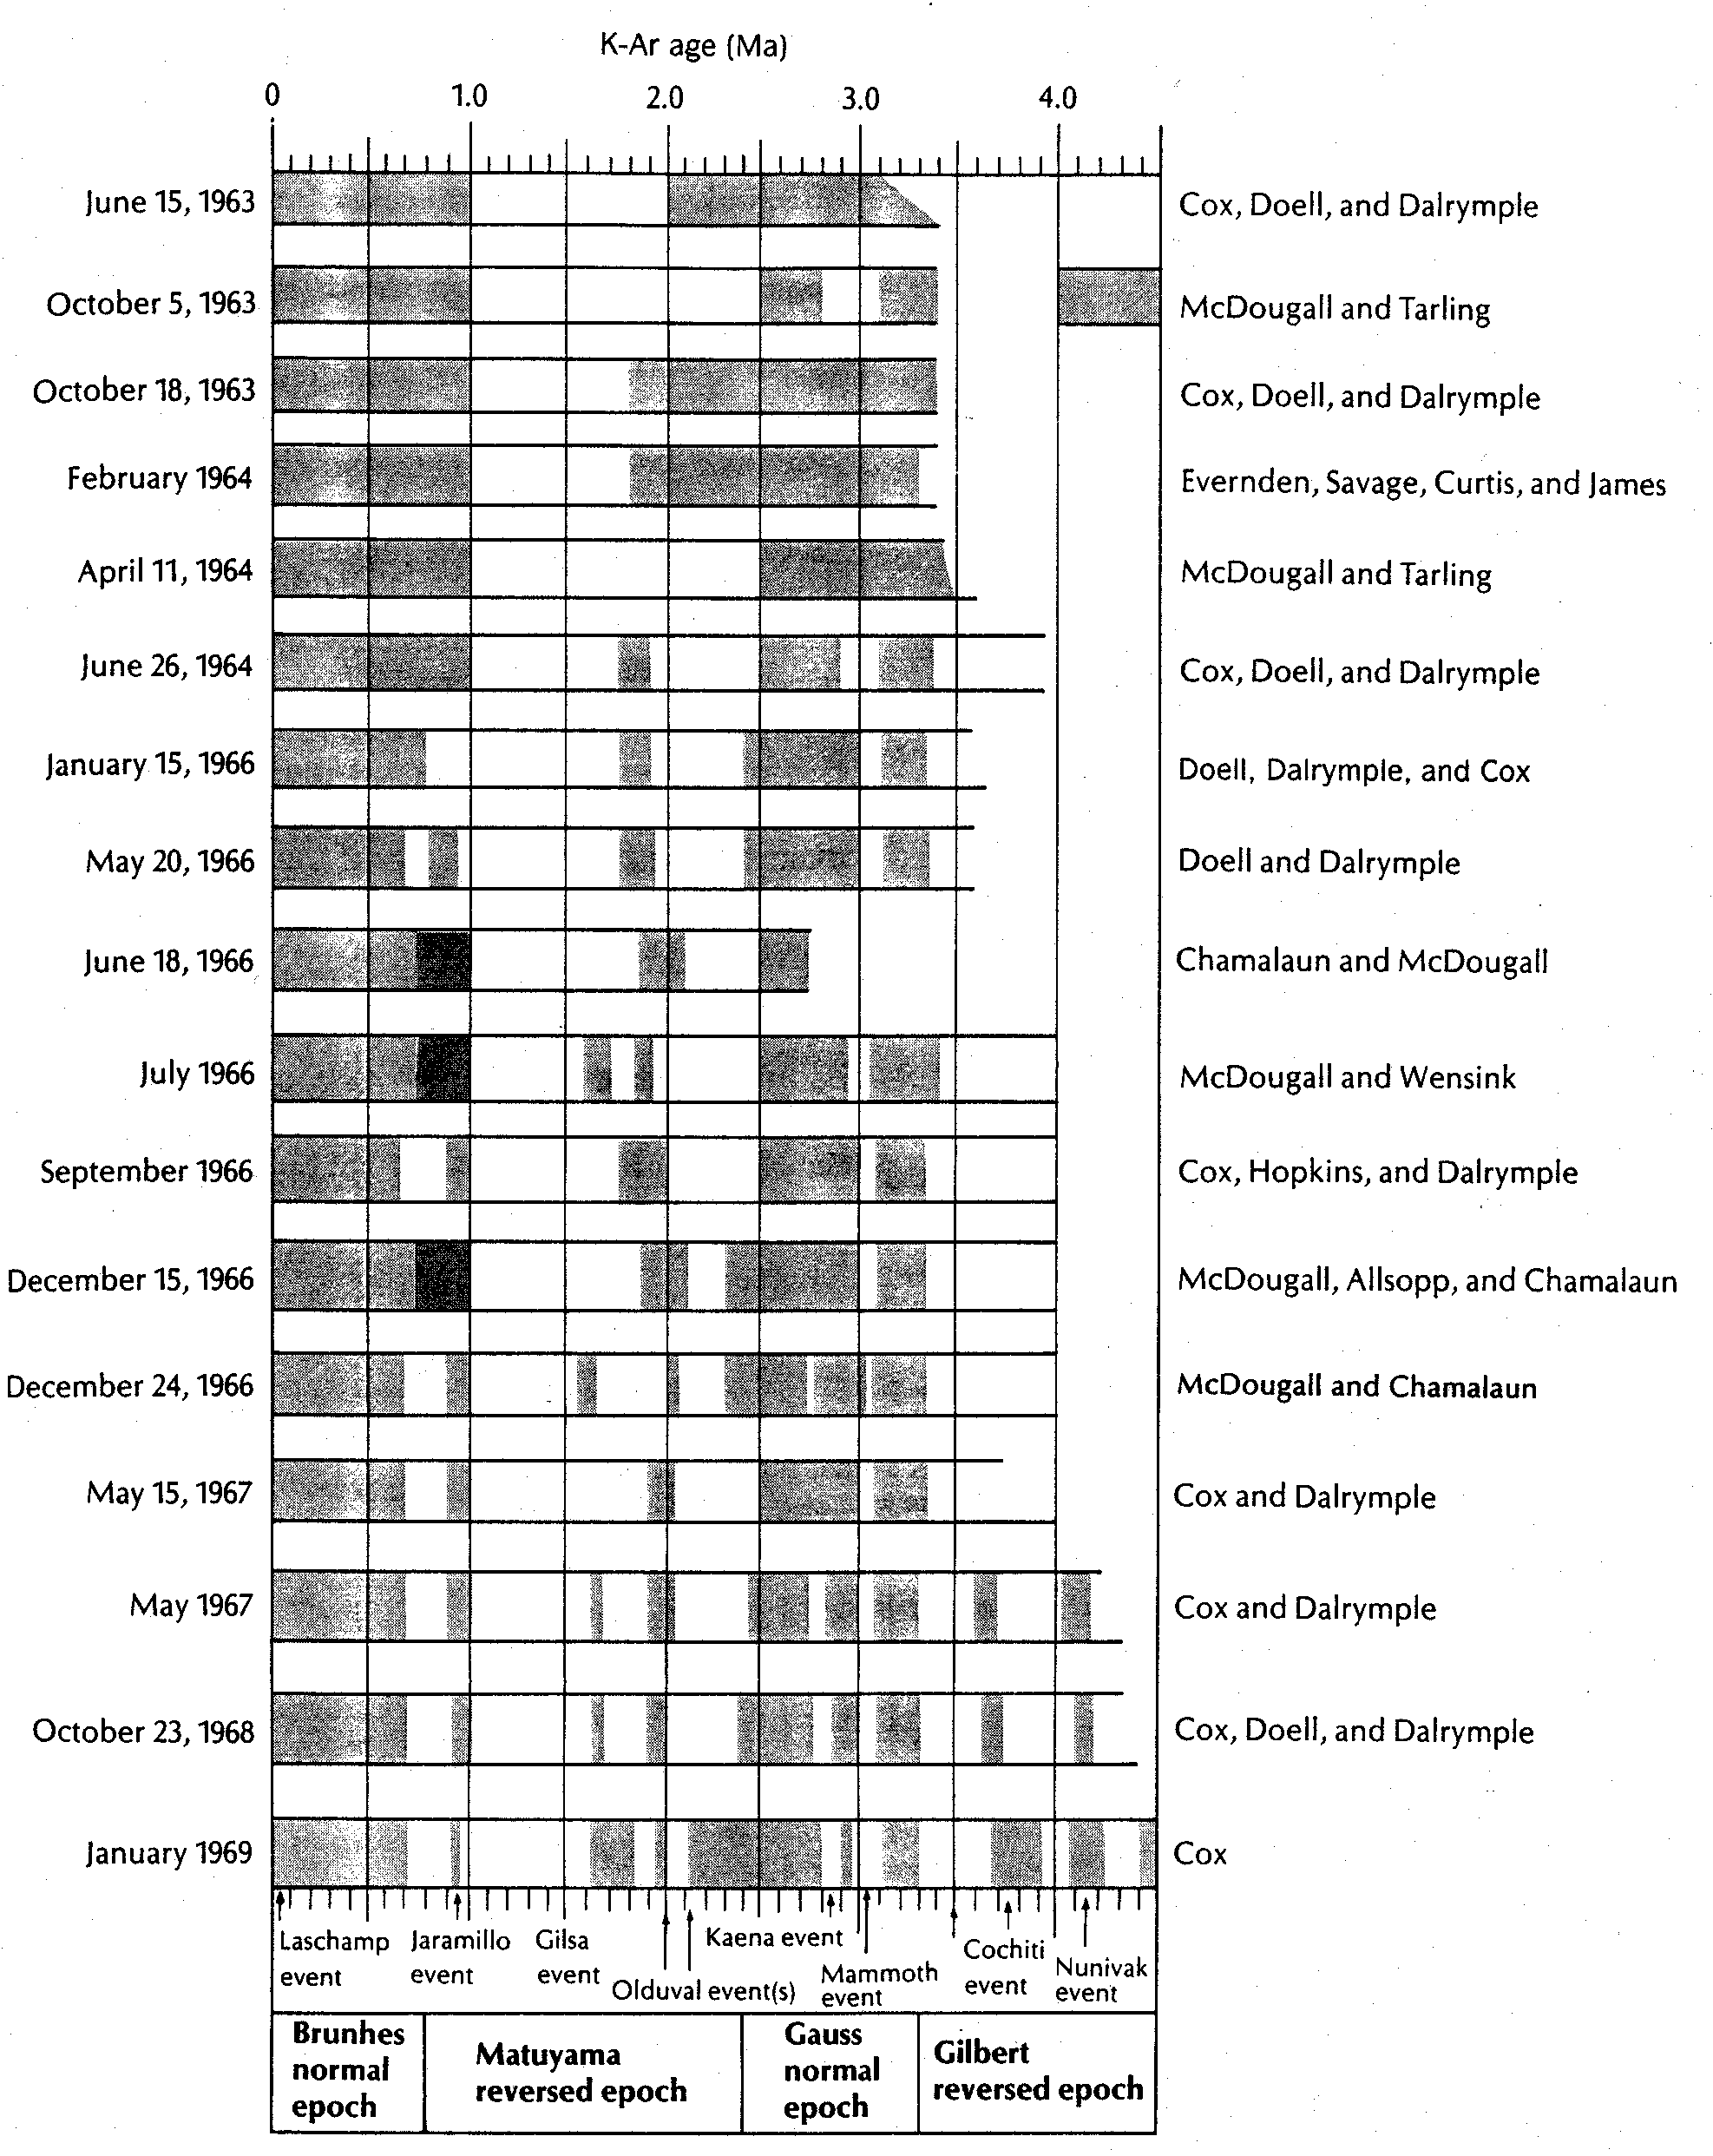

The long term pattern of Earth’s polarity shows that mixed intervals predominate, but there were also long periods in the Cretaceous with normal polarity and reversed polarity during the Permo-Carboniferous.

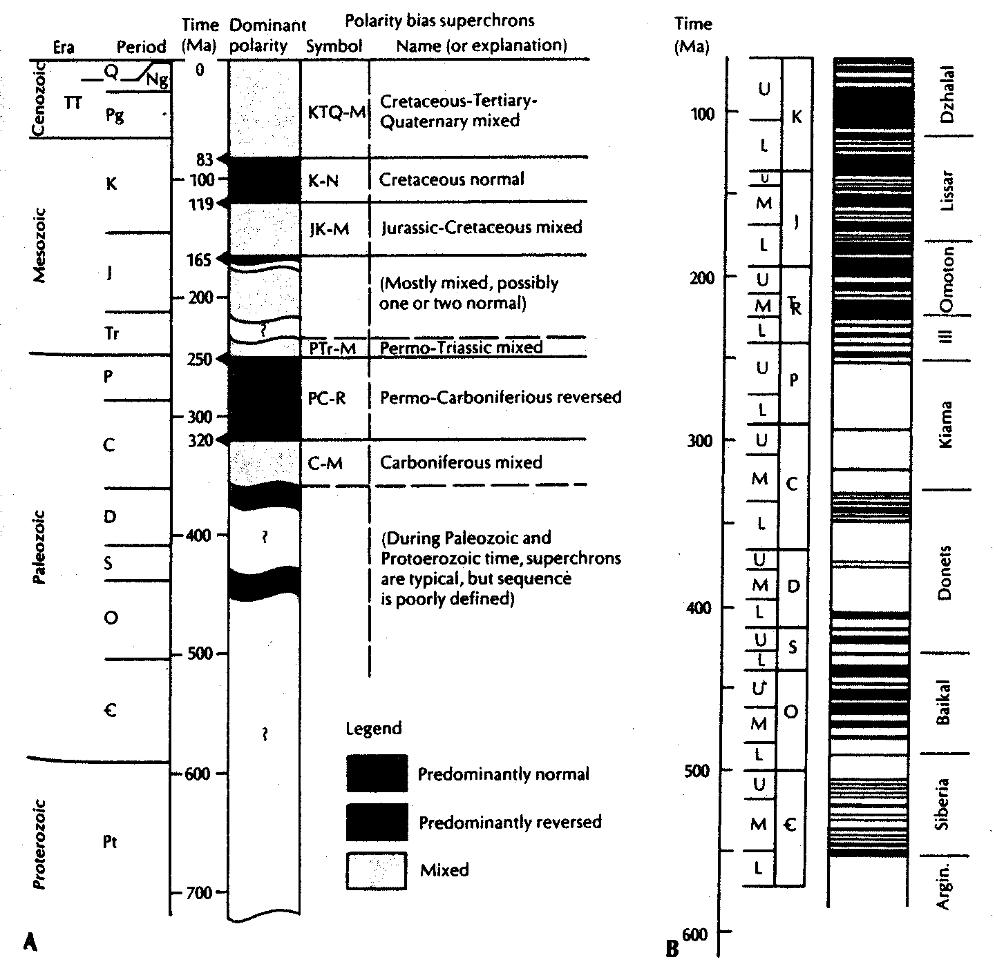

Rock Magnetics

The natural magnetic vector recorded in rocks is called the NRM: Natural Remanent Magnetization. Different kinds of remanence are recorded in the rocks, and care must be taken to measure the signature of deposition. This requires measuring the different components of the magnetization through a process called demagnetization, a step-wise removal of the magnetic remanence based on the mineral based magnetic or thermal character. The table below shows different kinds of magnetic remanence, and different minerals that typically carry a magnetic signature.
.
Name | Process | Common minerals
Detrital Magnetization | Orientation of magnetic grains by settling through the water column | Magnetite (hematite)
Chemical Magnetization | Post-depositional (diagenetic) growth of magnetic minerals | Hematite (goethite, limonite)
Thermal Magnetization | Cooling of magnetic minerals below their “Curie” temperature | Magnetite (hematite)
Acquired Remanent magnetization | Gained within strong electrical field (e.g., lightning strikes) | All
Viscous Remanent magnetization | Weak magnetic overprint cause by magnetic “diffusion” | All

Different demagnetization techniques help to sort out these different magnetizations. One is called AF (alternating field), in which the rock is exposed to increasingly strong magnetic fields that flip rapidly. This will overprint weaker and looser magnetic grains, and is typically used for loose and unconsolidated sediments (e.g., lake cores). The other primary tool is thermal demagnetization, in which rocks are heated stepwise to the Curie temperatures of different minerals. These stepwise processes produce changes in the total rock magnetic vector, which are mapped out in stereoplots and Zidjervelt diagrams.

Magnetic Susceptibility

A different measure of how easily magnetic minerals respond to external fields is increasingly used to generate time series through stratigraphic successions. Surprisingly, these changes appear to track climatically driven signals. This allows one to make quick and dirty correlations to other time scales (e.g., isotope or chemostratigraphic time scales) with greater speed and high accuracy.

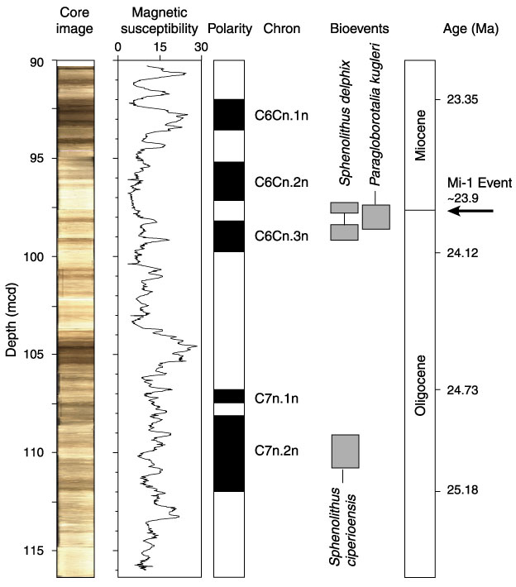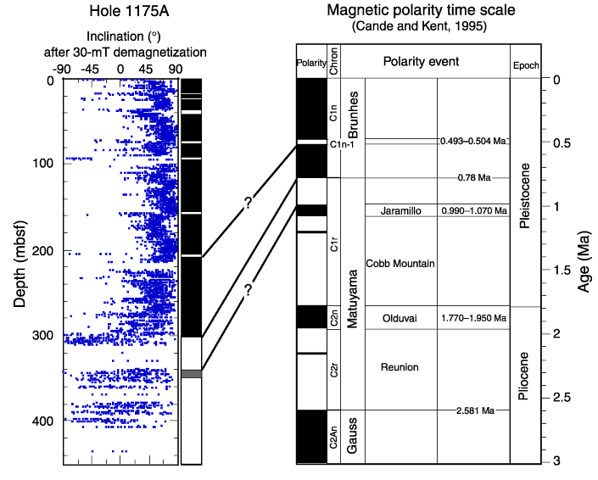

Importance

If a clean and long magnetic reversal stratigraphy can be constructed, then there is often very little ambiguity concerning the stratigraphic age. This allows excellent chronology of succession, and aids in correlation locally, regionally, and globally.

