GEOL 342 Sedimentation and Stratigraphy
Lecture 13: carbonate sediments
31 March 2005
Assoc. Prof. A. Jay Kaufman

Carbonate sediments

Carbonate is the most abundant chemical sediment in modern and (most) ancient oceans. As we will explore later, carbonates are sensitive recorders of the global marine environment, in particular as proxy signals for long-term and abrupt changes in the exogenic carbon cycle. These soluble minerals are also subject to diagenetic alteration by a variety of processes.
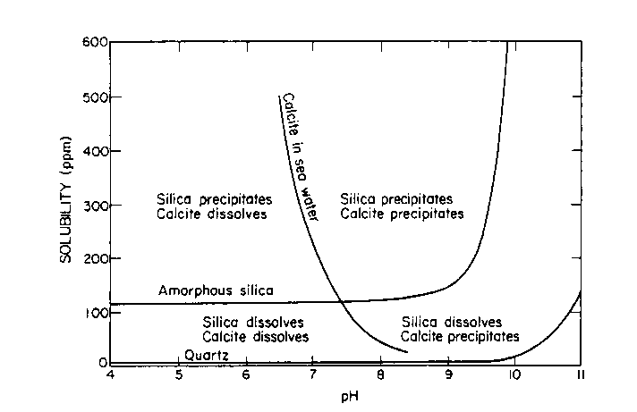
A more mundane but important aspect of the rocks is that they are sources of gravel, Ca and Mg for nutrition, and building facing stone. Carbonates are also host rock to Mississippi-type ore deposits, and when fractured can be good oil reservoir rocks. Carbonates are also the rock most likely to contain the globally-distributed marine fossils used in biostratigraphy.

Carbonates may also monitor changes in the atmosphere. Indeed most of the carbon in the early atmosphere (which existed as either CO₂ or CH₄ in high concentrations) reacted with the silicate Earth and water to form alkalinity, and is now stored as carbonate rock in the crust. The present atmosphere has a miniscule 350 ppmv CO₂ and ppb levels of CH₄.

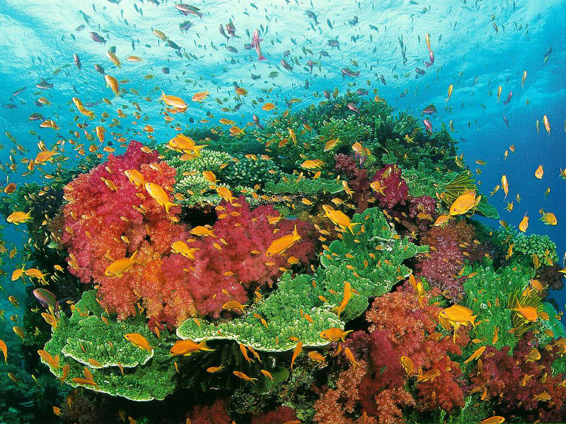

Are coral reefs net sources or sinks of atmospheric CO₂?

Carbonates form readily in most warm, shallow water environments. The main requirements for their formation are high concentrations of Ca²⁺ and HCO₃⁻ (alkalinity), which are products of silicate and carbonate weathering on land.

2NaAlSi₃O₈ + 2CO₂ + 11H₂O → Al₂Si₂O₅(OH)₄ + 2Na⁺ +2HCO₃⁻ + 4H₄SiO₄
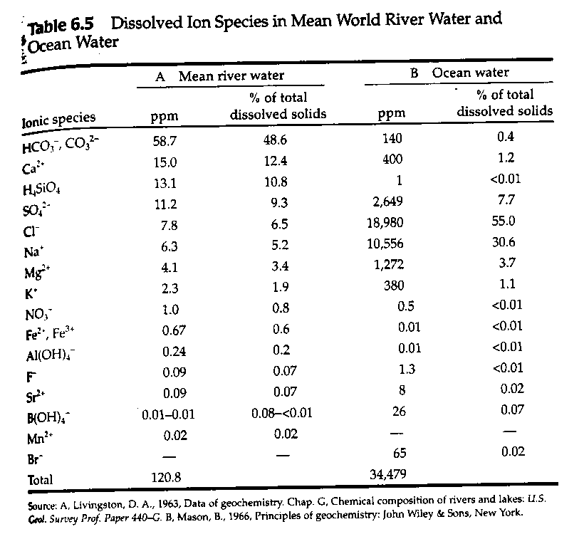

Since surface oceans are generally supersaturated with respect to calcite, this mineral and its sister, aragonite, form readily. Calcite has a rhombohedral structure that can substitute up to 5% Mg (high Mg calcite) for Ca. On the other hand, the aragonite structure is orthorhombic and its larger cation sites allow for the incorporation of larger elements, most notably strontium.

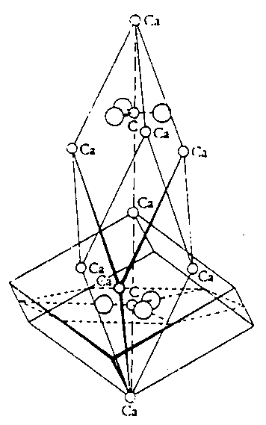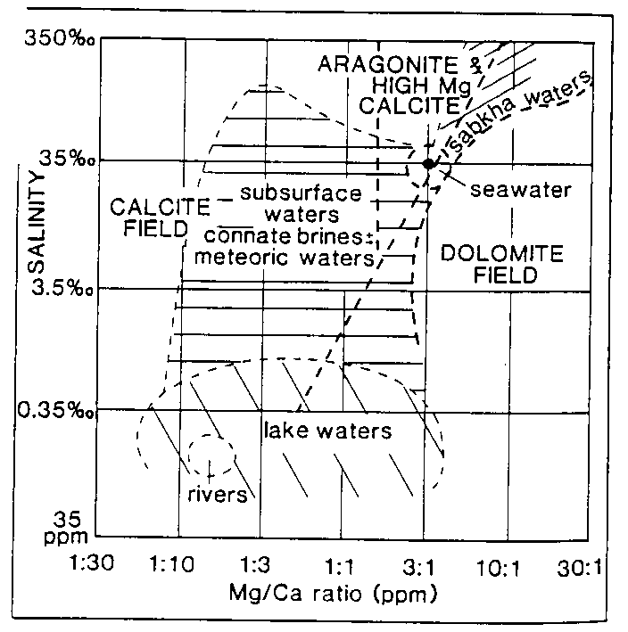

Organisms that calcify use a range of carbonate minerals to build their shells and homes.

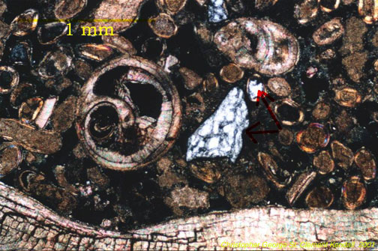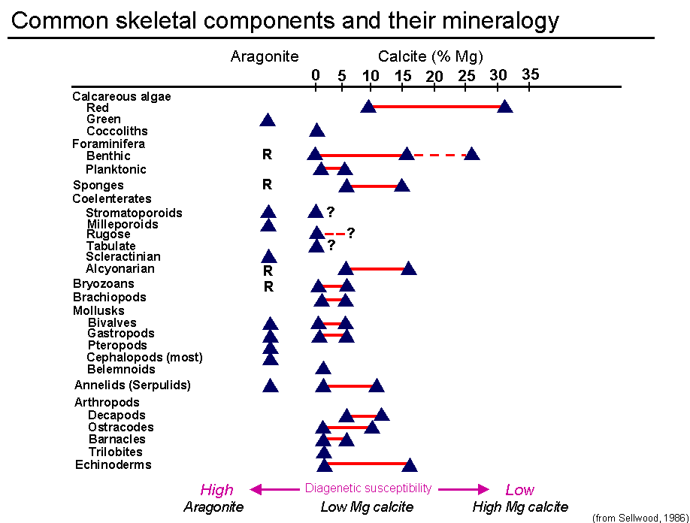

Carbonate chemistry

Equilibrium constants monitor the extent of chemical reactions at set temperatures and pressures. An equilibrium constant is equal to the concentration of products over reactants.

For a reaction A+B → C + D (reactants → products)
K_{eq}(1) = (C)(D)/(A)(B)

The reverse of this reaction C + D → A + B
K_{eq}(2) = (A)(B)/(C)(D)

If K(1) > K(2) the reaction moves to the right at equilibrium conditions.

So now consider the carbonate system of equilibrium reaction and constants:

1) CO₂ + H₂O → H₂CO₃ K_{eq} = 10^{-1.43}

2) H₂CO₃ → H⁺ + HCO₃⁻ K_{eq} = 10^{-6.40}

3) HCO₃⁻ → H⁺ + CO₃²⁻ K_{eq} = 10^{-10.33}

4) Ca²⁺ + CO₃²⁻ → CaCO₃ K_{eq} = 10^{-8.33} for aragonite
and 10^{-8.48} for calcite

So based on the kinetics of these reactions, is carbonate precipitation increased or decreased by the removal of CO₂ from seawater?

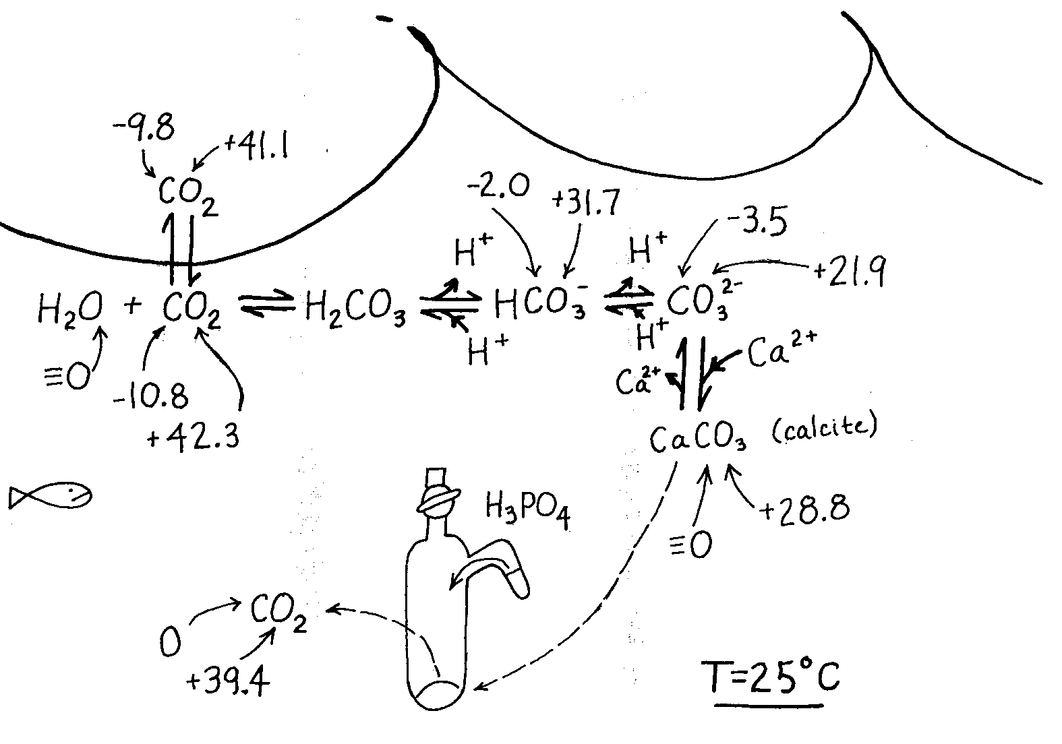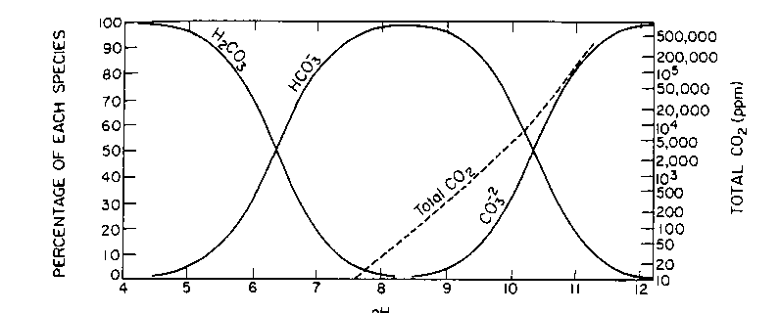

The chemical and physical controls on carbonate formation in oceans and lakes include:

- temperature
- pressure
- degree of agitation
- sediment masking
- light availability
- oxidation state

The effects of organic activity on CaCO₃ precipitation are manifold.

activity immediate effect ultimate effect

CaCO₃ extraction promotes skeletal growth forms allochems and mud
photosynthesis removes CO₂, pH increase promotes precipitation
decay adds CO₂, pH decrease hinders precipitation
feeding bioturbation generates pellets, stirs sediments
bacterial activity removes CO₂, pH increase calcifies microbial mats

Carbonate classification

Two main classification schemes have emerged for limestones. The Dunham classification is based on the recognition of depositional textures as well as the abundance of allochthonous and autothonous components. An allochem is a carbonate particle that was formed outside of the depositional area and transported in, hence carbonate sediments can be clastic.

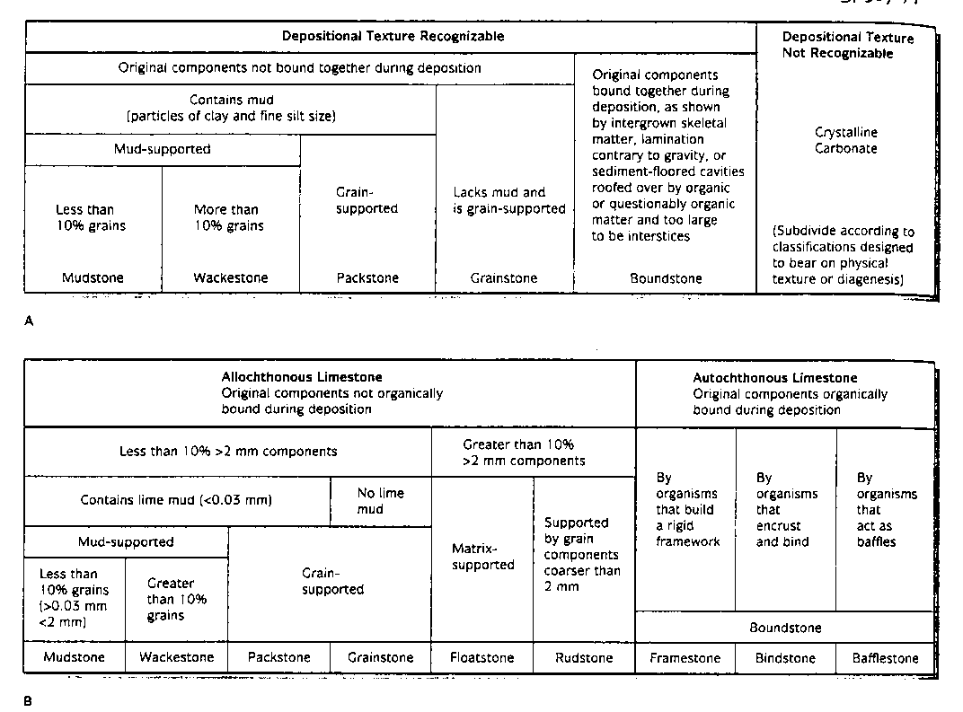

In contrast, the Folk classification relies on descriptive terms for the allochems linked to the dominant matrix material, either micrite or sparite. Folk also described a classification based on textural maturity.
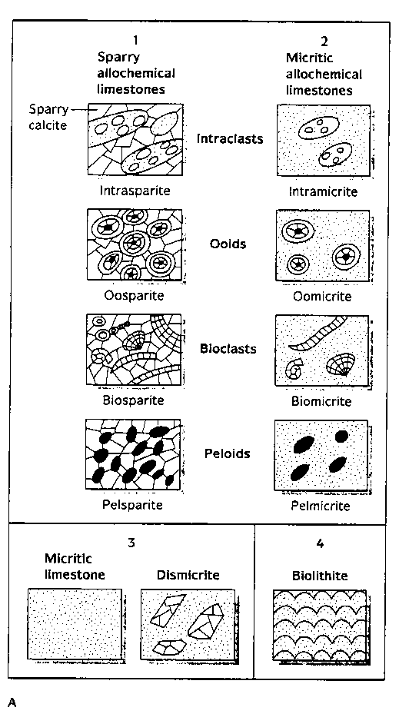

The most common allochems include:

- coated grains, including ooids (most smaller than 2 mm), grapestones, pisolites, and oncolites (rolled up mat)

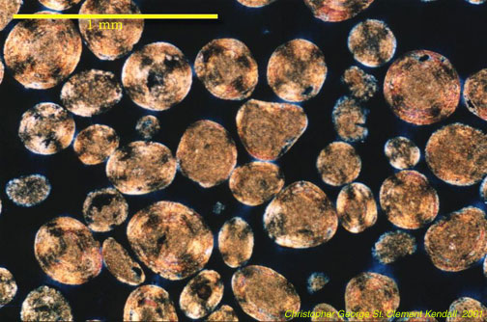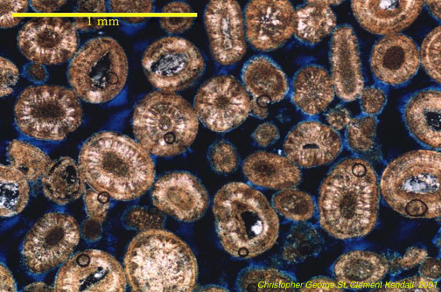

- skeletal fragments

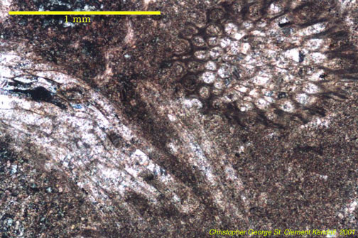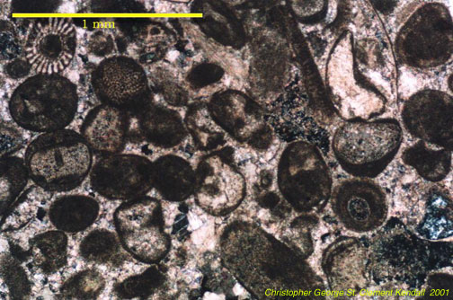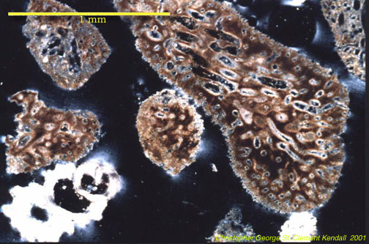

- intraclasts
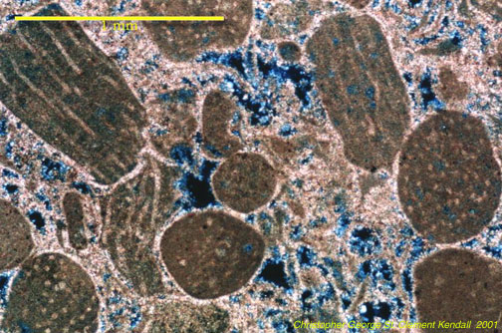

Orthochemical components that form within the depositional area represent the rock cement and include:

- micrite, a very fine grained component that may be an abiotic precipitate, or form due to the photosynthetic actions of nannoplankton.

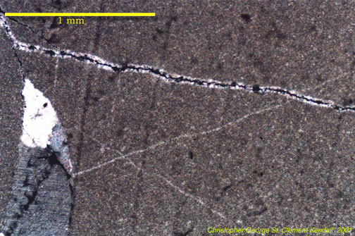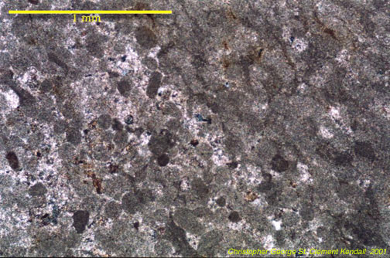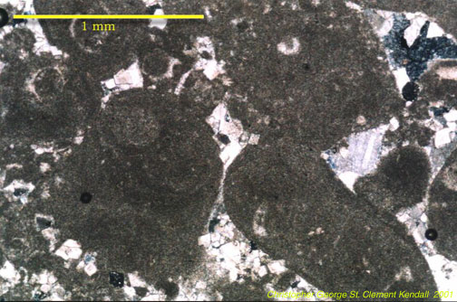

- spar
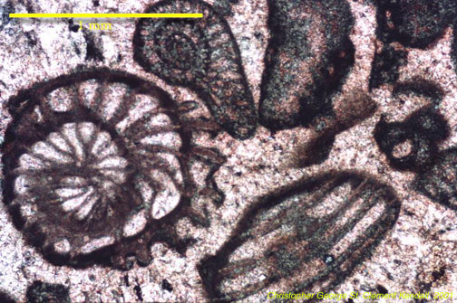

Under unusual chemical conditions (oftentimes diagenetic) a variety of other carbonate minerals can form in the marine and terrestrial environment. These include:

ankerite Ca(MgFe)(CO₃)₂ and siderite FeCO₃. These are common constituents in the Precambrian banded iron-formations, as well as concretions in peat-rich soils and organic-rich sandstones, and

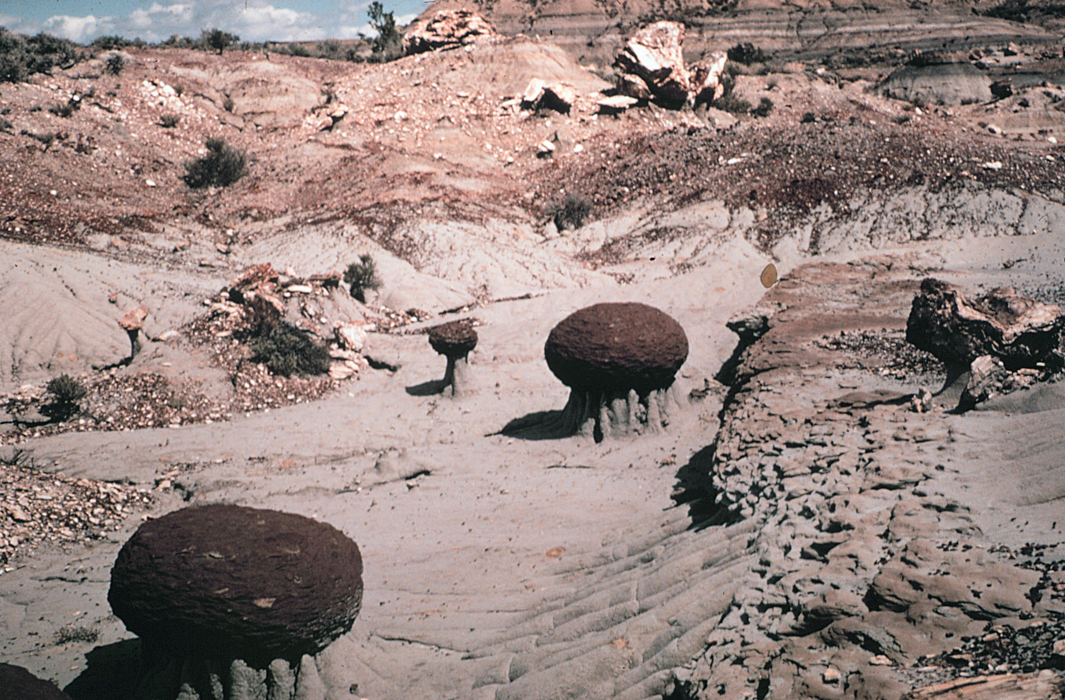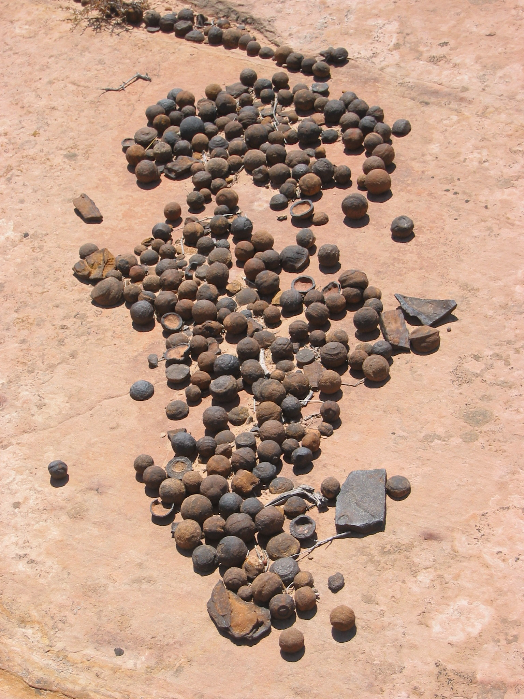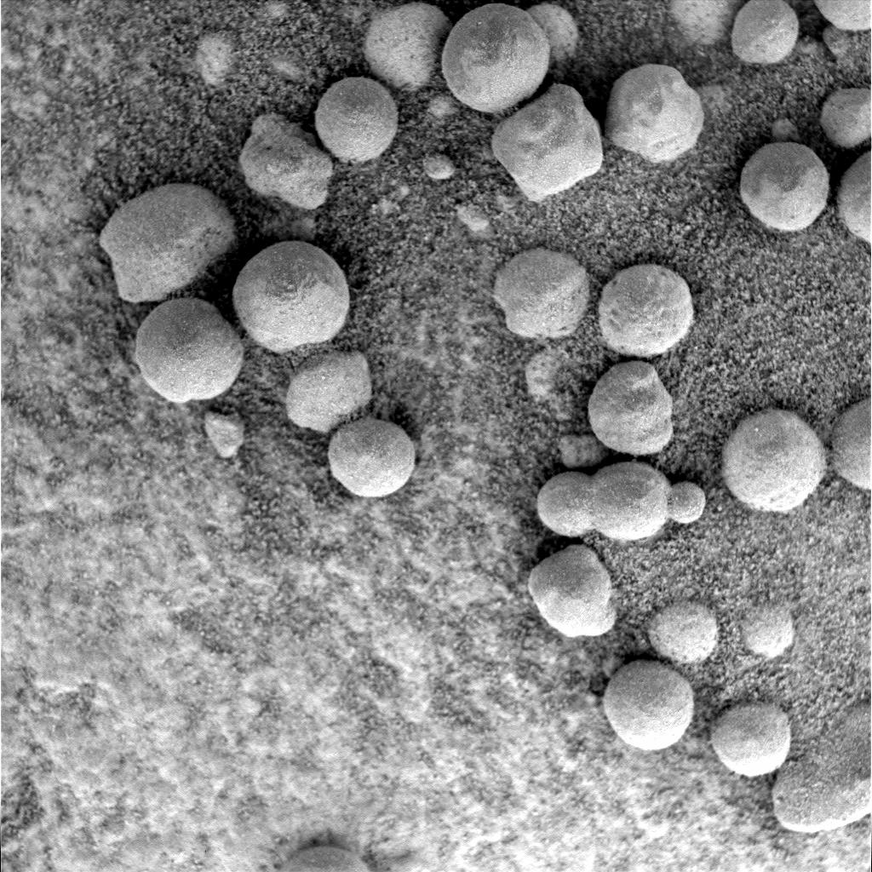

dolomite CaMg(CO₃)₂.

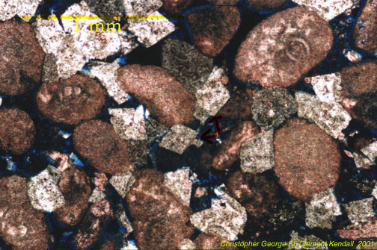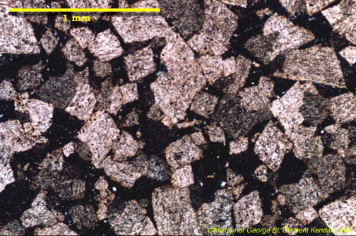
Most models of diagenetic dolomite formation require the kinetic barriers for the precipitation of this highly ordered mineral to be overcome. The barriers are 1) temperature, 2) salinity (effects of hydration on Mg²⁺ ion), 3) Mg/Ca ratio (seawater is 5.4 for dolomite to form must be > 8), and 4) sulfate concentration (28 mM in seawater). Environments where these barriers can be removed are warm, highly evaporitic, and mixed with fresh water sources. These factors promotes the precipitation of Ca and SO₄²⁻ bearing minerals, which increases Mg/Ca and decrease sulfate concentrations.

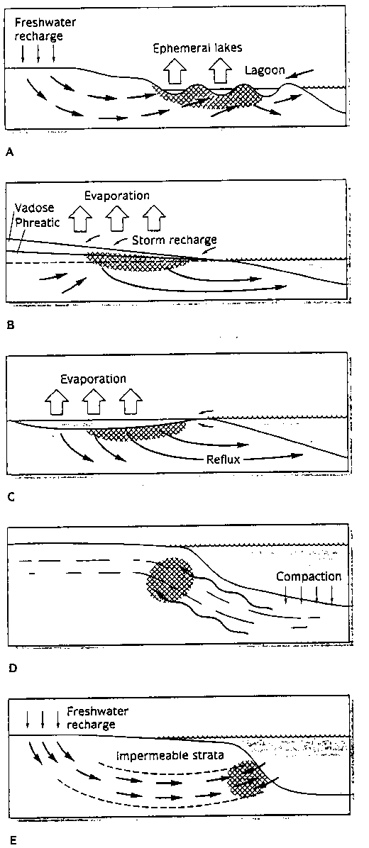

One modern environment where dolomite appears to be forming as a primary precipitate is the Coorong lakes, along the southern margin of Australia. The Coorong is an area of lagoons and alkaline lakes behind modern beach barriers, which are fed by seawater and groundwater. The temporary lakes are of high pH (8 to 10) and have Mg/Ca of up to 20. Dolomite forms in more landward lakes as minute spherical aggregates



