GEOL 342: Sedimentation and Stratigraphy
Lecture 14: carbonate environments
5 April 2005
Assoc. Prof. A. Jay Kaufman

Carbonate environments

Carbonate platforms have often been considered as “factories” due to the rapid buildup of carbonate in appropriate warm and shallow marine environments.

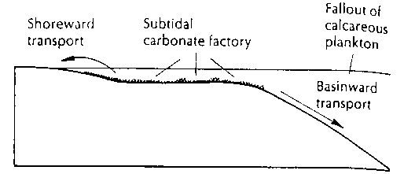

Carbonate factories frequently shallow to the surface where they may be exposed due to sea level fluctuations on various time scales, resulting in erosion and karstification. To continue carbonate sedimentation sea level would have to rise (or the platform subside), or the facies would have to migrate out to sea.

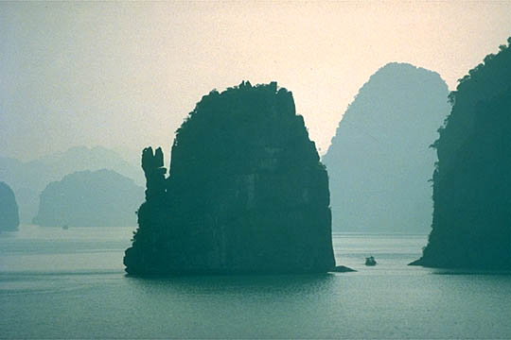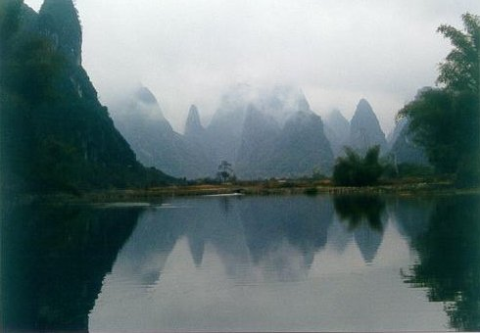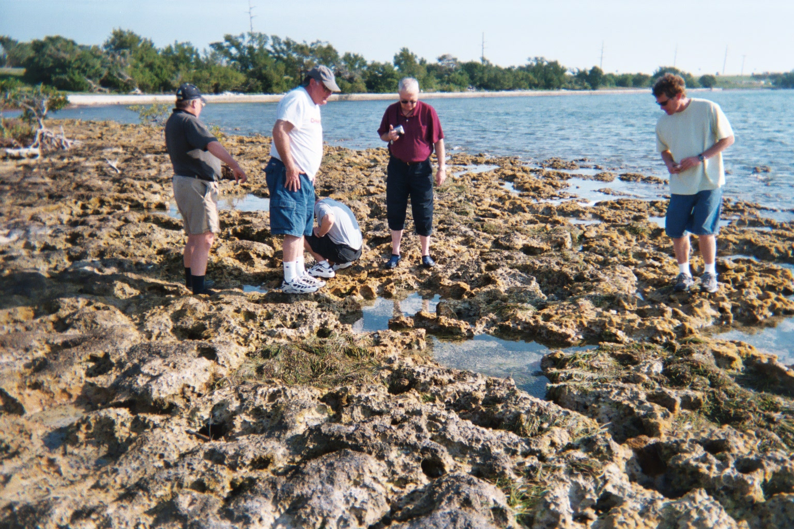

Material from the carbonate factory is constantly redistributed around the platform and off into the abyssal deep. Facies are subdivided into depth-restricted zones including 1) supratidal, 2) peritidal, and 3) subtidal environments where there are extreme variations in water depth, salinity, and organisms.

Supratidal

Supratidal refers to environments that are generally above the tidal range and are thus wet with seawater only during storm events. These are otherwise dominated by brackish or fresh water sources. A typical environment would be a marsh where it is likely to find high abundances of organic matter and where coal is likely to form. The organisms that inhabit this environment must be able to tolerate brackish conditions, and under extreme evaporitic conditions may be absent altogether.

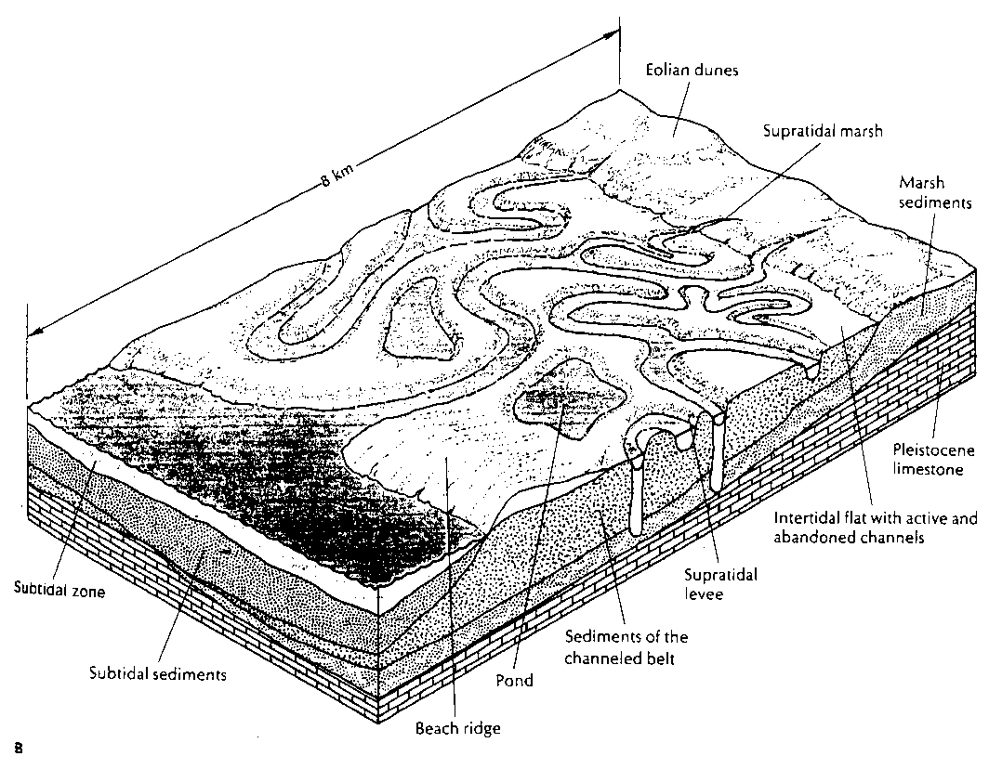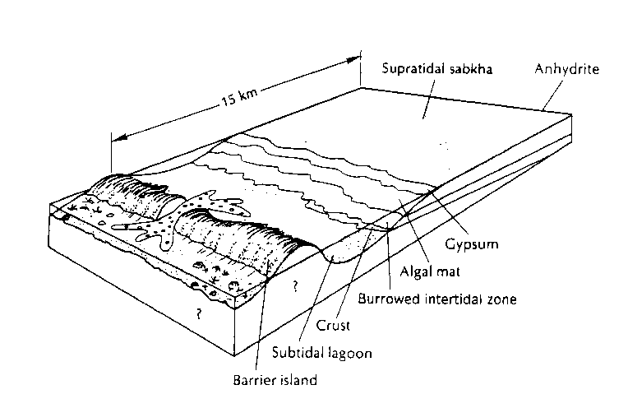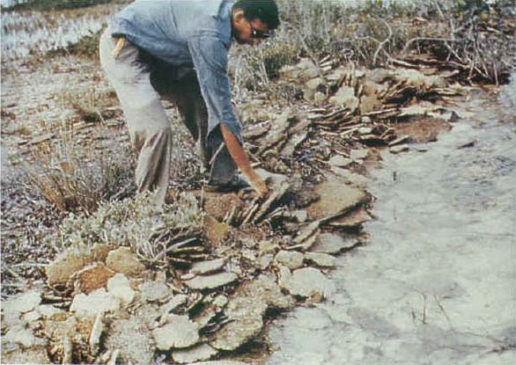

Peritidal

Peritidal environments commonly form in the tidal range and hence are daily exposed to seawater. Deposits are laterally persistent, evenly bedded limestone and dolomite that is often preserves flat laminations and shallowing upward cycles that are often repeated to great thickness. This environment is seen in modern and ancient tidal flats similar to those in the Persian Gulf.

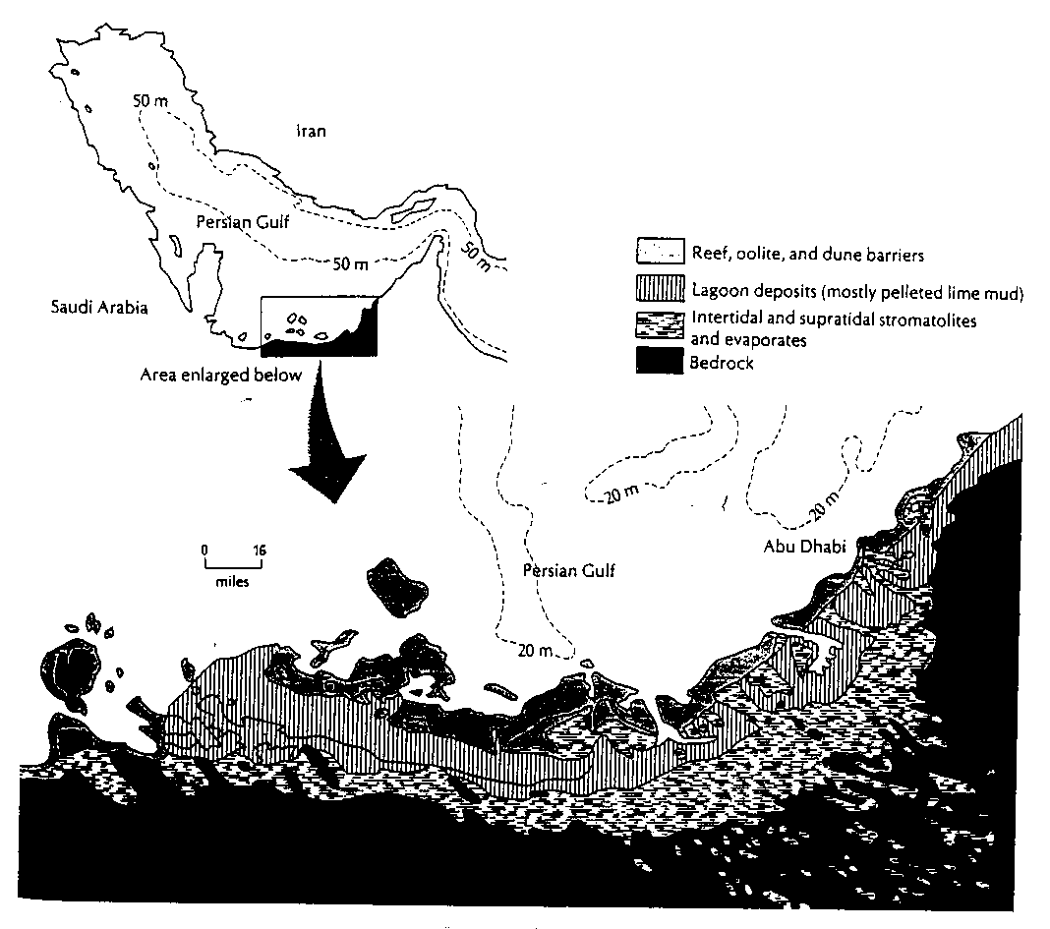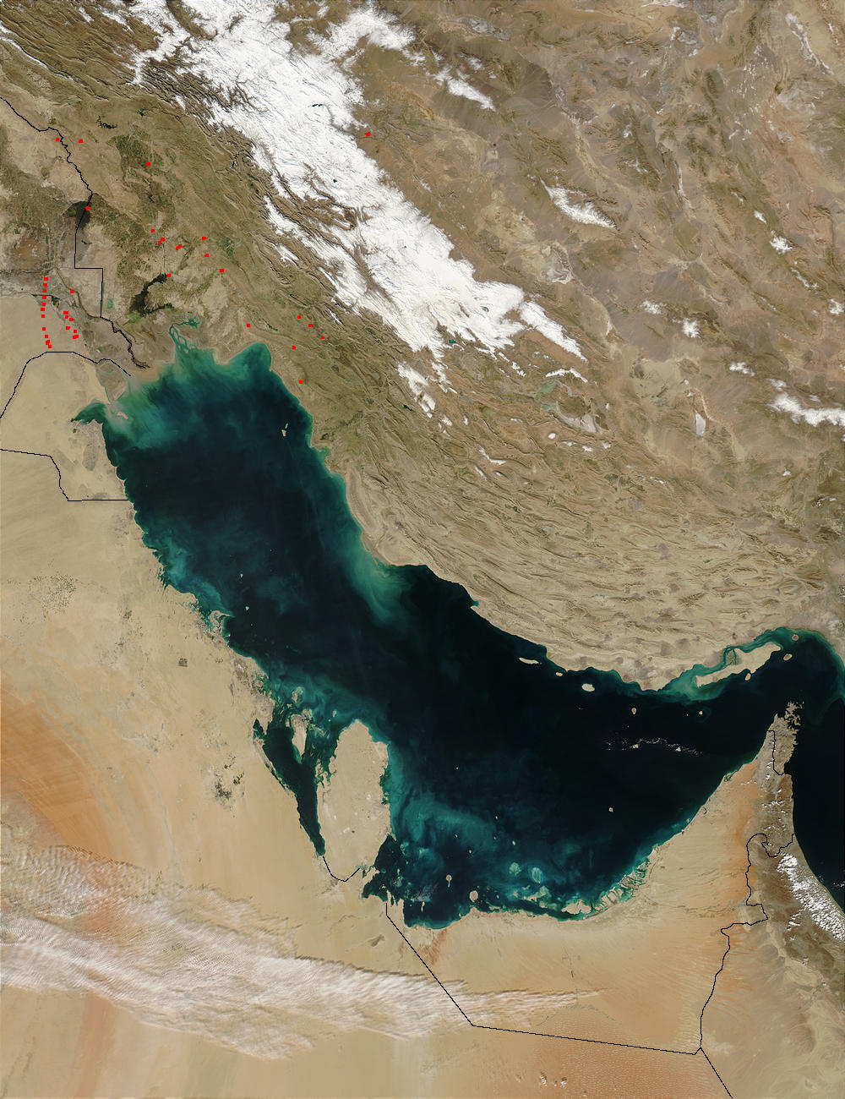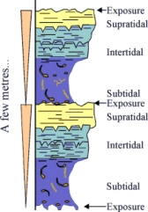

Due to the daily alternation of the tides peritidal environments often contain carbonate (dolomite) mudflats, evaporites, herringbone x-stratification, shell debris, and rip-up clasts or plate breccias, mud cracks and algal mats. Fenestral (sheet like) porosity or birds-eye structures are caused by the dissolution of evaporites or from voids originally filled with gas.

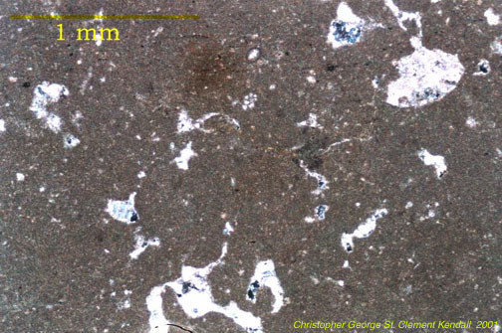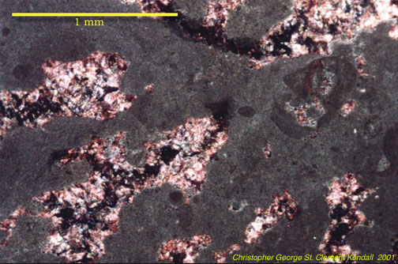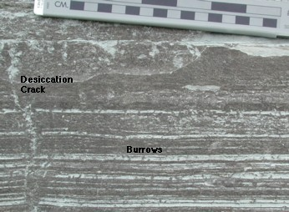

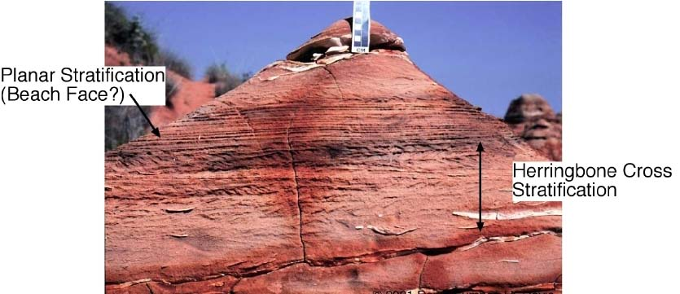

Subtidal

In our own backyard the Bahama Banks is an excellent laboratory of a subtidal carbonate factory. Subtidal environments with normal marine waters and a limited range of salinities produce thick carbonate blankets that can be up to 1000s of meters in thickness, depending on the rate of subsidence along the continental margin.

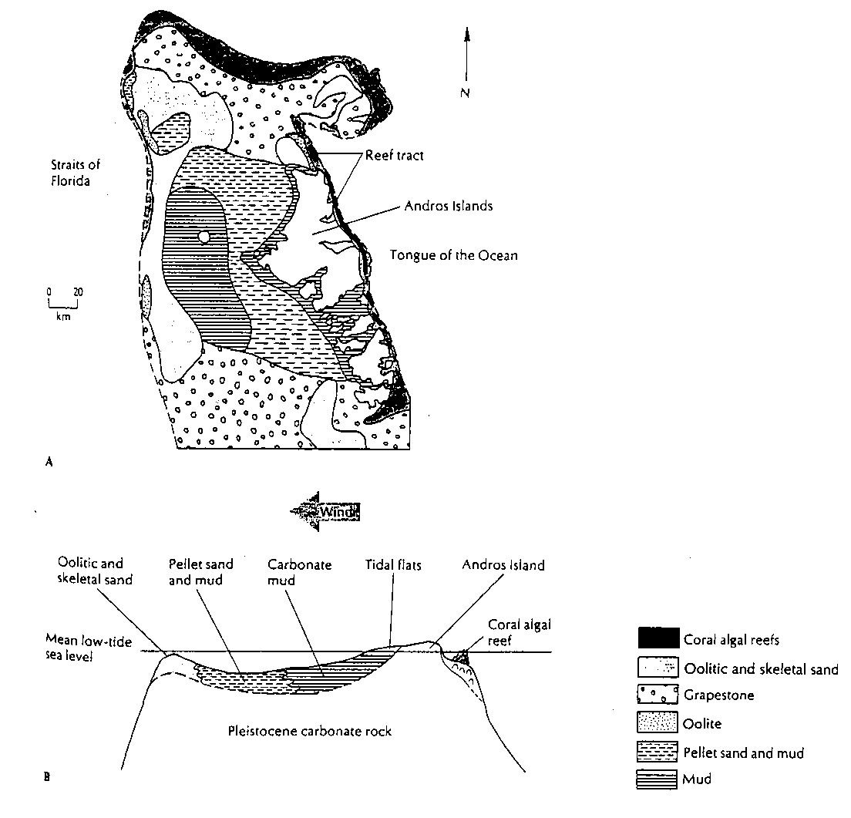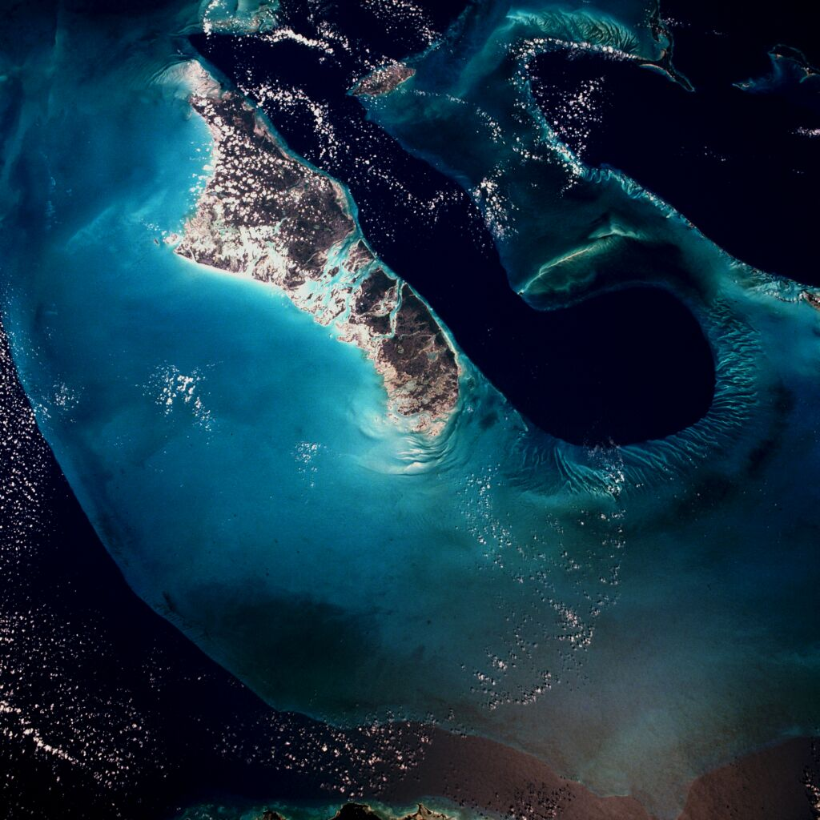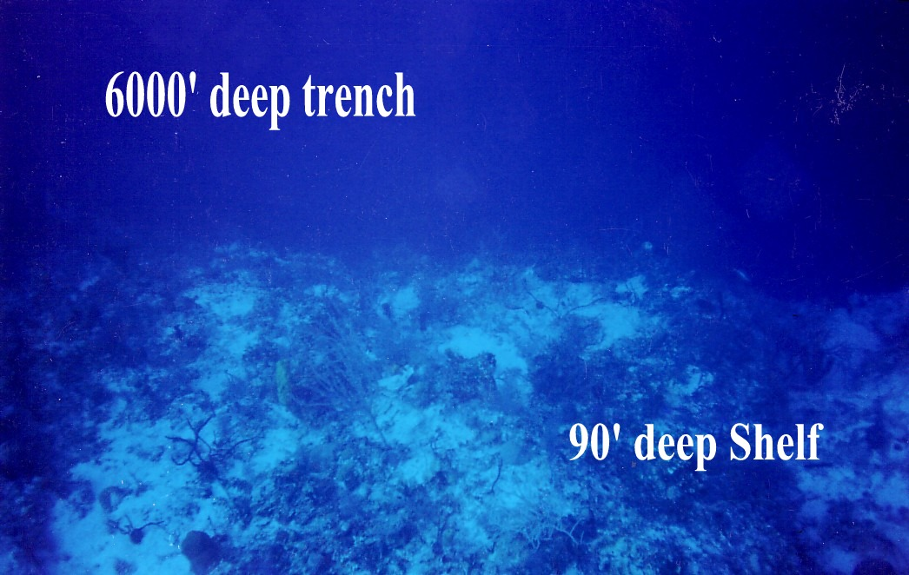

These muddy subtidal environments have a marine fauna which is more diverse than in peritidal environments, and sediments are often bioturbated.

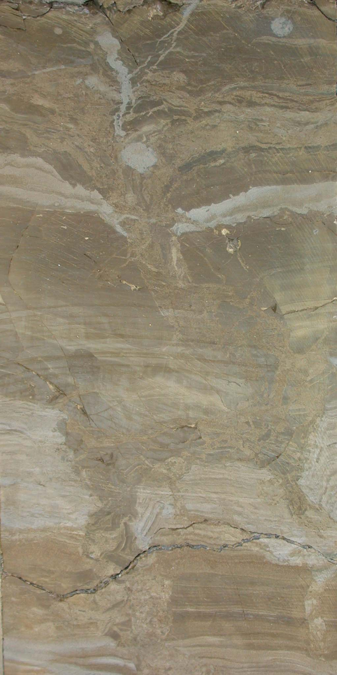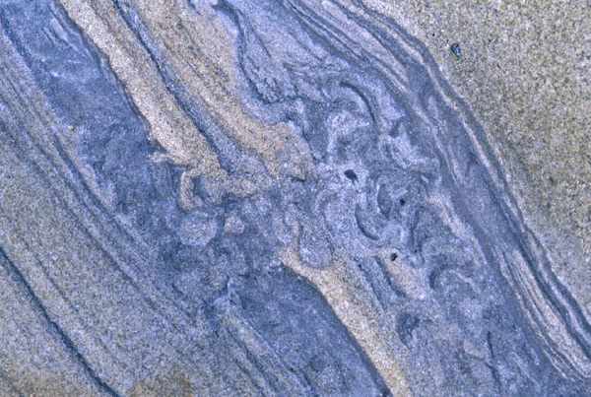

Subtidal environments can have a wide distribution of facies associated with both water depth and wave energy.

- reefs in high energy environment as well as ooid and skeletal shoals
- mud and pellet carbonate sands in protected lagoonal environments
- grapestones where ooids congregate and cement together before being coated again

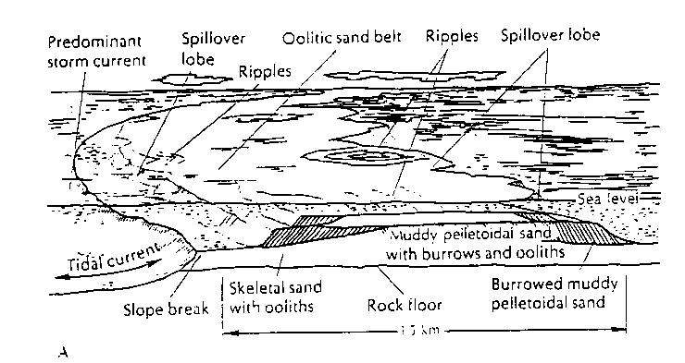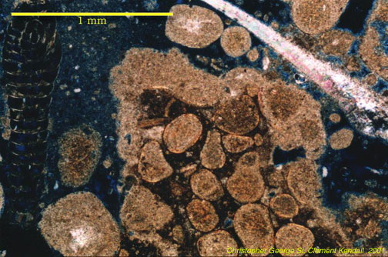

Repetitive changes in sea level cause cyclic deposition on carbonate platforms, which can be readily identified in the field. For subtidal facies, relative water depth may be inferred by the relative abundance of shaley interbeds and the thickness of carbonate layers.

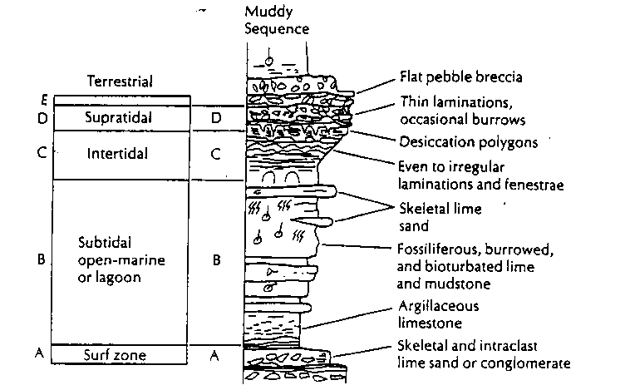

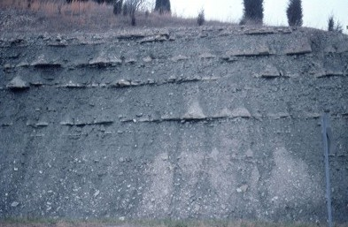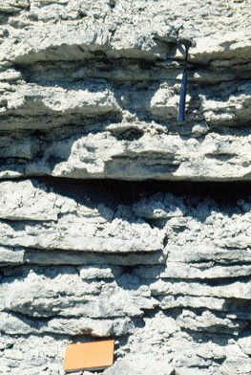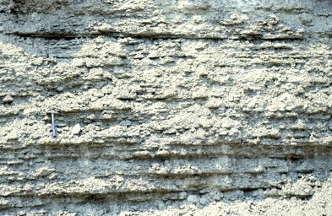

Reefs

Reefs are sediment systems built entirely from the organisms that call it a home. It is a wave resistant framework. Modern reefs primarily exist in oligotrophic environments and these rival the rainforests for biodiversity. Reefs, which form at the edges of carbonate banks, can be excellent oil traps.

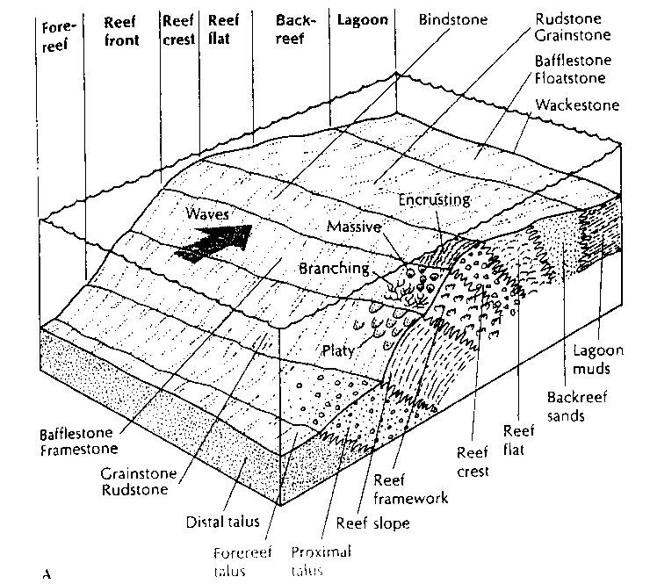

The architects of reefs (framework builders) include scleractinian coral, coralline algae, bryozoans and sponges, but in the past even microbial mats could built up reefs. However, framework builders are generally only 10% of the total volume of the reef, the remainder is composed of skeletal fragments, micrite, breccia and cements, which fill in the interstitial spaces of the reef framework
Corals are tiny marine animals (polyps) which live in small cone-like cells, commonly in warm, tropical waters. The animals have tentacles to assist feeding, and may seal the end of their cells with an operculum (lid). They often live in colonies, behaving either independently as individuals or with a degree of specialization of function so that the whole colony operates, to some extent, as an organism. Their skeletons often accumulate in vast quantities, sometimes as reefs, which may become consolidated as various types of limestone. There are many hundreds of different living species-700 alone in the Indo-Pacific region, and similar numbers of extinct species. Two extinct types of corals which are frequently preserved in limestones are the rugose and the tabulate corals, both of which arose in the Ordovician Period (434 to 490 million years ago) and became extinct at the end of the Permian Period (251 million years ago).
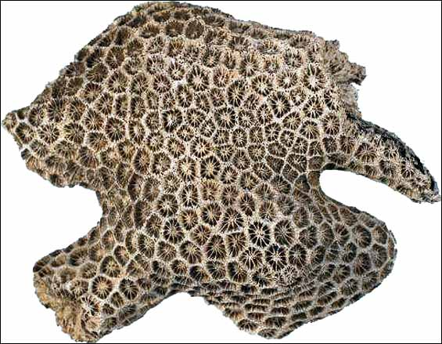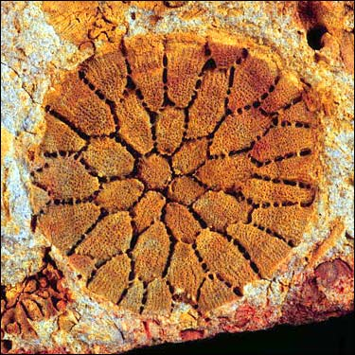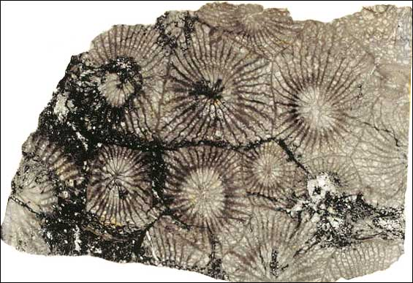
Thus largely due to mass extinction, the types of framework builders in reefs have changed through time.

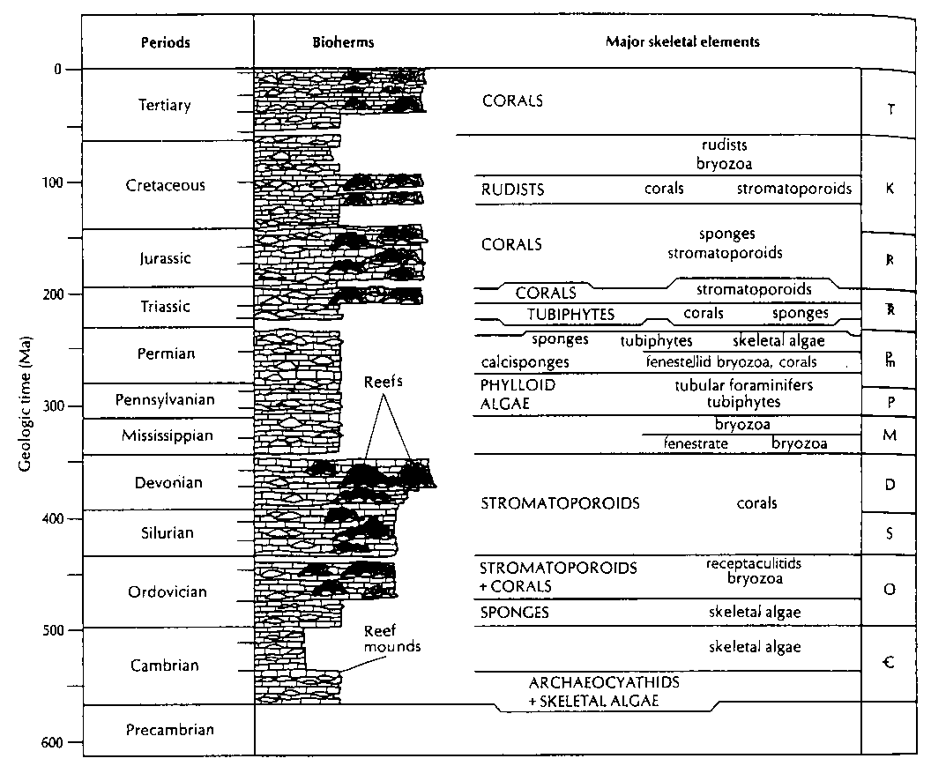

Diagenesis of carbonates

Due to their solubility, evaporites and carbonates can be readily modified by diagenetic processes (including anything that happens after deposition of the sediment). Dissolution of these minerals creates porosity, which might result in a hydrocarbon trap. Selective dissolution in carbonates creates some interesting textures, including fenestrae, oomoldic porosity, and stylolites. Stylolites are jagged irregular seams dividing limestone into two parts that are interpenetrating “tooth and socket” textures usually due to pressure solution (dissolution perpendicular to the plane of the stylolite).

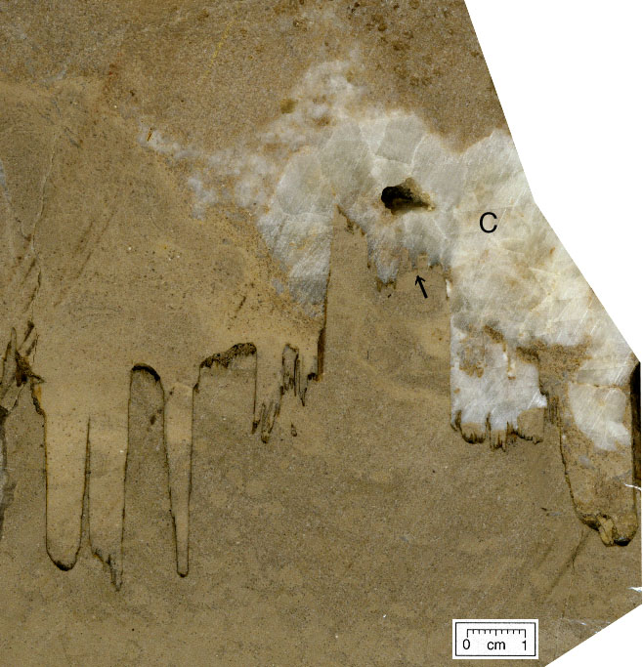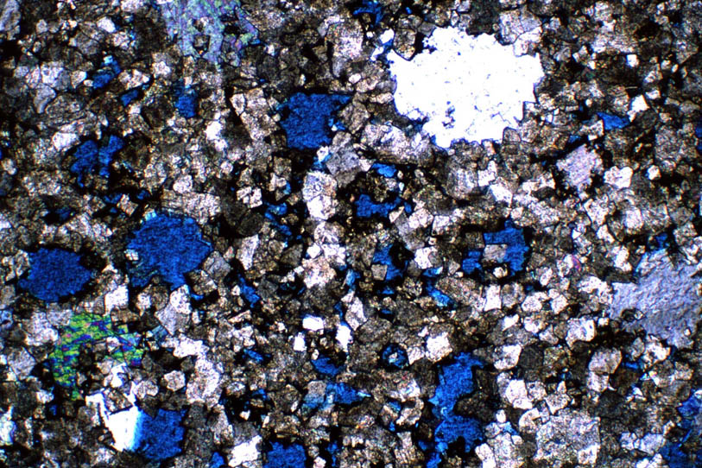

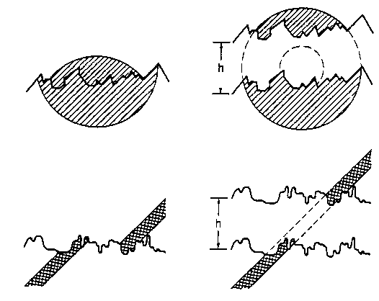

Carbonates may be rapidly cemented, especially in coastal environments, as a result of rapid changes in water chemistry. Beachrock, for example, forms quickly due to the evaporation of seawater on beaches that result in a loss of CO₂. Shallow subtidal areas with high rates of evaporation also result in hardgrounds, which are unconformities formed during times of non-deposition

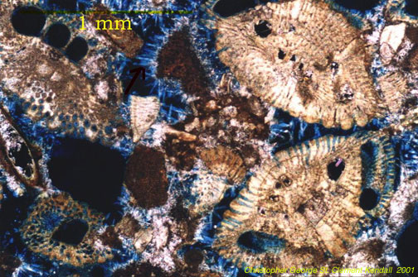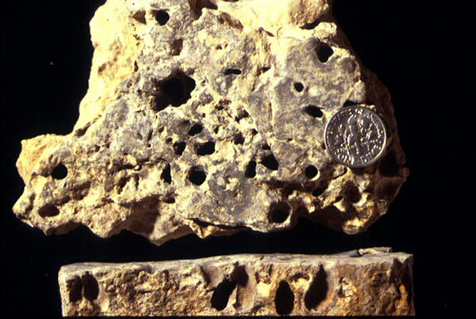

Various types of carbonate cement have been observed and described, including drusy, blocky, and rim types.

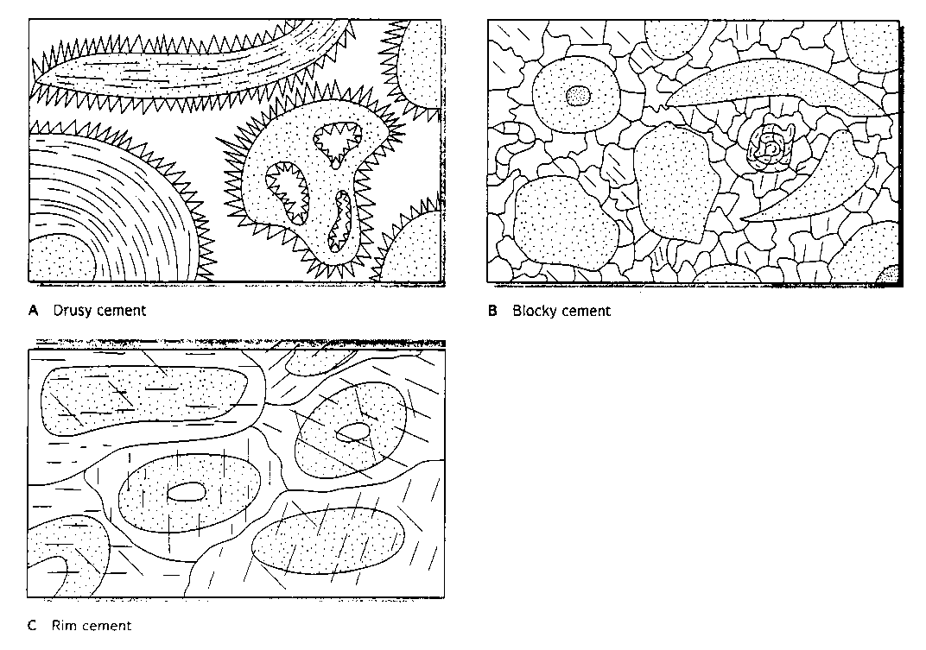

Syntaxial – if cement is in optical continuity with the pre-existing grain (goes to extinction as you sweep the polars across the thin section)

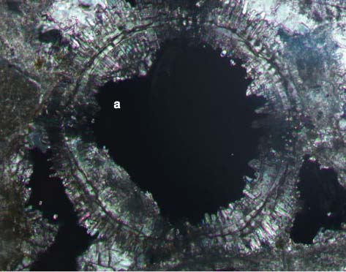

Drusy

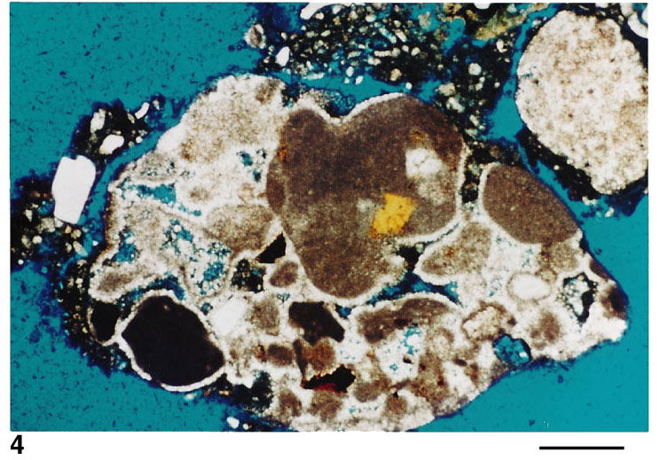

Blocky

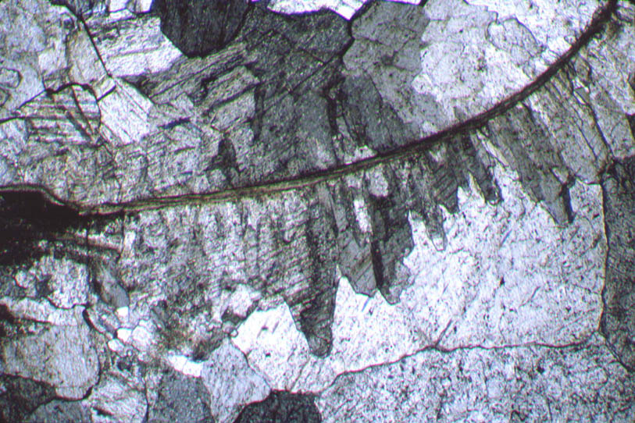

Neomorphism – the various diagenetic processes of recrystallization

Vadose and phreatic zone cements

Fresh (or meteoric) waters flowing through limestone can result in the formation of low-Mg cements. Cement types can be different in each zone. In the vadose zone meniscus and stalctite cements dominate while in the phreatic zone drusy and block cements are common.



