G342 Sedimentation and Stratigraphy
Lecture 21: geochronology
5 May 2005
Assoc. Prof. A. Jay Kaufman

Everyone is required to fill out the on-line course evaluation. Please do this as soon as possible. Undergraduate director John Merck will provide me with a list of respondents, who will receive extra credit on their final examination.

https://www.courses.umd.edu/online_evaluation
Geochronology

All we have learned about thus far is relative dating. Today we will discuss aspects of numerical (sometimes referred to as absolute) dating. Determining the numerical ages on ancient rocks became possible through the discovery of radioactive decay in the early 20th century, starting with Marie Curie’s discovery of radium. Although most radiometric studies are conducted on igneous and metamorphic rocks, the understanding of geochronology is essential to stratigraphy.



Lacking a mass spectrometer, however, some geoscientists have gone to the effort of counting varves in glacial lakes and in ice to determine numerical ages. Deep drill cores in ice from Greenland and Antarctica have captured ice layers dating back over 180,000 years.

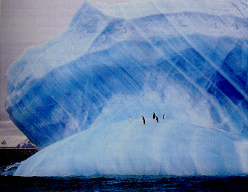

Alternatively, dendrochronology is the study of the annual variability of tree ring widths, which has been extended back to 8000 years ago. The study of trees provides climate information regarding temperature, runoff, precipitation, and soil moisture.

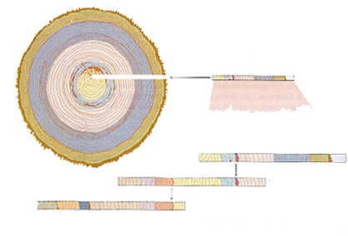

Radiometric techniques rely on the decay of radioactive elements and counting the parent and daughter products. These different techniques rely on different half-lives for different radioactive elements, so they fit different stratigraphic bandwidths. Similarly, they require separate materials, and thus are appropriate for different circumstances.

Parent-Daughter | Typical materials | Half Life | Typical Range | Other
Carbon (¹⁴C) – Nitrogen (¹⁴N) | Charcoal, plant material | 5730 | 0-30,000 (60,000 rarely) | High precision; uncertainty in <2000 years
Potassium (³⁹K) – Argon (⁴⁰Ar) | Feldspars, micas, ashes | 1.3 billion | 100,000 – 5 Ga (50,000 rarely) | Usually ⁴⁰Ar/³⁹Ar today
Uranium (²³⁸U) – Lead (²⁰⁶Pb) | Zircon, Monazite, Badellyite | 4.5 billion | > 10 Ma | Usually done in concert with ²³⁵U/²⁰⁷Pb
Uranium (²³⁴U) – Thorium (²³⁰Th) | Carbonates | 25,000 | 0 – 200,000 | One of many in Uranium Series dating
Rubidium (⁸⁷Rb) – Strontium (⁸⁷Sr) | Many minerals and rock types | 47 billion | > 10 Ma | Old technique – rarely used

Other (less quantitative) radiometric age techniques

However, there is a big gap between radiocarbon dating and ⁴⁰Ar/³⁹Ar, where many geomorphological and stratigraphic questions sit. As such, there are many other types of dating schemes with lower precisions, but with strong capabilities

thermoluminescence dating (TL) – The elements uranium and thorium in minerals, like zircon and quartz, decay to produce alpha particles. These can get trapped in the crystal lattice ultimately leading to saturation. Since this is a background process the accumulation of alpha particles can be used to constrain the age of ambient minerals. Heat and light will release the trapped particles, producing luminescence, which can be quantified. If the minerals are pristine, one can expose them to light and heat and count their scintillation to get an age. The errors are large, but the technique is good for direct dating of river and beach sediments. Range: 5,000 – 300,000 yrs.

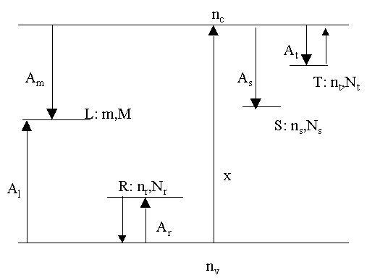

fission track – Alpha particle decay also makes tracks (holes) in crystals that can be seen and measured. Again, the rate of this process is understood, so one can count the tracks and get an age. The tracks close at relatively low temperatures (100 – 200ºC for different minerals), and as such, this technique is useful only for young, surface sediments. It DOES provide an uplift closure age of minerals (chiefly apatite). Range: 100,000 – 20 Ma

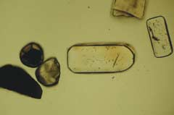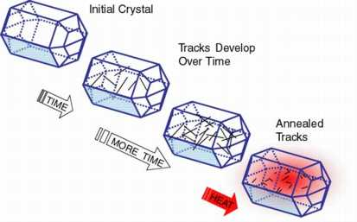

cosmogenic nuclide dating – The earth is constantly bombarded by cosmic rays, which create radioactive element during nuclear collisions (e.g., ¹⁴C). They do this with many elements, creating nuclides like ¹⁰Be, ²⁶Al, and ³⁹Cl. These nuclides appear in MANY different mineral types (e.g., olivine, quartz, calcite). As long as these minerals are exposed at the surface, they will collect cosmogenic elements until reaching a balance between the acquisition and decay rates. Estimates are more precise if multiple elements are cross-compared. This technique is good for calculating uplift and erosion rates. Range: 10,000 – 300,000.

amino acid racimization – Biological amino acids all have the same “handedness” – they spiral to the left. This spiraling, or chirality, changes through molecular kinetics after the organism dies. The process in sensitive to temperature and time, but if these can be constrained, and age can be determined by calculating a ration between left- and right-handed amino acids. This technique is good for dating shells and uplift terraces, although the uncertainties are often large. Range: 10,000 – 100,000 yrs.

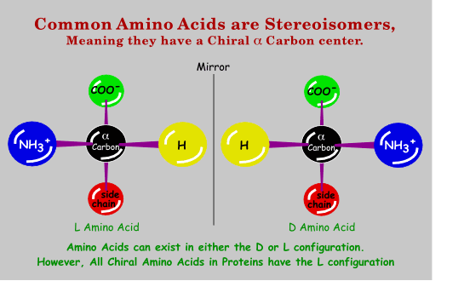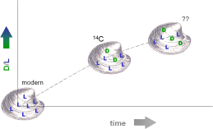

tephrachronology – Some volcanic eruptions have enormous ranges, and cover big chunks of the continent with ash. The ash may not contain any crystals, but will have distinct chemical signatures (e.g., trace element ratios). If these signatures are known, the ash can be analyzed and compared to a database of well calibrated ages. This requires clean samples and a good catalog of dated events, but is widely applied where these conditions are filled. Examples include the Bishop Tuff (0.78 Ma) and the Mazama ash (6000 yrs). Range: 0 – 2 Ma.

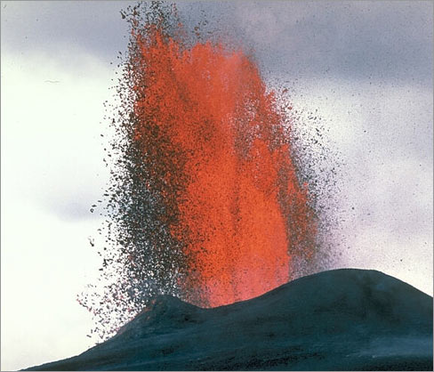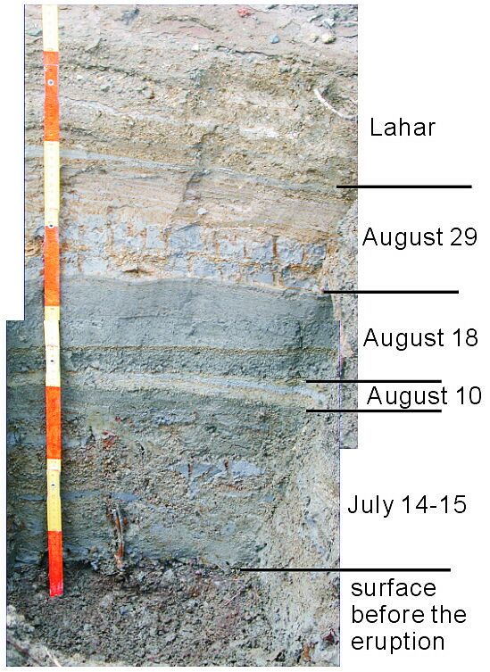

Astronomical Dating

The Earth changes its orbital patterns in repeated and predictable ways. This was recognized in the early 1940’s by Serbian mathematician, Milankovich. He calculated the type and rate of these changes, since called Milankovich cycles. These patterns affect the amount and distribution of sunlight coming to the eath’s surface, and thus change the climate. These signatures can be seen in the ice records, as well as in sedimentary records throughout much of earth history.

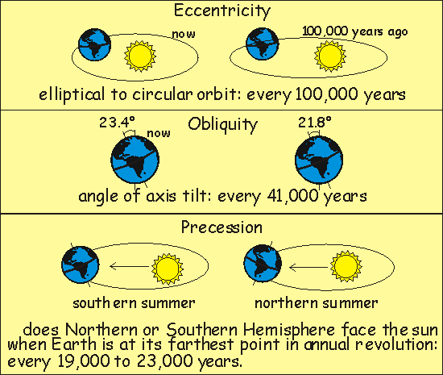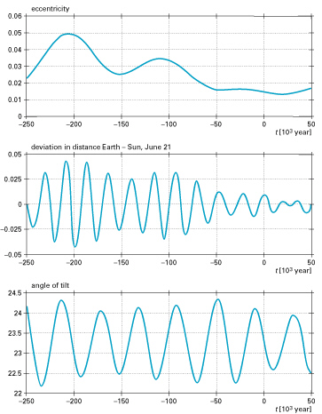

Milankovitch Cylces

The three orbital parameters of this cyclicity are listed here:

Name | Motion | Cycle duration | Other
Precession | Rolling like a top or gyroscope | 19 ky & 23 ky | Determines insolation in northern hemisphere
Obliquity | Changing tilt of earth’s rotational axis | 41 ky | Changes are small (21.8-24.4)
Eccentricity | Orbit becomes more or less elliptical | 100 ky, 119 ky, 400 ky. | As much as 30% changes

These cycles produce changes in insolation, or how much sun strikes the continents where and at what time (e.g., summer vs. winter). Insolation changes alter the rate of ice melting and evaporation, both of which change the volumes and distribution of water in the ocean. Eustatic sea-level fluctuations ar the result.

Sedimentary record of Milankovitch Cyclicity

Changes in sea level or lake level obviously change stratigraphic systems by changing accommodation space. However, changes in weathering rates, amounts, and sediment supply commonly change in response to Milakovitch forcing, as does oceanic circulation. These changes combine to produce a wide variety of changes in the rate, character, and distribution of sediment accumulation. Because they are so sensitive to these changes, carbonates, deep-sea, and lake sediments are those most often studied to understand the Milankovitch signal.

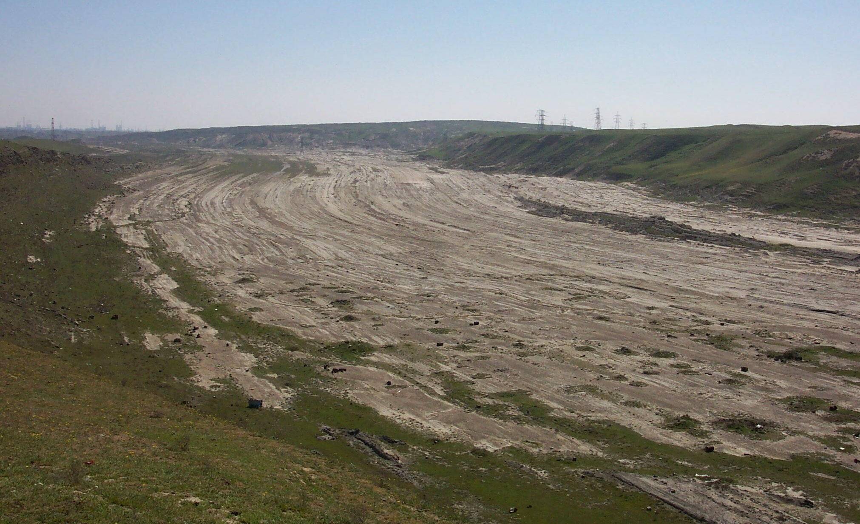
Astronomical Tuning

Since each Milakovitch cycle has a different period, and since these periods are not multiples of each other, there is a unique insolation character associated with any given stretch of time. Measurements from the ice cores and marine oceanographic record have produced a long record of these astronomical cycles (back >10 Ma)! If one know roughly where sediments sit within this chronology, it is possible to uniquely correlate a sedimentary package into this scheme and get precise age control and rates on sedimentary systems.

