GEOL 342 Sedimentation and Stratigraphy
Lecture 4: Sedimentary structures
8 February 2005
Assoc. Prof. A. Jay Kaufman

Sedimentary Structures

Sedimentary structures are probably the most critical means of interpreting sedimentary and post-depositional processes. Their recognition and application are key to defining depositional environments, geological history, and surface processes.

Types of Sedimentary Structures

Many different sedimentary structures correspond to different types of formation. They all reflect a series of processes: physical, chemical, and biological. We will discuss mostly the physical here; in later lasses we’ll go into depth about some chemical and biological structures. Below is a list of the classic break down associated with classification of structures:

Type | Class | Key processes | Some examples
Physical | Constructional | Flow of currents & sedimentary settling | Ripples, dunes, antidunes, hummocks; normal grading, clast imbrication; lamination
 | Erosional | Flow of currents (in excess of deposition) | Scours, flutes, gutters
 | External action | Many | Tool marks, rain drops, desiccation cracks
 | Modifying | Post-depositional mobilization | Soft-sediment deformation, injections, flame structures, dishes
Biological | Constructional | Many | Reefs, stromatolites, termite mounds
 | Modifying | Many | Burrows, foot prints, roots
Chemical | Primary | Evaporation | Crystal casts & forms
 | Secondary | Dissolution & precipitation | Soil horizonization, vugs, karst

- Plane bedding

Three basic mechanisms can form plane bedding, including 1) sedimentation from suspension, 2) horizontal accretion from a moving bedload, and 3) encroachment into the lee of an obstacle. Fine scale bedding (< 1cm) is called lamination.

Where would one most likely expect to find plane bed laminations?

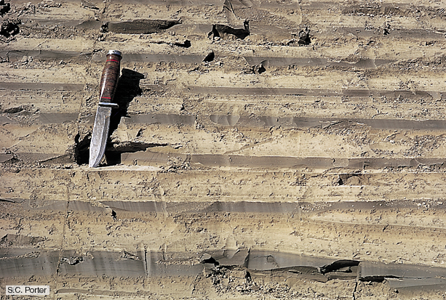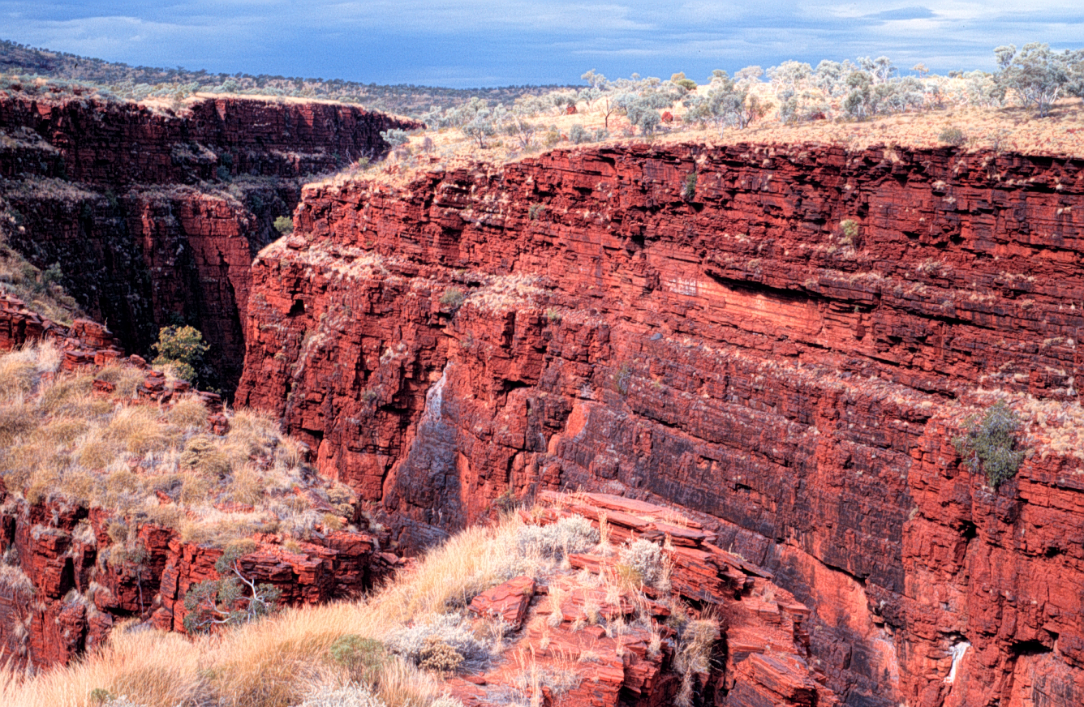

What factors might disrupt fine scale laminations in mudrocks?

- flocculation of clays – clumping before particles settle
- bioturbation – disturbance by organisms

- Bedforms generated by unidirections currents

As soon as flow attains a force sufficient to erode particles, sediments are transported in a set of structures on the surface of beds called bedforms. There is a predictable sequence of bedforms that depends on velocity, grains size and depth of flow. Temperature and viscosity (clay content) can also alter bedforms. Current ripples are generally assymetrical.

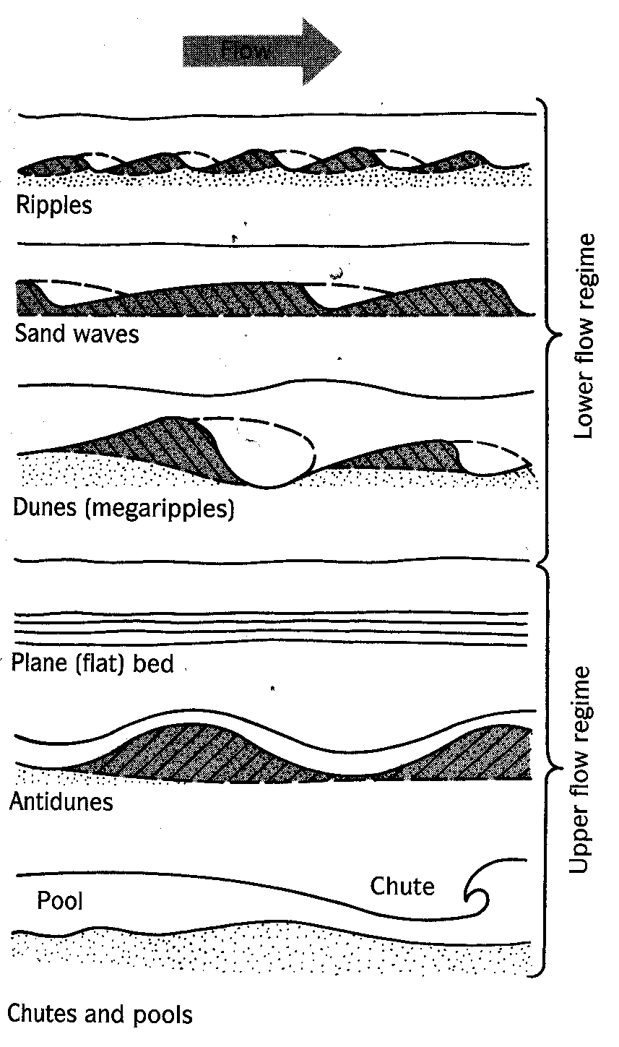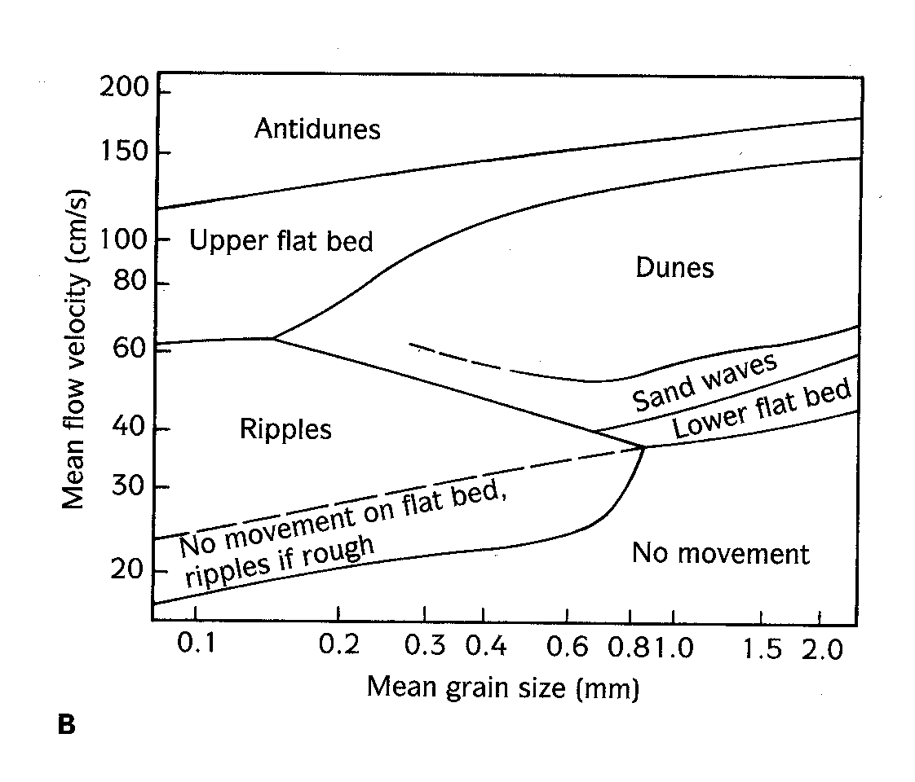

In sand finer than 0.7mm (coarse sand or silt) the first features to form are ripples. Generally their spacing is 10-20 mm or less, and their height is a few centimeters. As flow velocity increases the ripples enlarge to form sand waves and then dunes, which have spacing from 0.5 to 10m and heights of tens of centimeters to a meter or more.

Small irregularities in the bottom cause a slight turbulence as flow is diverted up and around them such that the flow over an obstacle no longer hugs the bottom, but separates from it at the point of flow separation. The point of flow reattachment is where most erosion occurs often forming troughs with long axes parallel to current flow. The zone of reverse circulation is an area of turbulence and backflow on the lee side of a ripple.

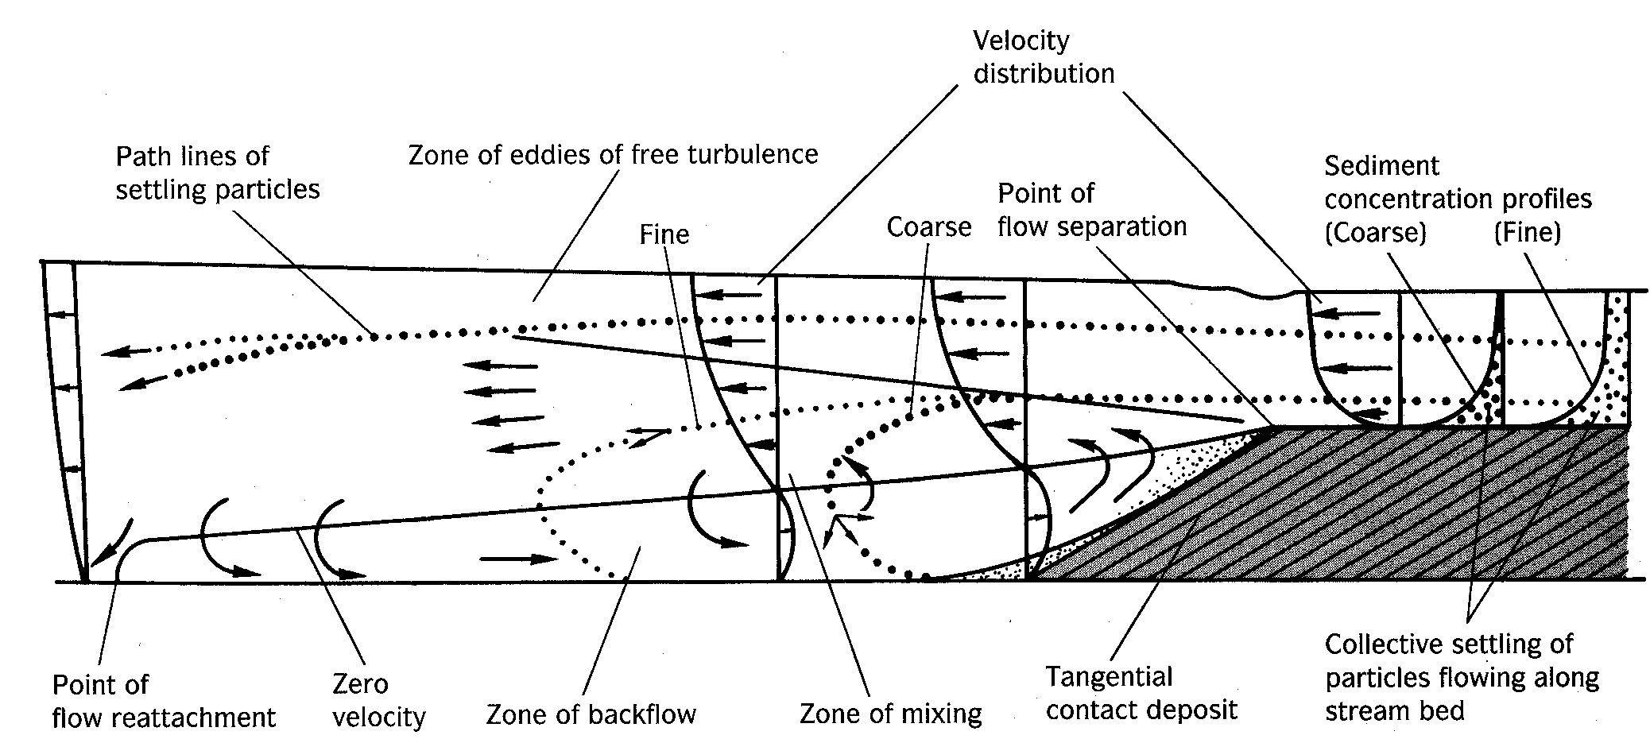

Sediment migrating up ripple avalanches down lee face to produces inclined forset beds that produce cross-bedding. These forms migrate downstream. The shape of the ripple depends on a balance between the bedload and deposition of suspended load such that if there is little suspended load the forests are steeper.

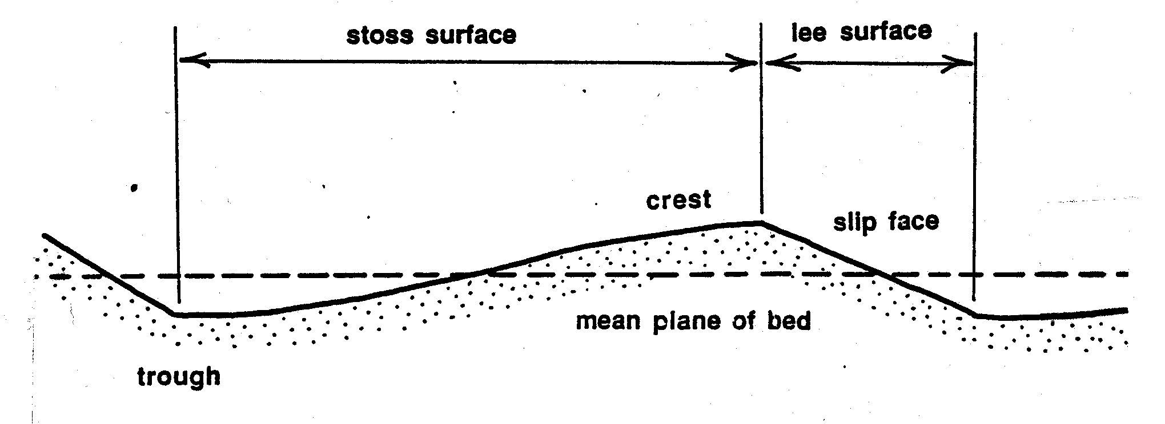

When current velocities are high turbulent flow turns to sheet flow (F_{R} > 1) and plane beds are formed. Antidunes are formed by even higher velocities – bedform in phase with surface waves and so they migrate by accretion on the upstream side.

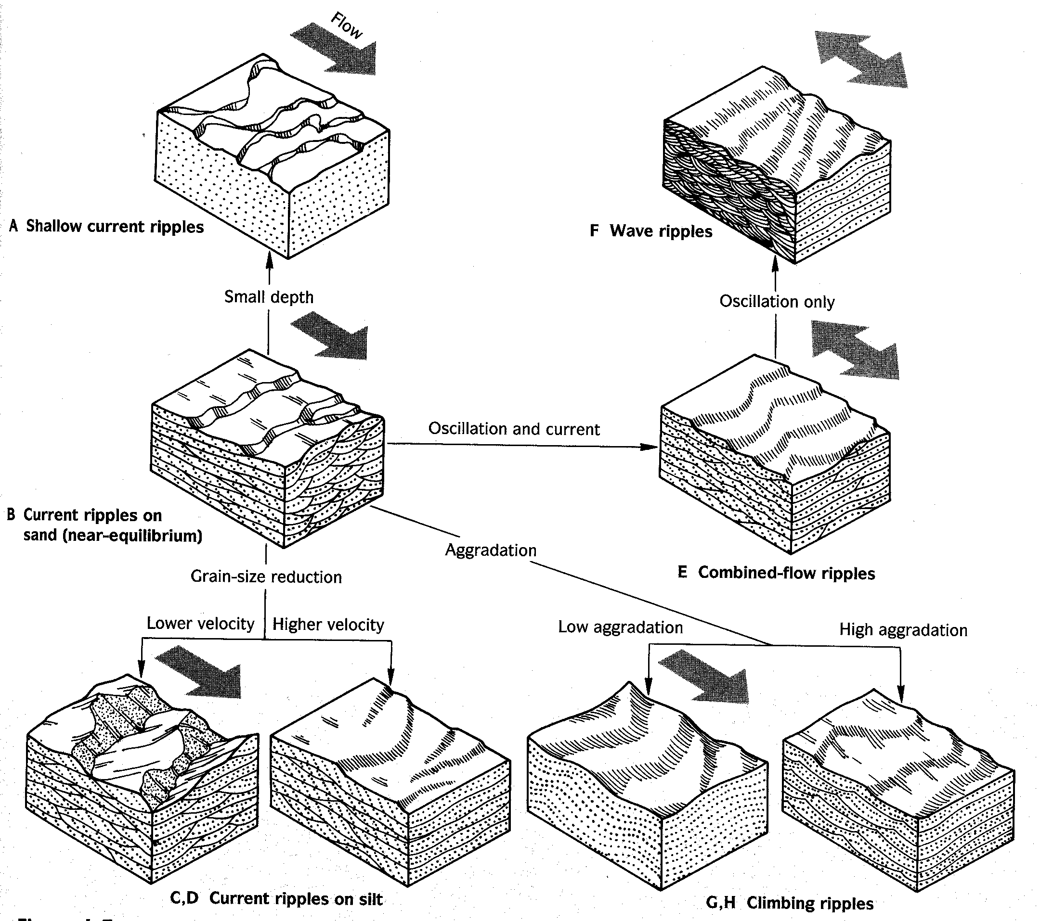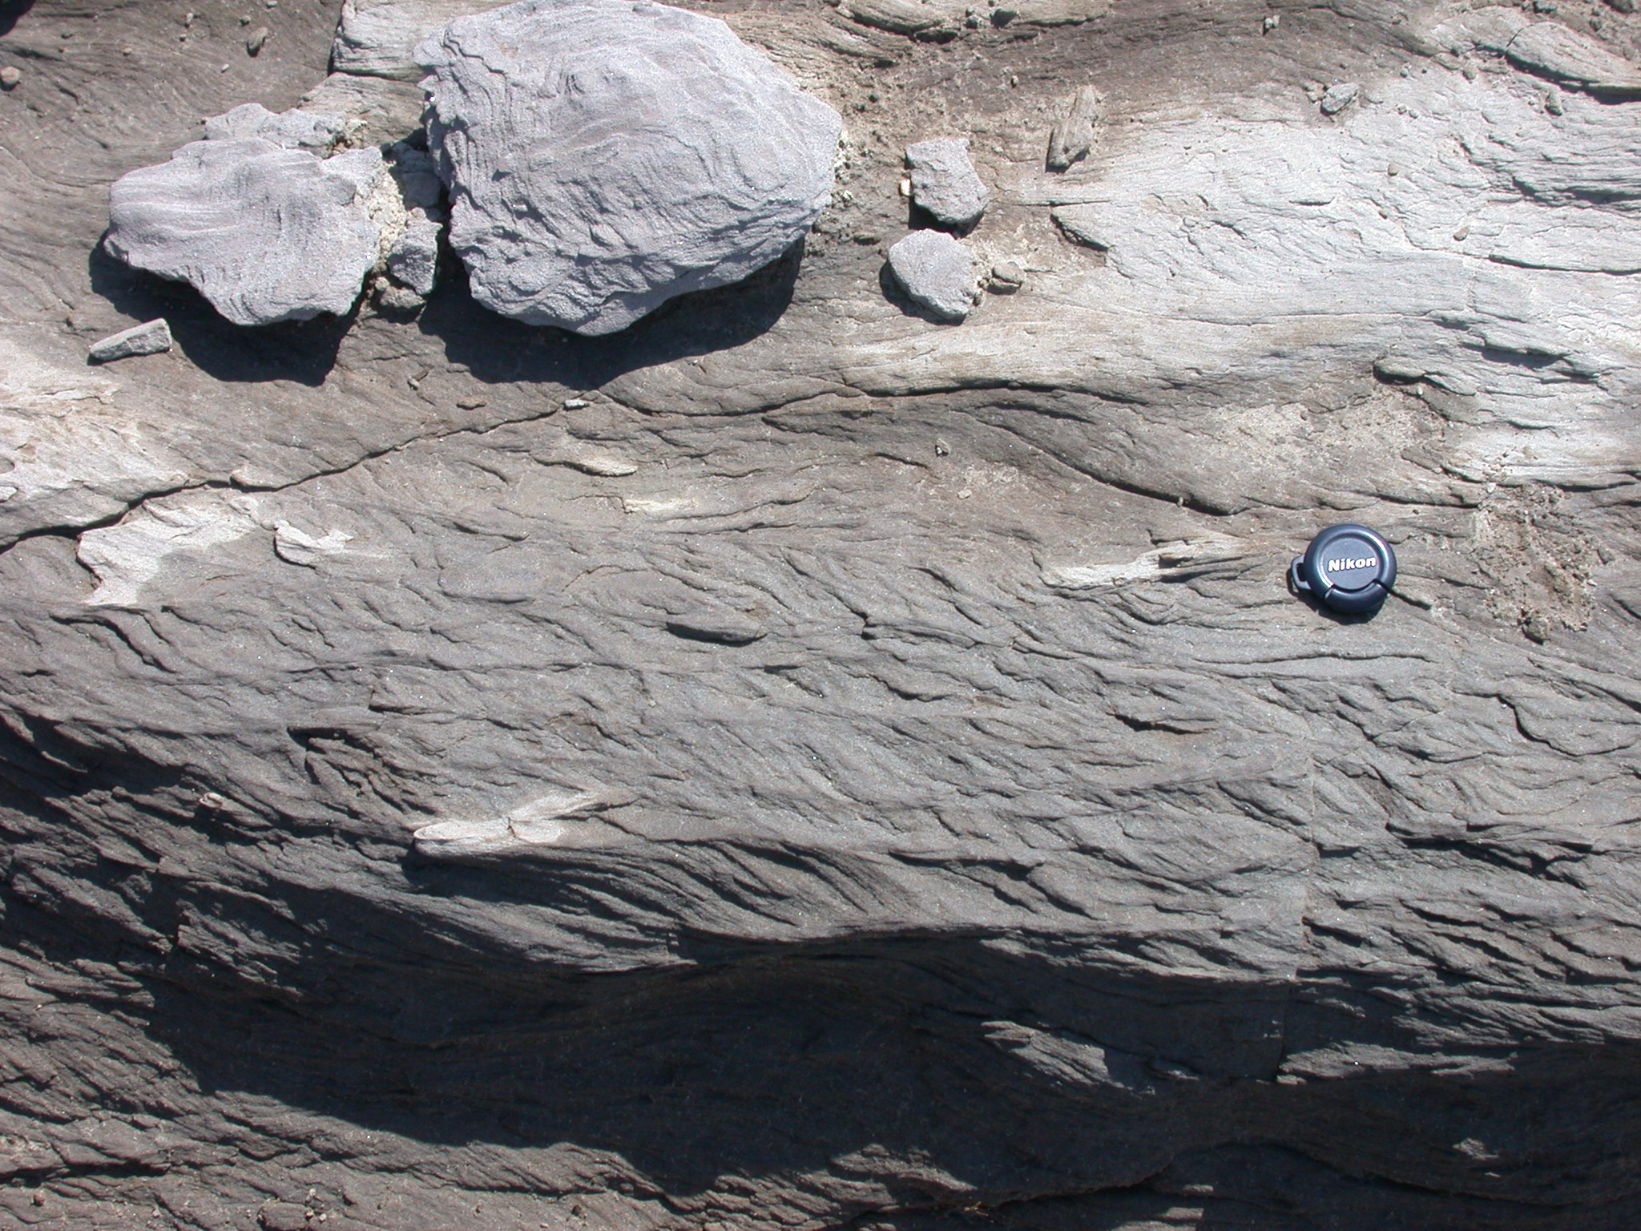

Often the migration of a ripple is interrupted and the ripple is eroded back and then buried by a new advancing bedform. Such an interruption produces a tiny erosional surface between cross-strata known as a reactivation surface.

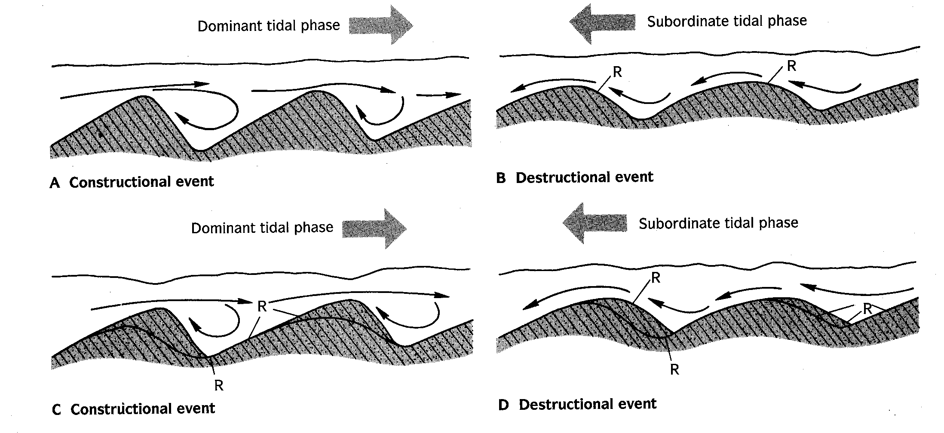

- Bedforms generated by multidirections currents

Wave ripples on beaches are formed in a similar manner to current ripples – a rotating eddy precedes a wave as it moves onshore, precipitating the sand load into troughs and ripples. As the wave crest passes, the eddy rises with the crest and disperses into the backwash. However, because of the bi-directional flow, wave ripples are often symmetrical with sharp peaks and broad troughs in contrast to current ripples

In marine environments dominated by tides, structures like herringbone cross-bedding and interference ripples are common. The most distinctive feature of tidal regions are caused by the mixing of sand and mud sized fractions to form lenticular, wavy, and flaser bedding.

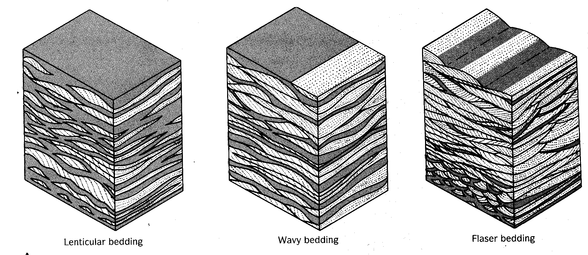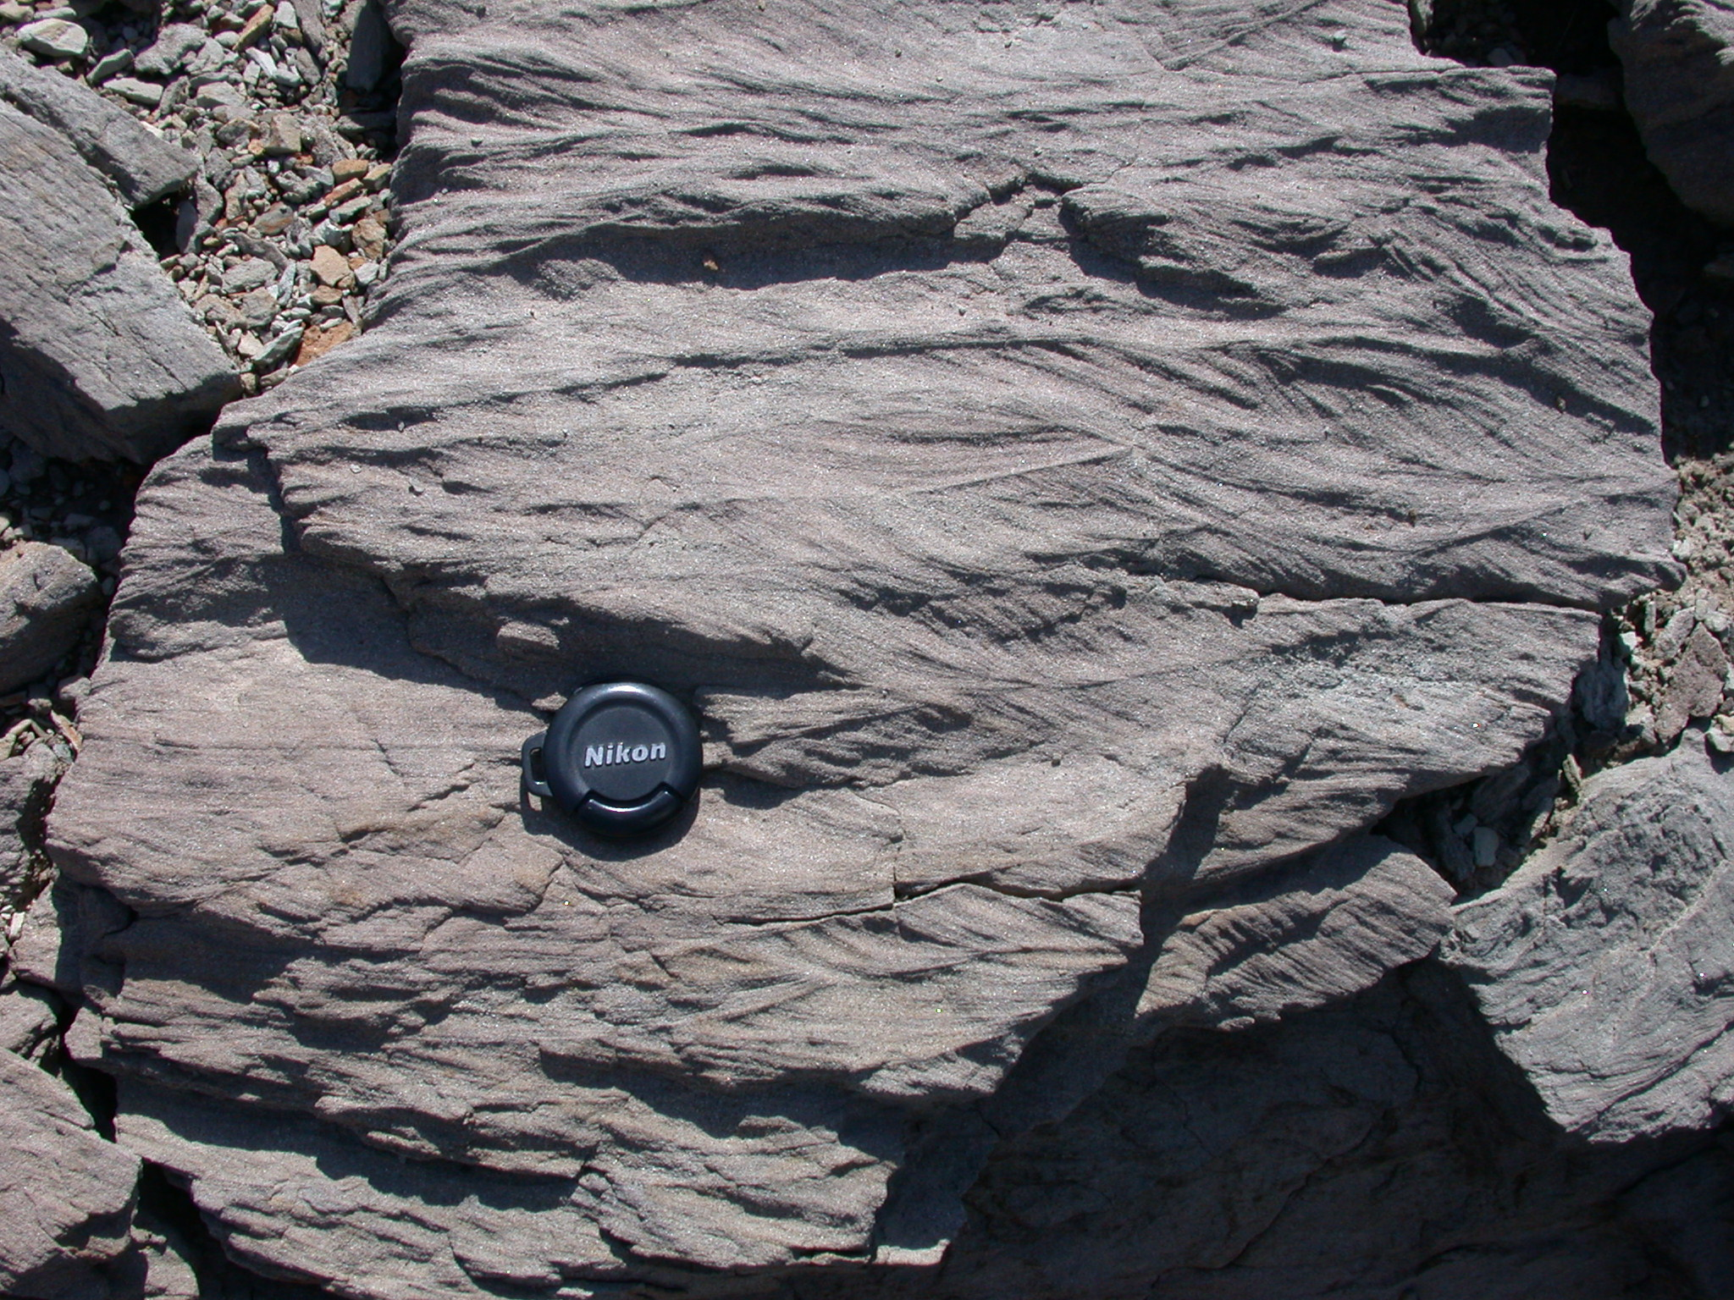

D. Bedding plane structures

Another class of sedimentary structures form on the interface between beds, usually on the exposed surface of a recently deposited bed before it is buried. These features are useful because they indicate current direction and post-depositional deformation of the sediment. These include 1) sole marks formed by currents

flute cast – elongate teardrop shaped depression that tapers upstream
tool mark – indention of the cohesive mud bottom by a “tool”

2) mudcracks, and 3) raindrop impressions. Geopetal structures indicate the top of beds, and these can be found as:

-scoured tops of ripple crests
-graded bedding
-infilling of fossils
-sole marks

Soft sediment deformation structures are usually due to a density instability between different sediments layers. The most common are load structures, irregular bulbous features formed with a denser material has sunk into a less dense material.

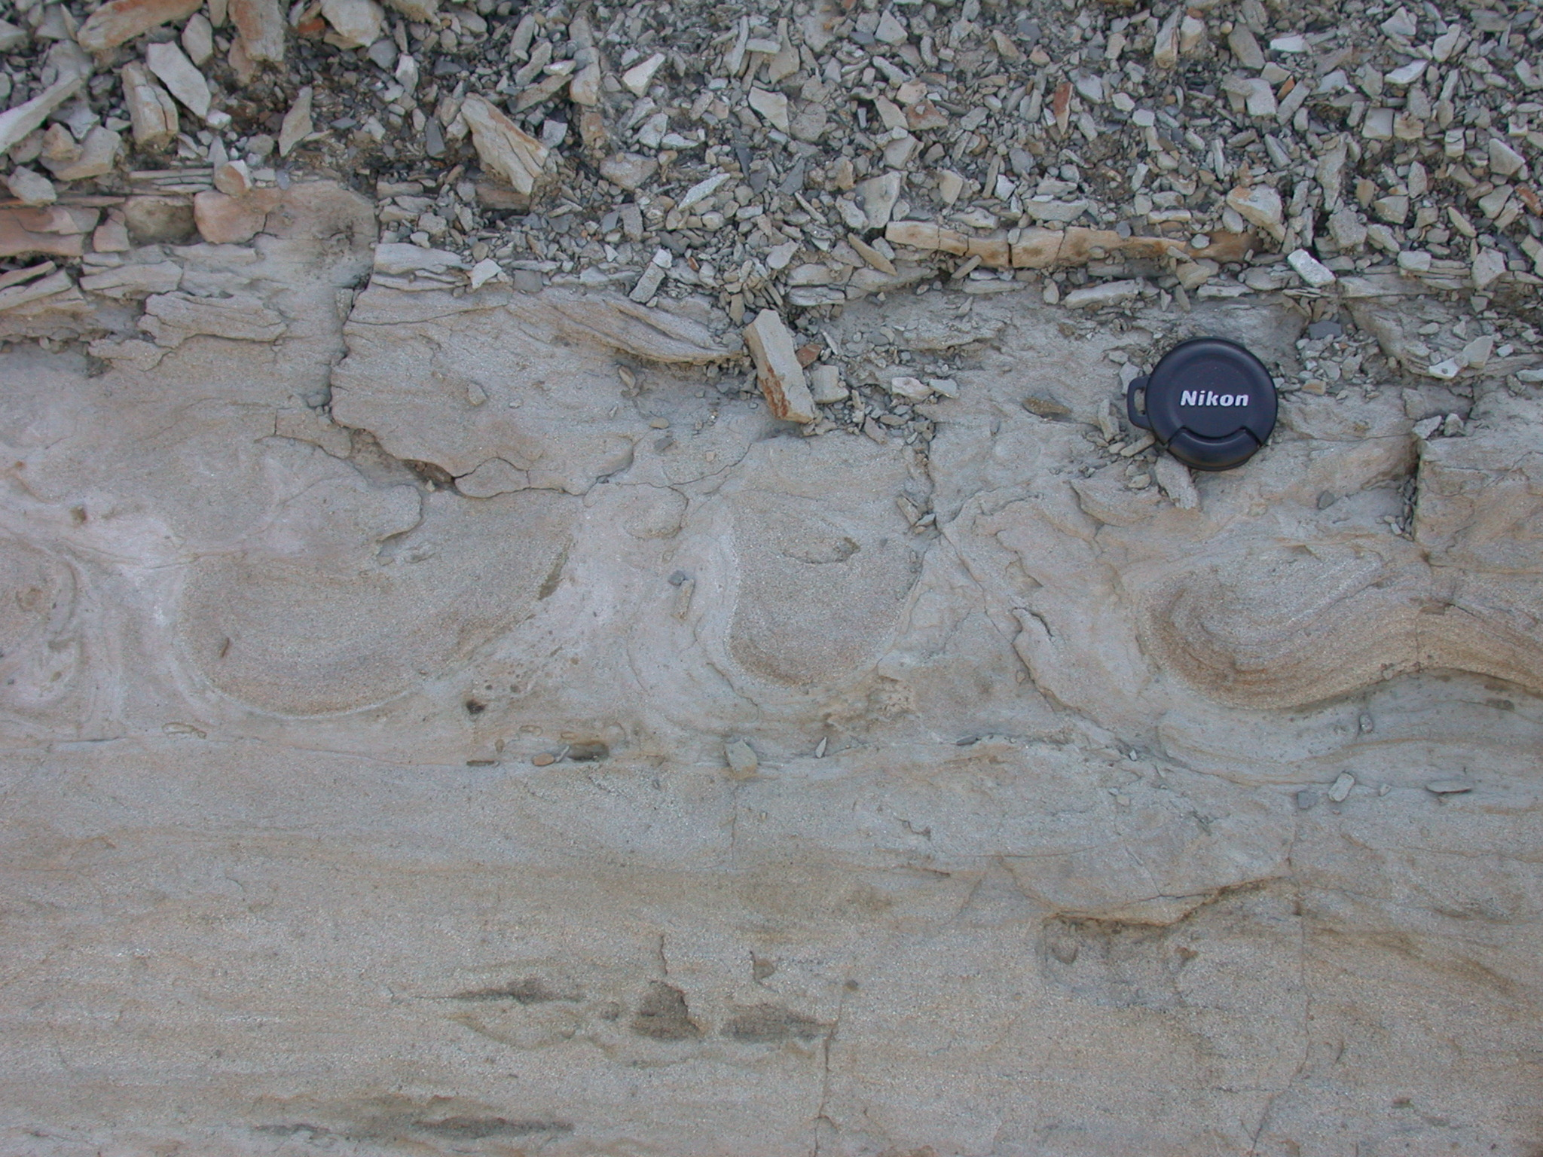

Sometimes balls of sand load downward into mud and are pinched off to form pseudonodules or “ball and pillow” structures. Tongue like protuberances of mud into overlying soft sediment is known as flame structures. Finally, deformation of soft sediment leads to convolute bedding, suggesting intense structural deformation.



