1 September 2005

G436 Biogeochemistry
Assoc. Prof. A. Jay Kaufman

Introduction to Principles of Biogeochemistry

Slide 1: Important events in the evolution of life

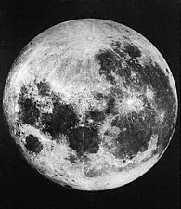

Slide 2: Important events in the evolution of life

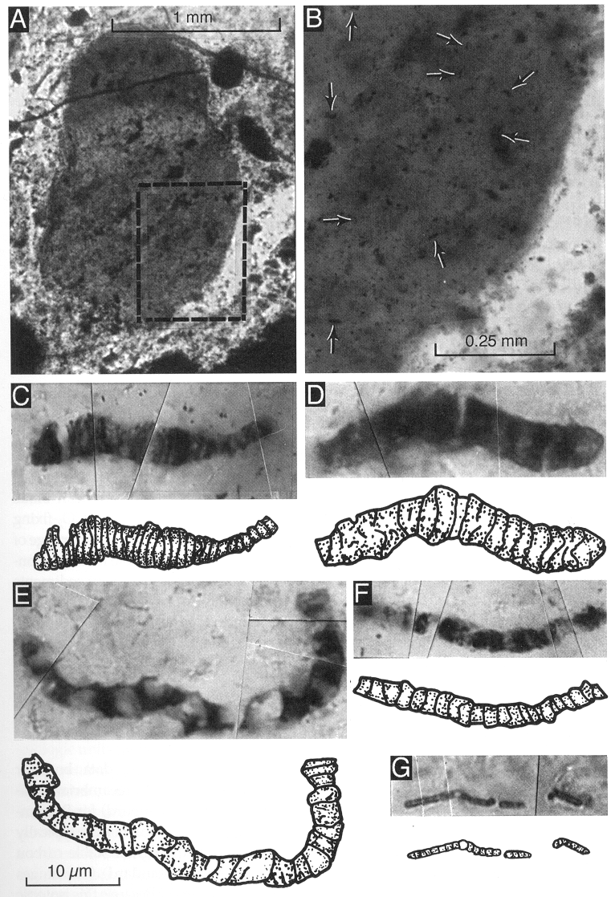

Slide 3: Important events in the evolution of life

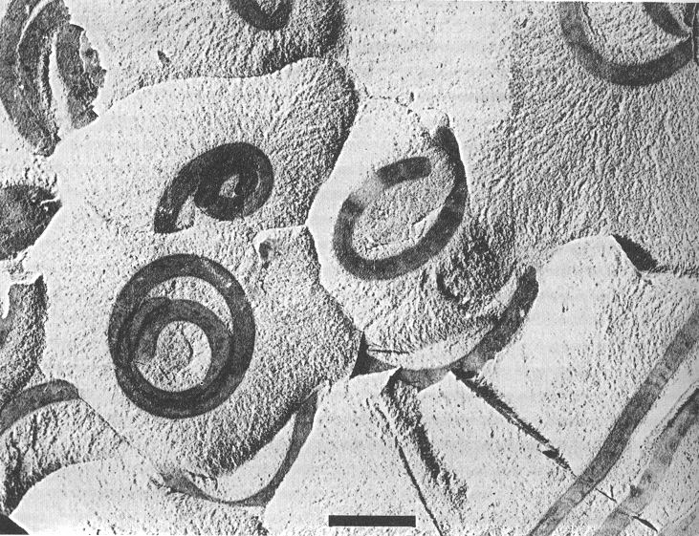

Slide 4: Important events in the evolution of life

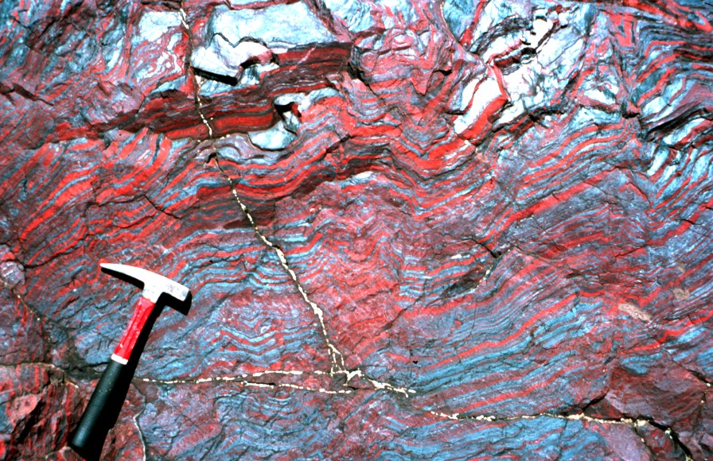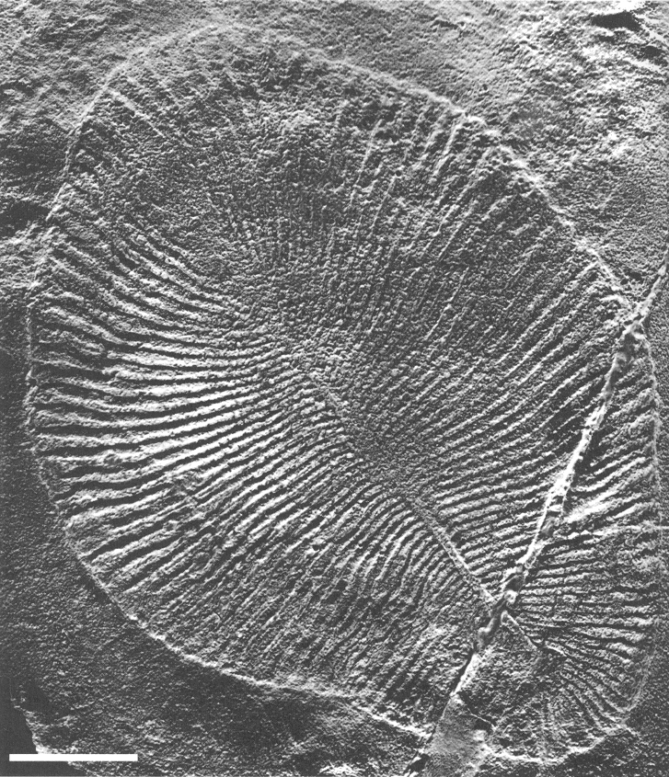

Slide 5: 16S RNA

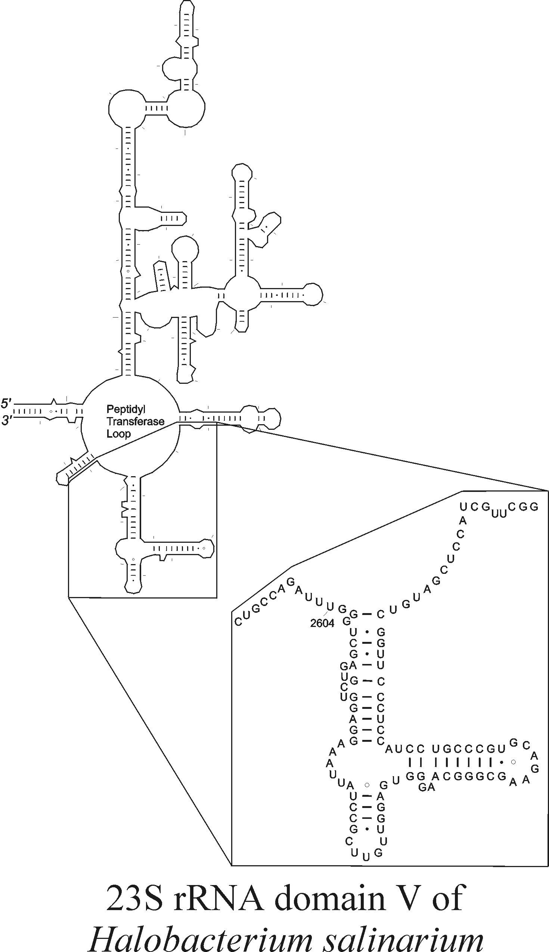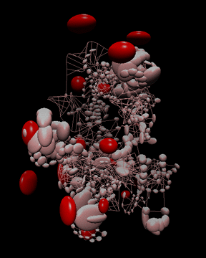

Slide 6: The universal tree of life

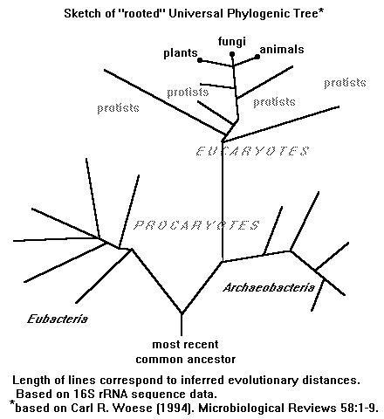

Slide 7: The universal tree of life

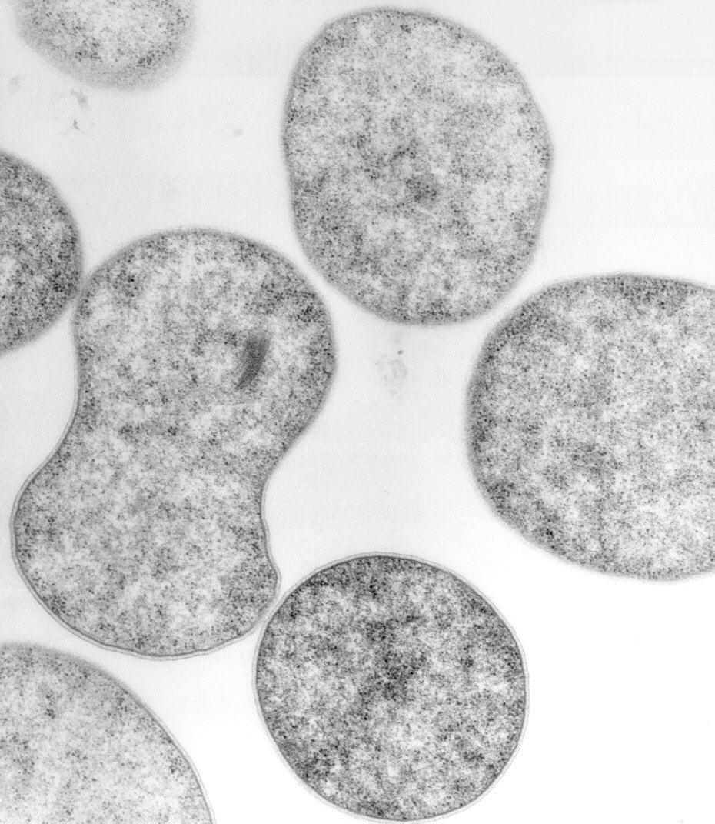

Slide 8: The Tree of Life and Biochemical Pathways of Carbon Fixation

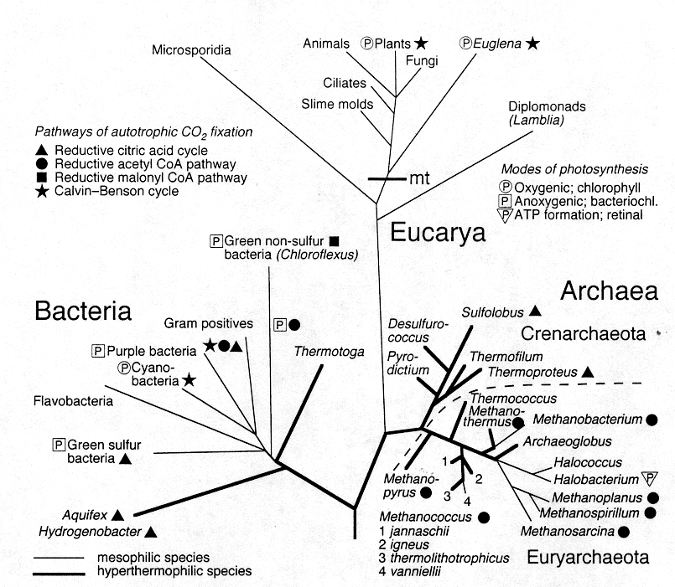

Slide 9: A Geological Timetable for Life

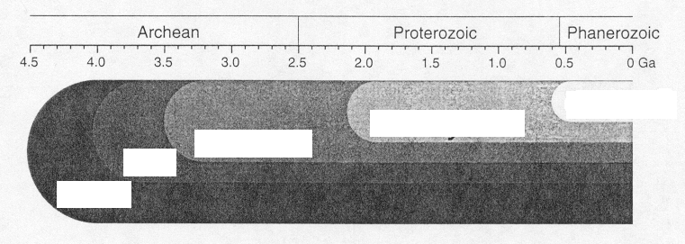
Earth
Life
Prokaryotes
Eukaryotes
Animals

Slide 10: The pre-Biotic Environment



