6 October 2004

G436 Biogeochemistry

Assoc. Prof. A. Jay Kaufman

Readings: Bacterial Biogeochemistry, chapter 6
Schulz et al. (1999) Dense Populations of a Giant Sulfur Bacterium in Namibian Shelf Sediments. Science 284, p.493-495

Microbial mats and stratified water columns

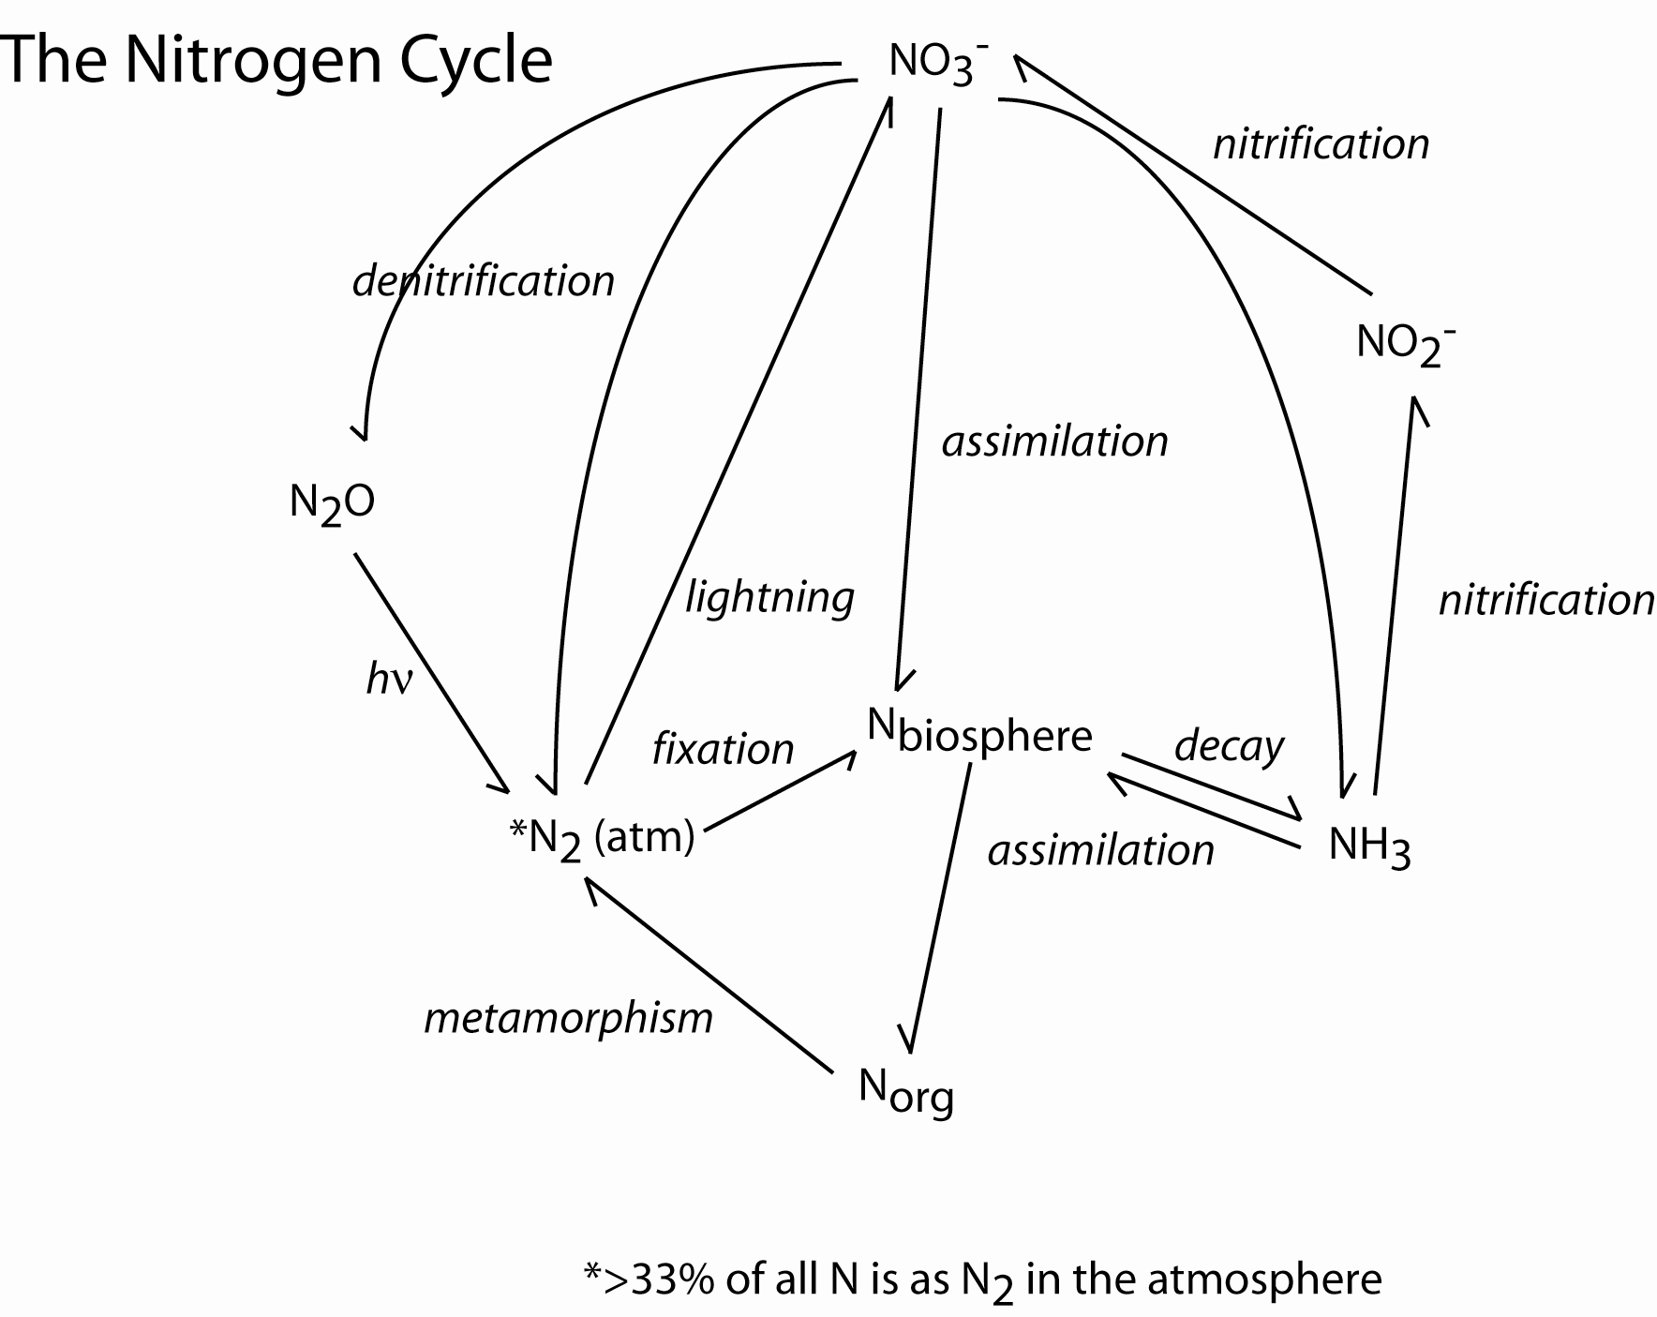
- fixation

N₂ (atm) → N_{biosphere}

This process only takes place in rigorous anaerobic environments, usually ‘heterocycsts’ in roots and specialized structures in cyanobacteria that keep out oxygen. It is likely to be a closed system where fixation is quantitative and no isotope effect is expected (ε ~ 0 to -4‰)

- decay

N_{biosphere} → NH₄⁺

(ε ~ -10‰ due to transamination reactions)

- nitrification

Nitrifiers are very important in nature as they oxidize ammonia to nitrite (e.g. Nitrosomonas, Nitrocystis)

2NH₄⁺ + 3O₂ → 2NO₂⁻ + 4H⁺ + 2H₂O

And then nitrite is further oxidixed in the presence of O2 to nitrate (e.g. Nitrobacter, Nitrococcus, Nitrospina).

2NO₂⁻ + O₂ → NO₃⁻

(ε ~ 0‰)

- denitrification

Nitrate reduction (or denitrification) is performed by facultative anaerobes including Escherichia, Bacillus and Pseudomonas.

5CH₂O + 4NO₃⁻ + 4H⁺ → 5CO₂ + 2N₂ + 7H₂O

(ε ~ -40‰)

However, the reduction to N₂ is often incomplete, resulting in NO or N₂O as metabolites. Some sulfur bacteria (see below) are able to use nitrate rather than O₂ as a terminal electron acceptor.

Microbial mats

Mat communities are dominated by photosynthetic and chemotrophic bacteria and bacterial processes that develop on surfaces in aquatic environments where nutrients are cycled by vertical diffusion. These mats are stratified with respect to the functional types of bacteria, which exhibit a high degree of mutual interaction. The coherence of the mats is due to the presence of filamentous prokaryotes and mucous polymers.

Mats are unlikely to survive if macrofaunal grazers and bioturbators are present, so they typically form in hypersaline or anaerobic environments, or in extreme cold.

While they are generally ephemeral phenomenon, some cyanobacterial mats may be permanent structures that accumulate layer upon layer of carbonate and organic matter (growth rates may be as high as 1 mm/year) eventually resulting in the formation of stromatolites. Recent microbial mats are considered to be analogues for the oldest biotic communities on Earth.

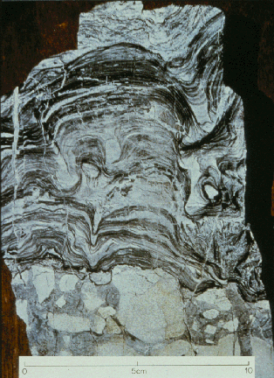

Colorless sulfur bacteria

One group of lithotrophic bacteria that typically form mats and is ubiquitous in aquatic environments is the colorless sulfur bacteria. These organisms oxidize reduced sulfur compounds with molecular oxygen (or nitrate), and are thus microaerophiles (preferring about 5% pO₂).

HS⁻ + 2O₂ → SO₄²⁻ + H⁺

These bacteria may also use Sº and S₂O₃⁻ as substrates when sulfide concentrations are limited.

Examples: Beggiatoa, Thiovulum

Colorless sulfur bacteria are a common component of cyanobacterial mats, lying below the aerobic top layers during the day when O₂ penetration reduces sulfide concentrations. At night when the cyanobacteria are dormant, sulfide concentrations increase and colorless sulfide bacteria migrate upward. Permanent colonies of colorless sulfur bacteria develop in deeper waters in darkness or dim light where O₂ is limited, but where there are large fluxes of organic matter.

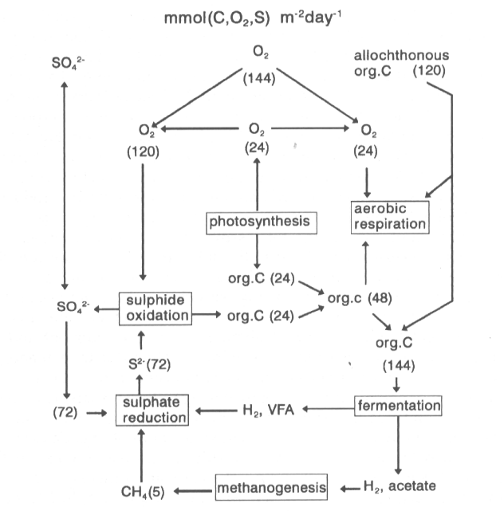

The largest bacterium ever found is colorless sulfur bacteria that grow as a string of white beads large enough to be visible to the naked eye (see Schultz et al., 1999). The bacteria shine white because of the presence of large elemental sulfur inclusions. It has been named Thiomargarita namibiensis (for sulphur pearl of Namibia). Genetic sequencing indicates Thiomargarita is closely related to the marine species of the filamentous sulphur bacteria, Thioploca and Beggiatoa. The extremely large forms of Thiomargarita have an average diameter of 180 microns but can reach diameters of up to 750 microns. These organisms are nitrate-respiring sulfide-oxidizers. Large central vacuoles accumulate high nitrate concentrations (0.1-0.8 molar), and the cytoplasm is restricted to a thin outer layer.

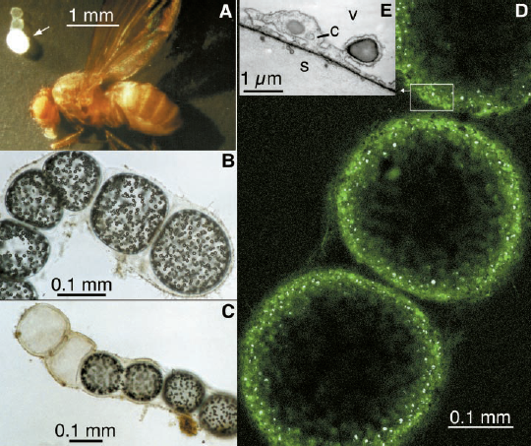

Because nitrate is limiting in the environment where these bacteria live, they are literally “holding their breath” while they wait for something to stir up off the ocean floor. Since they must store nitrate, this may be the reason they have grown so large. Unlike their close relatives, Thioploca and Beggiatoa, Thiomargarita are not mobile and cannot follow fluctuating sulfide and nitrate gradients. Instead, they stay put and wait for the return of more favorable conditions. The Namibia shelf off the southwest African coast is an area of strong upwelling, with high plankton productivity and oxygen depleted bottom water, and bacterial degradation of this organic material leads to high sulfide levels in the sediments.

Geological sources of sulfide provide nutrients for colorless sulfide oxidizing bacteria in some amazing places, like in hydrothermal vent communities. The bacteria grow in thick, white-to-yellow-to-pink mats that cover all the hard surfaces around the vents from rocks to clam shells to tubeworm tubes. Many of the animals living at vents eat these sulfide-oxidizing bacteria – the first case of animals that depend on chemosynthesis rather than photosynthesis for their ultimate source of energy. One of the most significant events in the earth and life sciences in this century was the realization that hydrothermal activity can support life in the absence of sunlight.

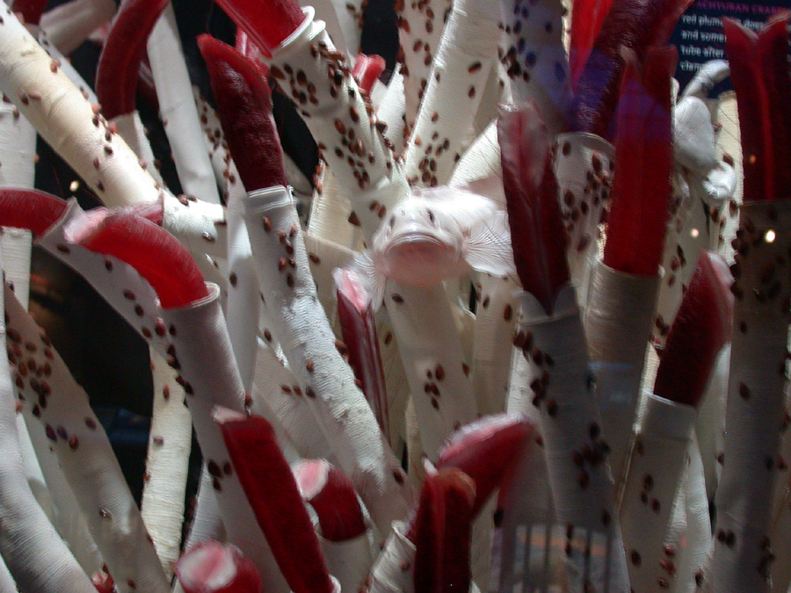
The tube worm is the most unique organism of the hydrothermal vent communities. This animal can reach a length of several meters and live in a chitin tube from which the red tipped end of their body protrudes to catch food and nutrients. The real mystery about this creature is that it has no mouth, stomach, or anus. The red end of their bodies directly absorbs food and transports it to the necessary tissues throughout the body. It has been determined that the tube worms contain modified hemoglobin in their blood to allow them to live in the acrimonious conditions of the hydrothermal vents.
Cyanobacterial mats
Most of the studied mats are those dominated by filamentous cyanobacteria in environments that discourage grazing by spineless invertebrates. These show characteristic color bands ranging from green to red or purple to black, which crudely reflects the zonation of phototrophic processes.

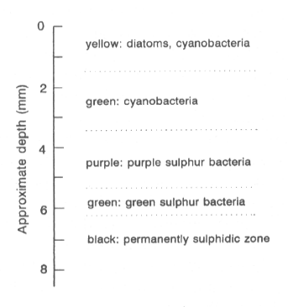
The layering also reflects the types of light gathering pigments including, chlorophyll a, phycobillins, and bacteriochlorophyll a and b. The purple layer is dominated by purple sulfur bacteria (e.g. Thiocapsa, Tiopedia, Chromatium), which may be the oldest known photoautotrophs, but these do not produce oxygen as a byproduct since they gain their electrons by splitting hydrogen sulfide rather than water (some are tolerant and others intolerant to the presence of O₂).

2H⁺ + 2HS⁻ + CO₂ → CH₂O + 2Sº + H₂O

and

5H₂O + 2Sº + 3CO₂ → 3CH₂O + 2SO₄²⁻ + 4H⁺

[Overhead of purple sulfur bacteria]

The green sulfur bacteria (e.g. Chlorobium, Pelochramtium) have bacteriochlorophyll c or d. They are autotrophic, strictly anaerobic organisms that use sulfide as an electron donor, but they only oxidize it to Sº, which is excreted. They live below the purple sulfur bacteria in mats or in anoxic water columns in the ocean.

The thickness of cyanobacterial mats is dependent on light penetration. Light generally can penetrate down to 3-4 mm (1% light irradiance, which is the lower limit for photosynthesis). Infra-red light can penetrate somewhat deeper; these wavelengths are preferentially utilized by bacteriochlorophyll.

Mineral cycling

Most of the energy flow in cyanobacterial mats is within the first cm of the surface; the slow anaerobic degredation in deeper layers plays a small role for mat metabolism. In the day the mat produces O₂ and at night it consumes O₂. The mineral cycles are relatively closed systems, although the loss of nitrogen due to the process of denitrification must be compensated by N fixation (by cyanobacteria and other bacteria).


