6 September 2005

G436 Biogeochemistry
Assoc. Prof. A. Jay Kaufman

Seven Clues to the Origin of Life

by A.G. Cairns-Smith

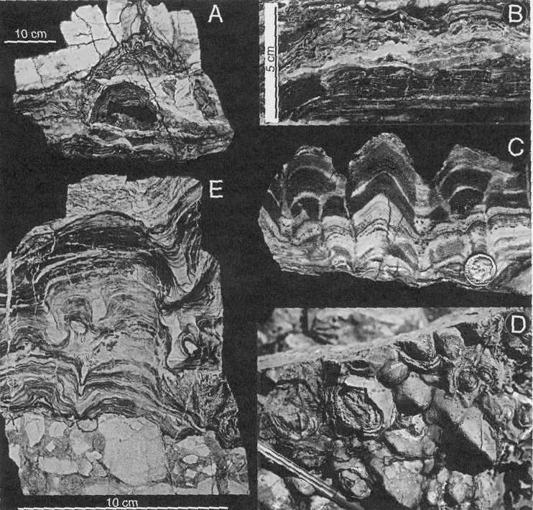

Clue #1 from Biology

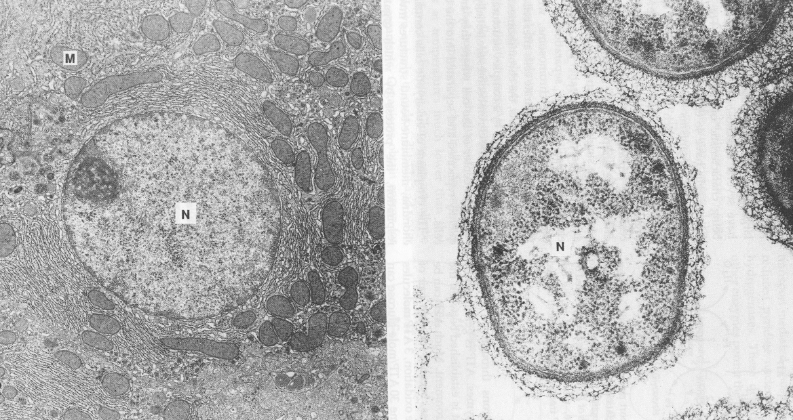

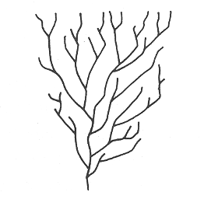

Clue #2 from Biochemistry
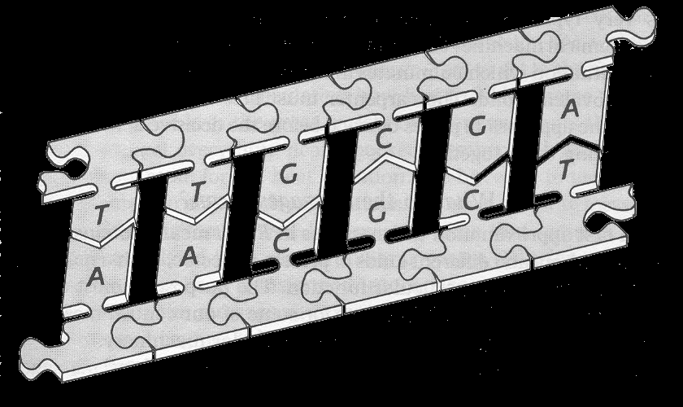

Clue #3 from the Building Trade
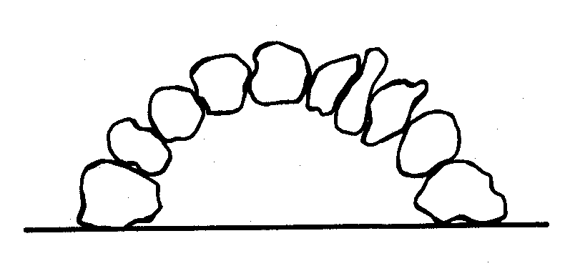

Clue #4 from the Nature of Ropes

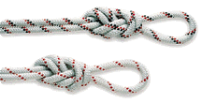

Clue #5 from the History of Technology
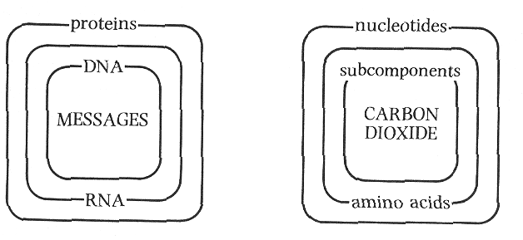

Clue #6 from Chemistry

Clue #7 from Geology
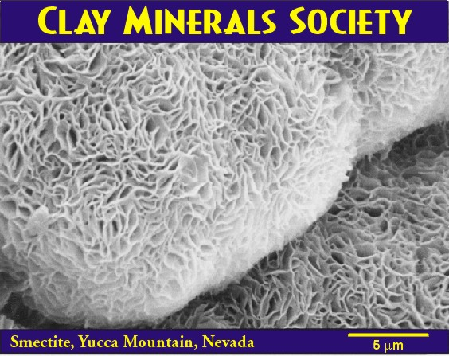
KAlSi₃O₈ + H⁺ = Al₂Si₂O₅(OH)₄ + K⁺ + H₄SiO₄

