8 September 2005

G436 Biogeochemistry

Assoc. Prof. A. Jay Kaufman

Origins and evolution of biogeochemical cycles

Prebiotic Earth and mineral cycles

Residence time: τ (time) = M (mass or volume)/ϕ_{in or out} (mass or volume/time)

Important characteristics of abiological cycles of elements include:

- acid-based (CO₂) weathering of uplifted crustal minerals

CO₂ + H₂O = H₂CO₃

2CO₂ + 3H₂O + CaSiO₃ = 2HCO₃⁻ + Ca²⁺ + H₄SiO₄

2NaAlSi₃O₈ + 2CO₂ + 11H₂O → Al₂Si₂O₅(OH)₄ + 2Na⁺ +2HCO₃⁻ + 4H₄SiO₄

- fluvial transport of elements released by weathering
- compositional changes of weathered materials due to changing chemical environments
- adsorption, exchange, precipitation and aggregation reactions
- metamorphic effects

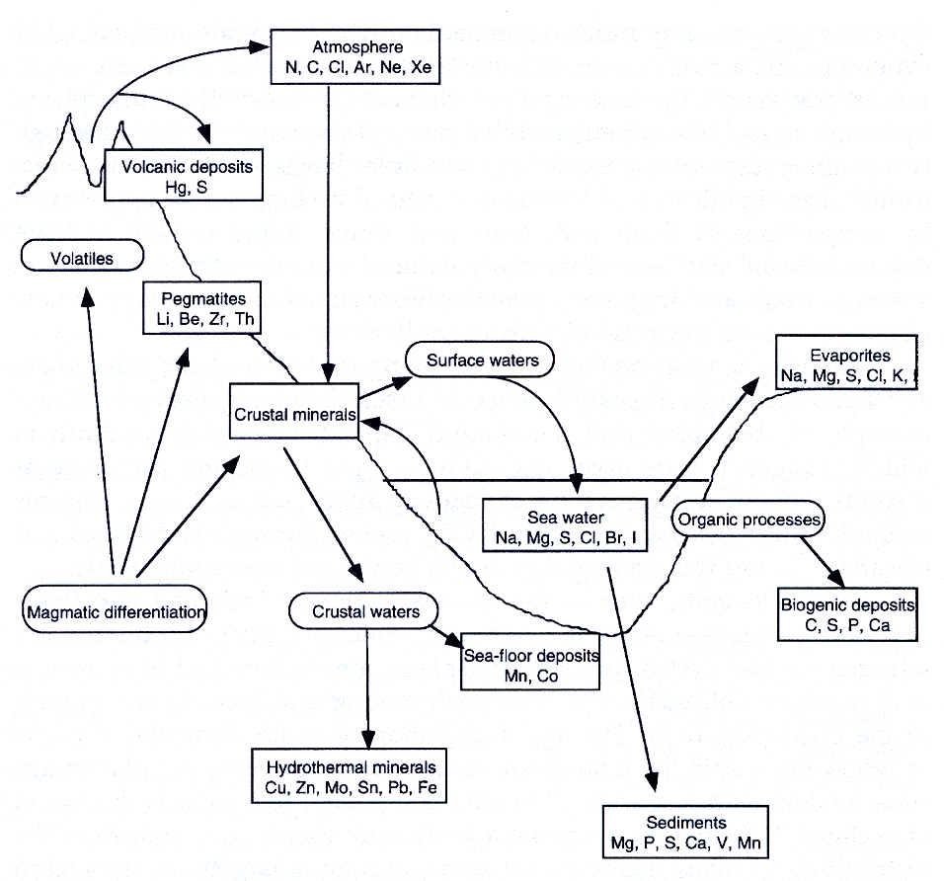

Redox Cycles

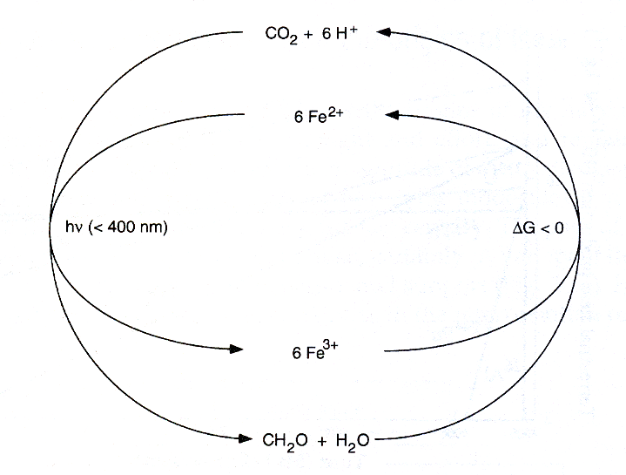

Theoretical Perspectives on the Origin of Life

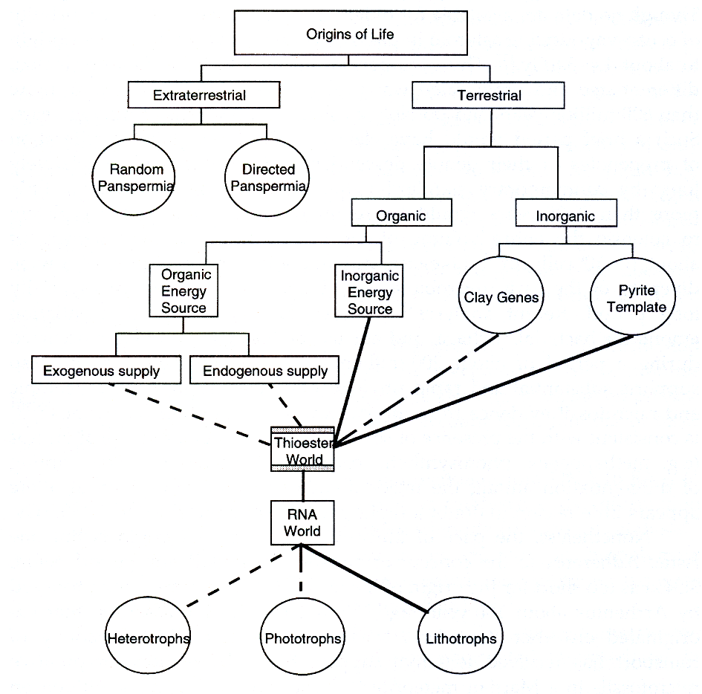

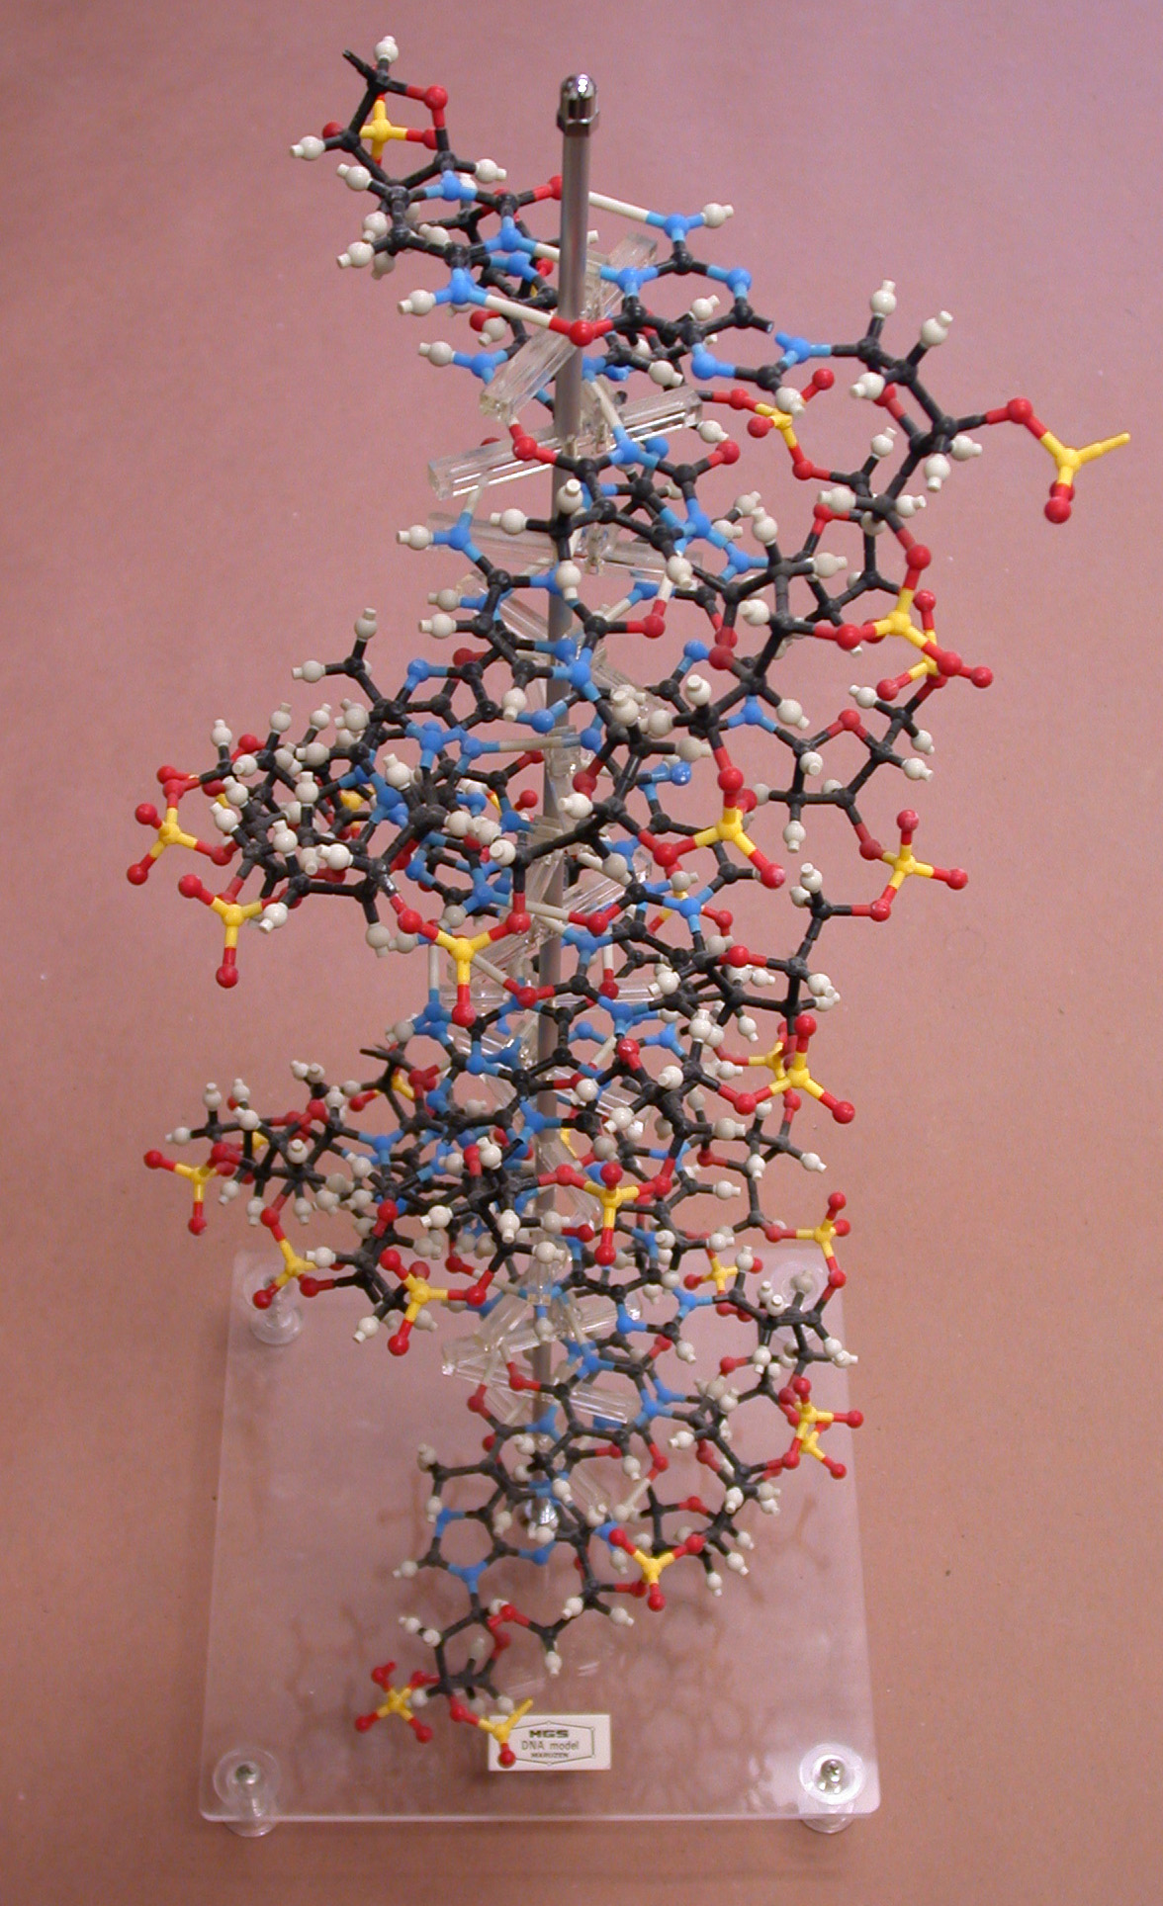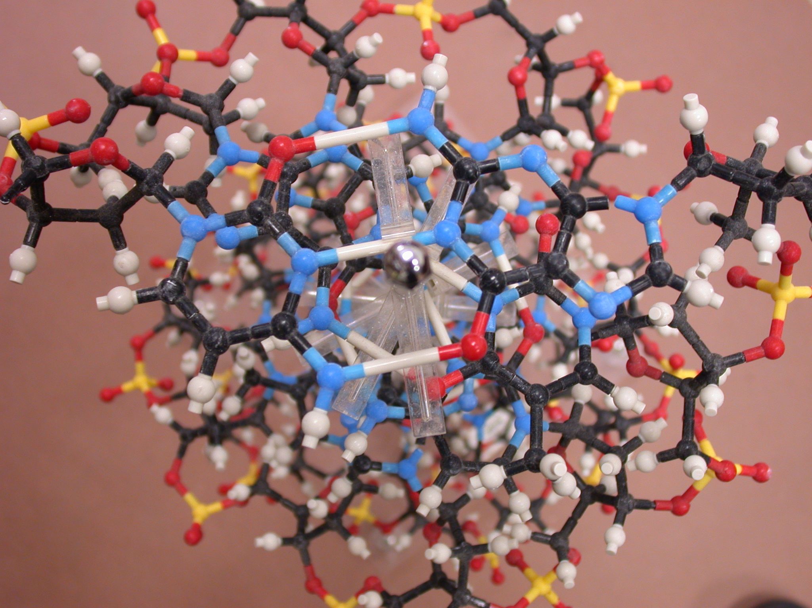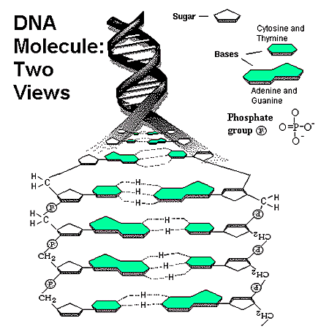

- the universality and conservation of chirality in biopolymers, especially amino acids.
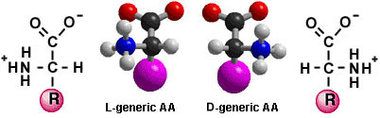
Play the chirality game at:
http://nobelprize.org/chemistry/educational/chiral/

- the universality of ATP as the main currency of energy conservation.

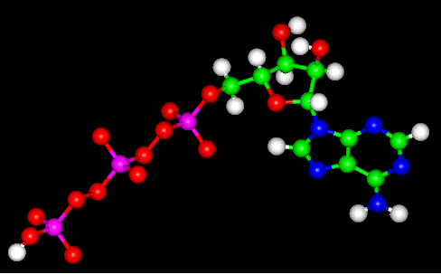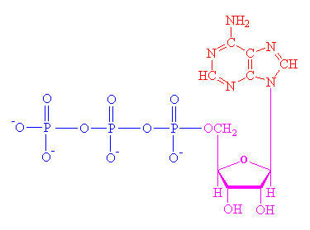

- the universality of typical scarce metals as required components of enzymes, co-factors, and electron transport chains.

- the phylogenetic relationships of exant Archea, Bacteria, and Eucarya.

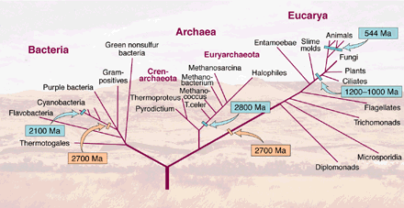

- the evolution of two distinct and exclusive membranes and their related transport systems.

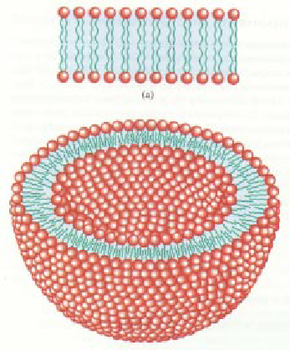

- the central role of thermophyly and sulfur metabolism at the base of the archeal, bacterial, and eucaryal domains.

- the availability of chemical and electromagnetic energy sources.

The Oparin-Haldane theory



