Questions for Discussion – Reading 1

- What are chronic and periodic hazards? Discuss some examples and complications?

- Why may it be important to recognize that within some cultures myths and legends are still used as the primary explanation for natural hazards?

- What point does the author make about published scientific articles in relation to myths? Do you agree or disagree with his assertion?

- What is the difference between uniformitarianism and catastrophism? Discuss which model do you think best applies to the earth and why?

- What factors effect how countries can handle natural disasters? Would you add any others to the list the author makes?

- How does the Marxist viewpoint apply to human society and natural hazards? Do you agree or disagree?

- Which areas experience the highest numbers of natural hazard events? Do you recognize any of these areas from your geography quiz?

- The author presents statistics in terms of deaths, injuries and homeless. What statistics do you think are important to determine the damage caused by natural disasters? What might you add/remove?

- Which myth described in the reading was your favorite and what was its geologic interpretation?

- What is the most frequent geologic hazard? Which is the most costly?

- Below is a graph for the frequency of natural disasters reported from 1900 to 2002. Does this mean that natural disasters have increased over time? Why or why not?
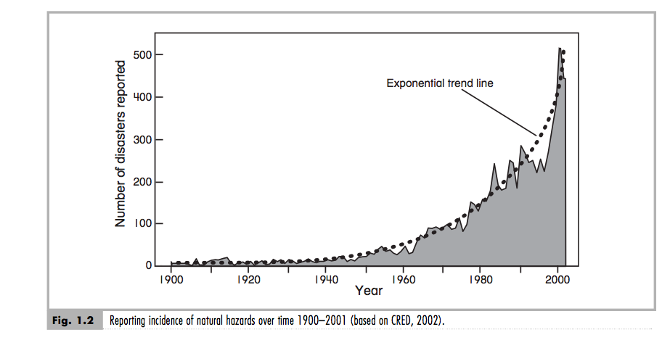

https://www.youtube.com/watch?v=BirIEDYrw0Y&list=PLF88CEDD1CA8A5B

